Data analysis is a process of inspecting, cleansing, transforming, and modeling large and complex data sets with the goal of discovering useful information, informing conclusions, and supporting decision-making.

Analysis refers to breaking a whole into its separate components for individual examination. Data analysis is a process for obtaining raw data and converting it into information useful for decision-making by users. Data is collected and analyzed to answer questions, test hypotheses or disprove theories.

Data mining is a particular data analysis technique that focuses on modeling and knowledge discovery for predictive rather than purely descriptive purposes, while business intelligence covers data analysis that relies heavily on aggregation, focusing mainly on business information.

In statistical applications, data analysis can be divided into descriptive statistics, exploratory data analysis (EDA), and confirmatory data analysis (CDA). EDA focuses on discovering new features in the data while CDA focuses on confirming or falsifying existing hypotheses.

Predictive analytics focuses on application of statistical models for predictive forecasting or classification, while text analytics applies statistical, linguistic, and structural techniques to extract and classify information from textual sources, a species of unstructured data. All of the above are varieties of data analysis.

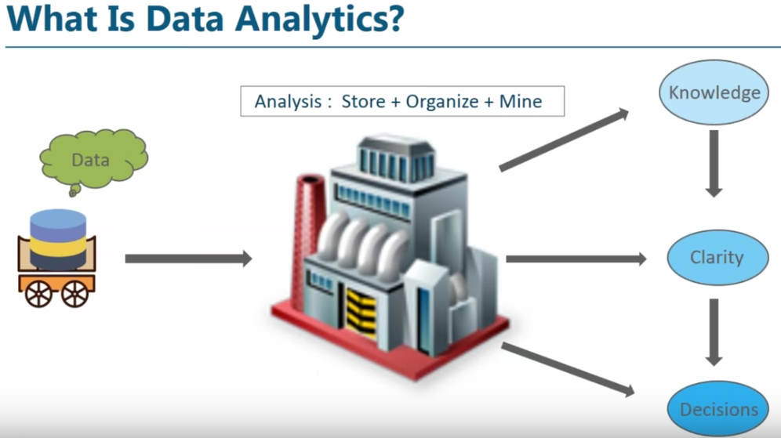

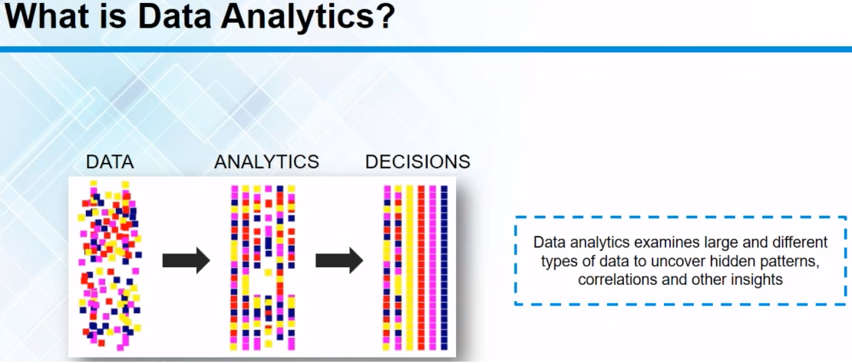

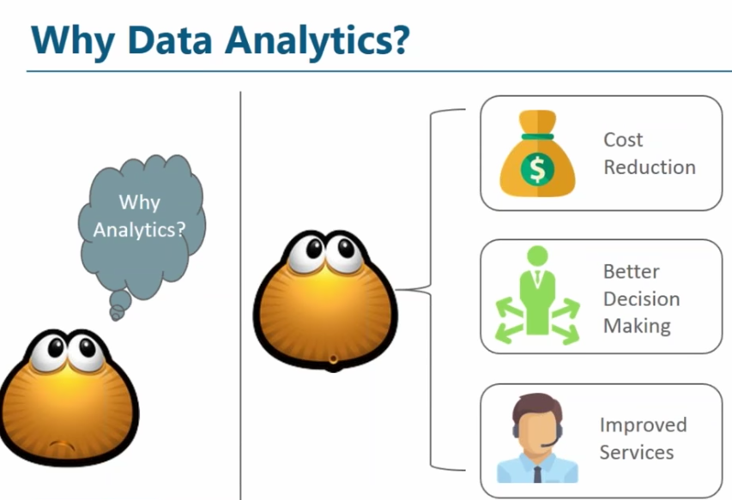

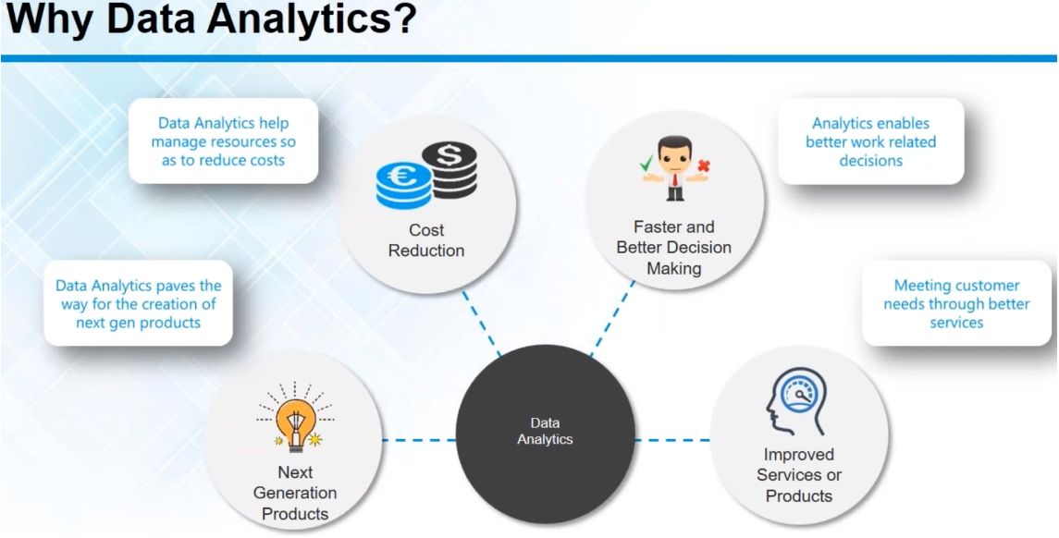

* Predict customer trends and behaviours
* Analyse, interpret and deliver data in meaningful ways
* Increase business productivity
* Drive effective decision-making



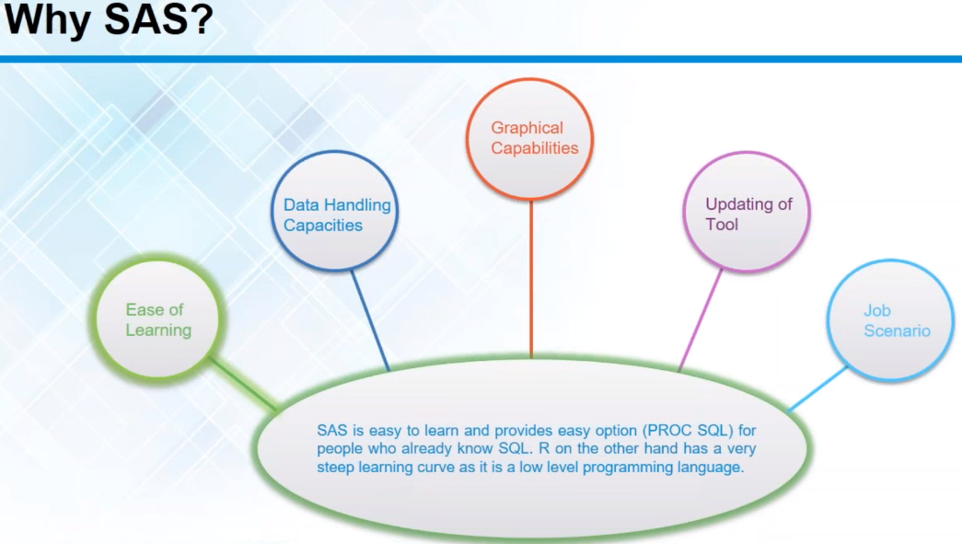

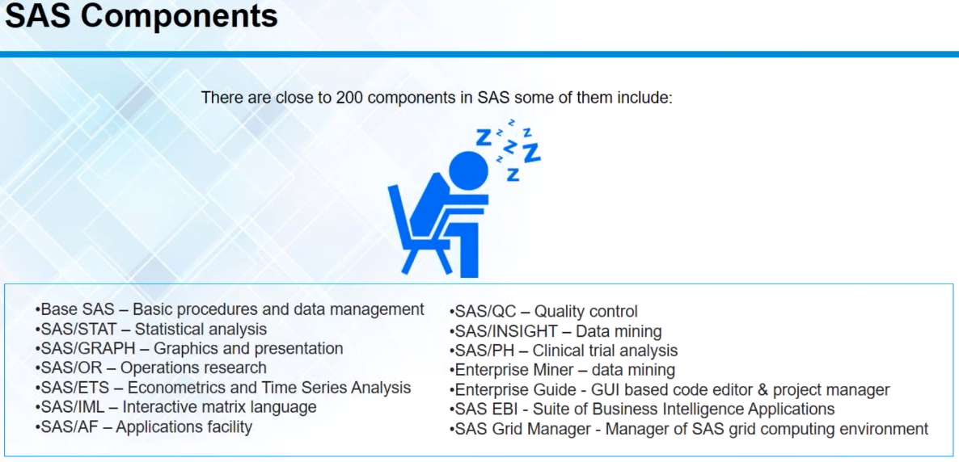

# SAS

Originally, the acronym "SAS" stood for "Statistical Analysis System." Because the system has now grown to be so diverse and can do so much more than perform statistical analyses, the SAS Institute now no longer treats "SAS" as an acronym, but rather the software's name.

SAS is a fourth-generation programming language (or 4GL), a fourth-generation programming language is "a programming language designed with a specific purpose in mind such as the development of commercial business software." All 4GLs are designed to reduce programming effort and minimize the time and cost it takes to develop software.

SAS System is an integrated system of modular software products. It enables we to:

* Enter, retrieve and manage the data easily
* Create slick reports and pretty pictures
* Analyze the data statistically and mathematically
* Plan, forecast and make decisions concerning the business
* Manage the projects and perform research on how we conduct the operations
* Improve the quality of the processes, as well as Develop entirely new software applications.

We can also use SAS for many large-scale functions, such as data warehousing, data mining, human resources management, decision support, and financial management.



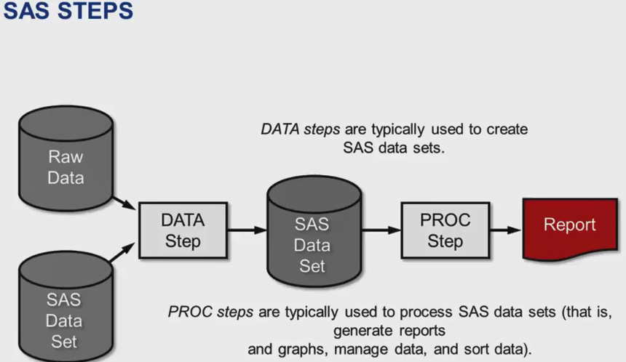

## SAS STATEMENTS

The basic requirements for SAS statements are:

* All SAS statements (except those containing data) must end with a semicolon (;).
* SAS statements typically begin with a SAS keyword. (Examples in the above program include OPTIONS, TITLE, DATA, INPUT, DATALINES, RUN, PROC, and VAR.)
* SAS programs can be freely formatted:
* SAS statements are not case sensitive, that is, they can be entered in lowercase, uppercase, or a mixture of the two.
* Comments may (and should!) be used to annotate the program. Two methods are:
* A delimited comment begins with a forward slash-asterisk (/*) and ends with an asterisk-forward slash (*/).
* An alternative comment begins with an asterisk (*) and ends with a semicolon (;).

## SAS NAMES

SAS names are used for SAS data set names, variable names, and other such items. Rules for SAS names are:

* LIBREF names can have max 8 characters.
* Variable and Dataset names must contain between 1 and 32 characters.
* The first character appearing in a name must be a letter (A, B, ...Z, a, b, ... z) or an underscore (_). Subsequent characters must be letters, numbers, or underscores. That is, no other characters, such as $, %, or & are permitted. Blanks also cannot appear in SAS names.
* SAS names are not case sensitive, that is, they can be entered in lowercase, uppercase, or a mixture of the two. (SAS is only case sensitive within quotation marks.

# BASE SAS

Base SAS software contains the following:

* A data management facility
* A programming language
* Data analysis and reporting utilities

Learning to use Base SAS enables we to work with these features of SAS. It also prepares we to learn other SAS products, because all SAS products follow the same basic rules.

## DATA MANAGEMENT FACILITY

SAS organizes data into a rectangular form or table that is called a SAS data set. The following figure shows a SAS data set. The data describes participants in a 16-week weight program at a health and fitness club. The data for each participant includes an identification number, name, team name, and weight (in U.S. pounds) at the beginning and end of the program.

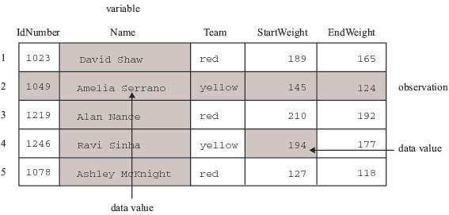

The following SAS program creates a SAS data set named WEIGHT_CLUB from the health club data:

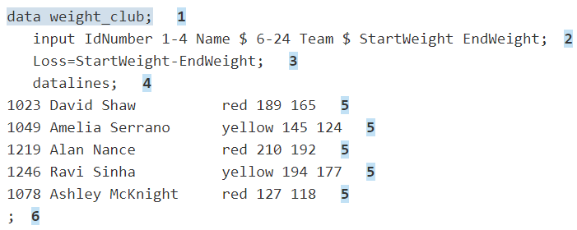

The following list corresponds to the numbered items in the preceding program:

* The DATA statement tells SAS to begin building a SAS data set named WEIGHT_CLUB.
* The INPUT statement identifies the fields to be read from the input data and names the SAS variables to be created from them (IdNumber, Name, Team, StartWeight, and EndWeight).
* The third statement is an assignment statement. It calculates the weight each person lost and assigns the result to a new variable, Loss.
* The DATALINES statement indicates that data lines follow.
* The data lines follow the DATALINES statement. This approach to processing raw data is useful when we have only a few lines of data. (Later sections show ways to access larger amounts of data that are stored in files.)
* The semicolon signals the end of the raw data, and is a step boundary. It tells SAS that the preceding statements are ready for execution.

## PROGRAMMING LANGUAGE

The statements that created the data set WEIGHT_CLUB are part of the SAS programming language. The SAS language contains statements, expressions, functions and CALL routines, options, formats, and informats – elements that many programming languages share. However, the way we use the elements of the SAS language depends on certain programming rules. The most important rules are listed in the next two sections.

### RULES FOR SAS STATEMENTS

The conventions that are shown in the programs in this documentation, such as indenting of subordinate statements, extra spacing, and blank lines, are for the purpose of clarity and ease of use. They are not required by SAS. There are only a few rules for writing SAS statements:

* SAS statements end with a semicolon.
* We can enter SAS statements in lowercase, uppercase, or a mixture of the two.
* We can begin SAS statements in any column of a line and write several statements on the same line.
* We can begin a statement on one line and continue it on another line, but we cannot split a word between two lines.
* Words in SAS statements are separated by blanks or by special characters (such as the equal sign and the minus sign in the calculation of the Loss variable in the WEIGHT_CLUB example).

### RULES FOR MOST SAS NAMES

SAS names are used for SAS data set names, variable names, and other items. The following rules apply:

* A SAS name can contain from one to 32 characters.
* LIBREF should not exceed 8 characters.
* The first character must be a letter or an underscore (_).
* Subsequent characters must be letters, numbers, or underscores.
* Blank spaces cannot appear in SAS names.
* Special Rules for Variable Names

For variable names only, SAS remembers the combination of uppercase and lowercase letters that we use when we create the variable name. Internally, the case of letters does not matter. “CAT,” “cat,” and “Cat” all represent the same variable. But for presentation purposes, SAS remembers the initial case of each letter and uses it to represent the variable name when printing it.

## DATA ANALYSIS AND REPORTING UTILITIES

The SAS programming language is both powerful and flexible. We can program any number of analyses and reports with it. SAS can also simplify programming for we with its library of built-in programs known as SAS procedures. SAS procedures use data values from SAS data sets to produce pre-programmed reports, requiring minimal effort from we.

For example, the following SAS program produces a report that displays the values of the variables in the SAS data set WEIGHT_CLUB. Weight values are presented in U.S. pounds.

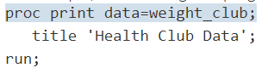

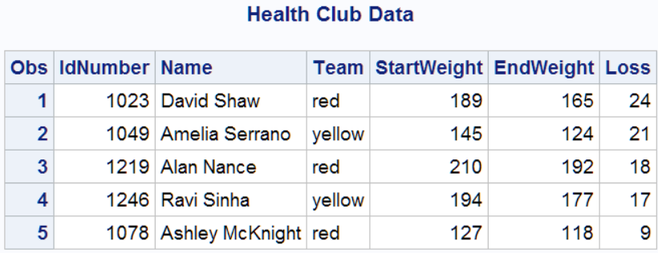

# OUTPUT PRODUCED BY THE SAS SYSTEM

A SAS program can produce some or all of the following Traditional types of output:

* SAS data set
* SAS log
* Report or simple listing
* Other SAS files such as catalogs (SAS/GRAPH software)
* External files or entries in other databases (using SAS/ACCESS)

## OUTPUT FROM THE OUTPUT DELIVERY SYSTEM (ODS)

The Output Delivery System (ODS) enables us to produce output in a variety of formats, such as the following:

* HTML file
* Traditional SAS Listing (monospace)
* PostScript file
* RTF file (for use with Microsoft Word)
* Output data set

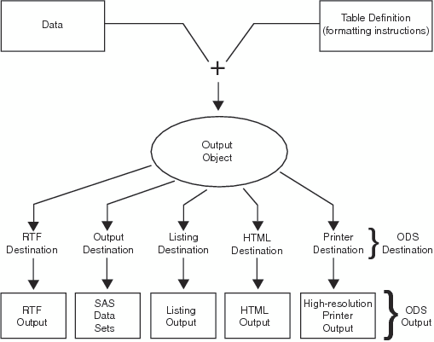

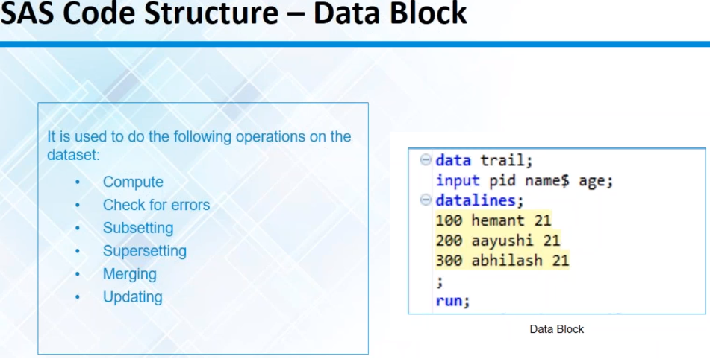

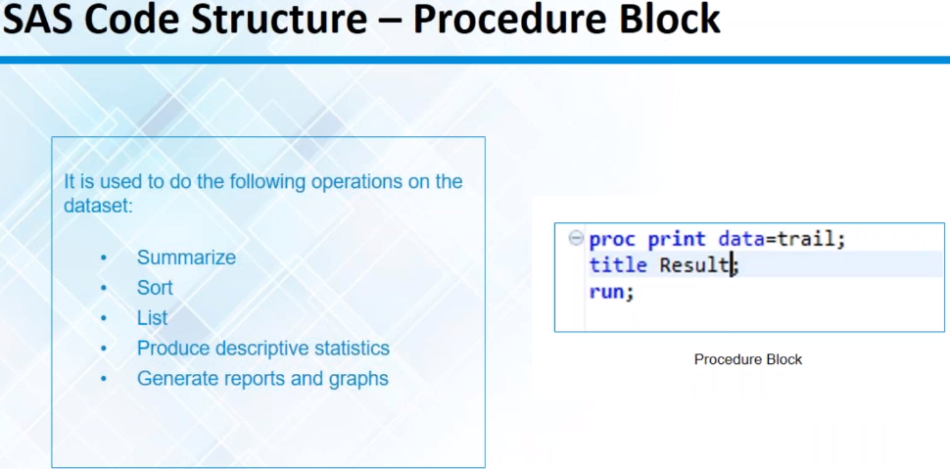

# SAS DATA SET

Before we can do anything with the data, the First step is to get the data into a form that SAS can recognize and process. After the data is in that form, we can analyze it and generate reports.

We begin with raw data, that is, a collection of data that has not yet been processed by SAS. We use a set of statements known as a DATA step to get the data into a SAS data set. Then we can further process the data with additional DATA step programming or with SAS procedures.

The following figure shows the process how data is transformed within SAS using DATA and PROC steps:

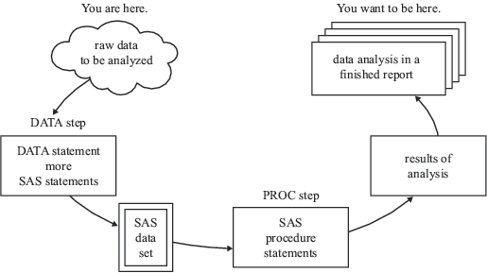

From raw data to SAS Data set:

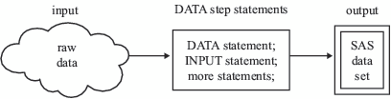

Using one SAS Data Set to create another:

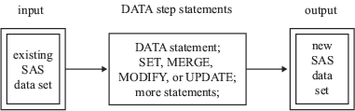

How data fits into SAS dataset

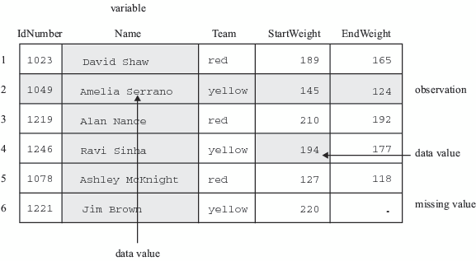

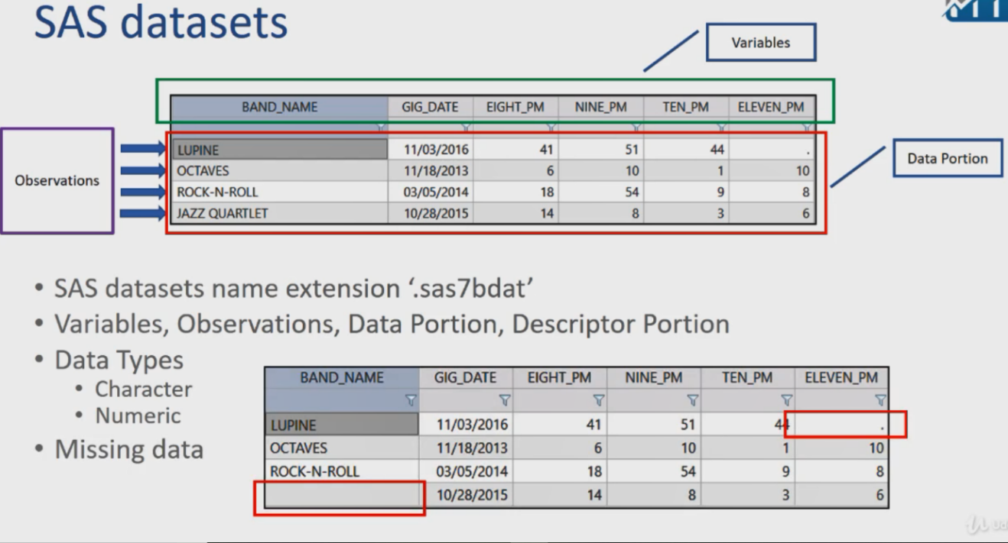

Along with data values, each SAS data set contains a descriptor portion, as illustrated in the following figure:

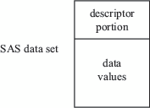

The descriptor portion consists of details that SAS records about a data set, such as the names and attributes of all the variables, the number of observations in the data set, and the date and time that the data set was created and updated.

The type of variable is just one of six variable attributes that SAS stores in the descriptor portion of every SAS data set. The six attributes that SAS stores are:

* The variable's name
* The variable's type
* The variable's length
* The variable's format (if any)
* The variable's informat (if any)
* The variable's label (if any)

## FILENAME

The FILENAME statement assigns a fileref to an external file. The association between a fileref and an external file lasts only for the duration of a SAS session or until you change the fileref by using another FILENAME statement.

A FILENAME statement uses the following format:



Note: FILEREF cannot exceed 8 characters.

## LIBNAME

The LIBNAME statement assigns a libref to a SAS data set or to a DBMS file that can be accessed like a SAS data set. The association between a libref and a SAS library lasts only for the duration of the SAS session or until you change the libref by using another LIBNAME statement.

A LIBNAME statement uses the following format:



Note: LIBREF cannot exceed 8 characters.

## TEMPORARY DATA SETS

When you use a DATA step to create a SAS data set with a one-level name, you normally create a temporary SAS data set, one that exists only for the duration of your current session. SAS places this data set in a SAS library referred to as WORK. In most operating environments, all files that SAS stores in the WORK library are deleted at the end of a session.

The following is an example of a DATA step that creates the temporary data set WEIGHT_CLUB.

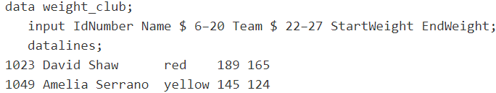

## PERMANENT DATA SETS

To create a permanent SAS data set, you must indicate a SAS library other than WORK. (WORK is a reserved libref that SAS automatically assigns to a temporary SAS library.) Use a LIBNAME statement to assign a libref to a SAS library on your operating environment's file system. The libref functions as a shorthand way of referring to a SAS library. Here is the form of the LIBNAME statement:

The following is an example of the LIBNAME statement that is used with a DATA step:

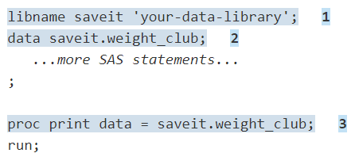

The following list corresponds to the numbered items:

* The LIBNAME statement associates the libref SAVEIT with your-data-library, where your-data-library is your operating environment's name for a SAS library.
* To create a new permanent SAS data set and store it in this SAS library, you must use the two-level name SAVEIT.WEIGHT_CLUB in the DATA statement.
* To reference this SAS data set in a later DATA step or in a PROC step, you must use the two-level name SAVEIT.WEIGHT_CLUB in the PROC step.

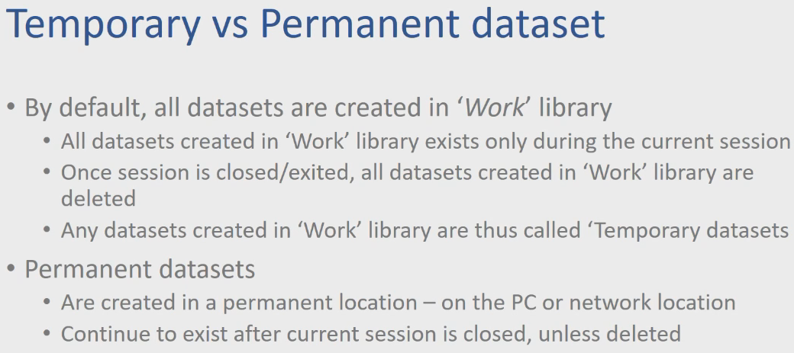

# SAS STATEMENTS

A SAS statement is a string of SAS keywords, SAS names, special characters, and operators that instructs SAS to perform an operation or that gives information to SAS. Each SAS statement ends with a semicolon.

SAS has two types of statements:

* Statements that are used in DATA step programming
* Statements that are global in scope and can be used anywhere in a SAS program.

## DATA STEP STATEMENTS

DATA step statements are executable or declarative statements that can appear in the DATA step.

### EXECUTABLE STATEMENTS

Executable statements result in some action during individual iterations of the DATA step.

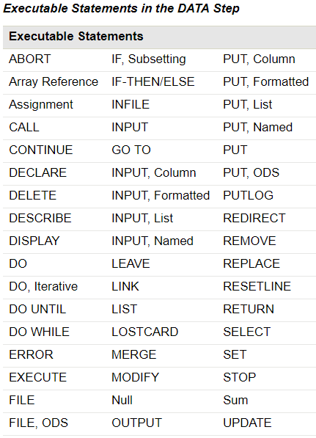

### DECLARATIVE STATEMENTS

declarative statements supply information to SAS and take effect when the system compiles program statements.

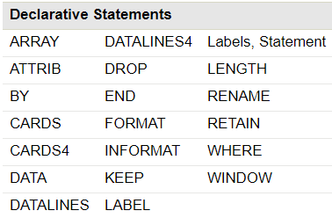

DATA step statements can be grouped into six functional categories

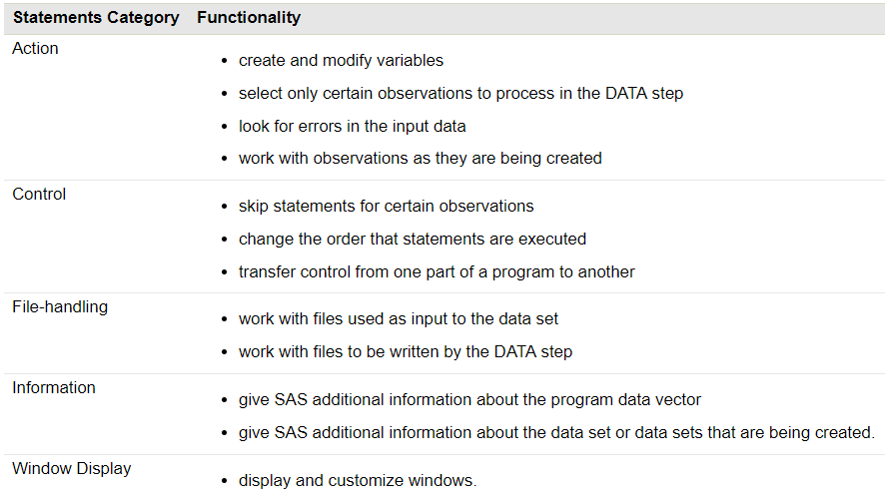

## GLOBAL STATEMENTS

Global statements generally provide information to SAS, request information or data, move between different modes of execution, or set values for system options. Other global statements (ODS statements) deliver output in a variety of formats, such as in Hypertext Markup Language (HTML). You can use global statements anywhere in a SAS program. Global statements are not executable; they take effect as soon as SAS compiles program statements.

Global statements can be divided into eight functional categories.

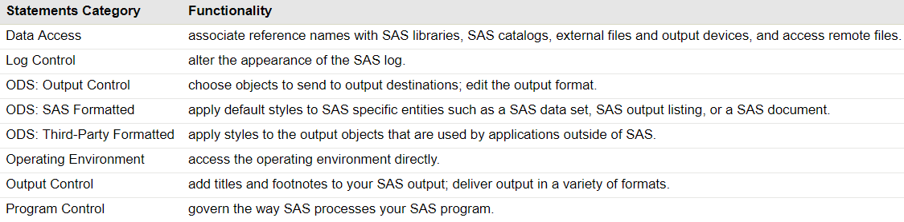

# DATA STEP

The DATA step consists of a group of SAS statements that begins with a DATA statement. The DATA step is one of the basic building blocks of SAS programming. It creates the data sets that are used in a SAS program's analysis and reporting procedures.

In general, DATA steps are used to manage data. For example, DATA steps are used to read data into a SAS data set, to modify data values, to check for and correct data errors, and to subset or merge data sets.

The following figure illustrates the flow of action in a simple DATA step.

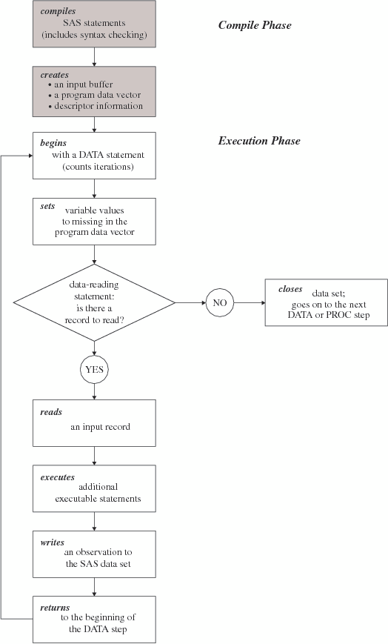

## COMPILATION PHASE

When you submit a DATA step for execution, SAS checks the syntax of the SAS statements and compiles them, that is, automatically translates the statements into machine code. SAS further processes the code, and creates the following three items:

* **Input buffer:** Is a logical area in memory into which SAS reads each record of data from a raw data file when the program executes. (When SAS reads from a SAS data set, however, the data is written directly to the program data vector.)
* **Program Data Vector (PDV):** Is a logical area of memory where SAS builds a data set, one observation at a time. When a program executes, SAS reads data values from the input buffer or creates them by executing SAS language statements. SAS assigns the values to the appropriate variables in the program data vector. From here, SAS writes the values to a SAS data set as a single observation.

The program data vector also contains two automatic variables, _N_ and _ERROR_. The _N_ variable counts the number of times the DATA step begins to iterate. The _ERROR_ variable signals the occurrence of an error caused by the data during execution. These automatic variables are not written to the output data set.

* **Descriptor Information:** is information about each SAS data set, including data set attributes and variable attributes. SAS creates and maintains the descriptor information.

## EXECUTION PHASE

All executable statements in the DATA step are executed once for each iteration. If your input file contains raw data, then SAS reads a record into the input buffer. SAS then reads the values in the input buffer and assigns the values to the appropriate variables in the program data vector.

SAS also calculates values for variables created by program statements, and writes these values to the program data vector. When the program reaches the end of the DATA step, three actions occur by default that make using the SAS language different from using most other programming languages:

* SAS writes the current observation from the program data vector to the data set.
* The program loops back to the top of the DATA step.
* Variables in the program data vector are reset to missing values.

The following exceptions apply:

* Variables that you specify in a RETAIN statement are not reset to missing values.
* The automatic variables _N_ and _ERROR_ are not reset to missing.

If there is another record to read, then the program executes again. SAS builds the second observation, and continues until there are no more records to read. The data set is then closed, and SAS goes on to the next DATA or PROC step.

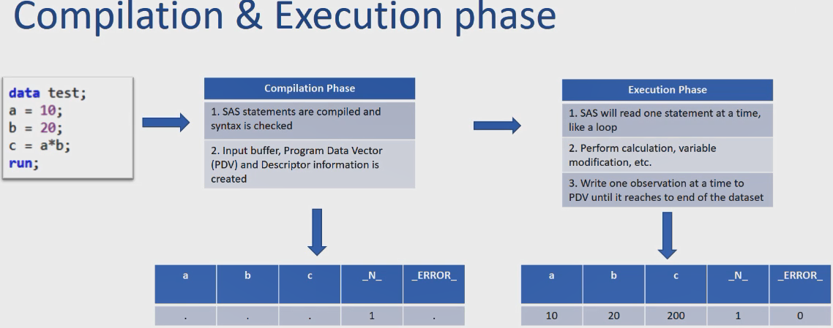

## EXAMPLE

The following simple DATA step produces a SAS data set from the data collected for a health and fitness club. As discussed earlier, the input data contains each participant's identification number, name, team name, and weight at the beginning and end of a 16-week weight program:

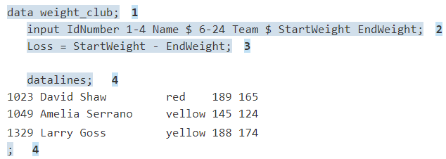

The following list corresponds to the numbered items in the preceding program:

* The DATA statement begins the DATA step and names the data set that is being created.
* The INPUT statement creates five variables, indicates how SAS reads the values from the input buffer, and assigns the values to variables in the program data vector.
* The assignment statement creates an additional variable called Loss, calculates the value of Loss during each iteration of the DATA step, and writes the value to the program data vector.
* The DATALINES statement marks the beginning of the input data. The single semicolon marks the end of the input data and the DATA step.

Note: A DATA step that does not contain a DATALINES statement must end with a RUN statement.

# VARIABLES IN SAS

SAS stores all the variables as either NUMERIC data or CHARACYER data.

So far we have seen that the INPUT statement instructs SAS on how to read raw data lines. At the same time that the INPUT statement provides instructions for reading data, it defines the variables for the data set that come from the raw data. By assuming default values for variable attributes, the INPUT statement does much of the work for you. Later in this documentation that you will learn other statements that enable you to define variables and assign attributes to variables. This section and Starting with Raw Data: The Basics concentrate on the use of the INPUT statement.

SAS variables can have these attributes:

* Name
* Type
* Length
* Informat
* Format
* Label
* Position in observation
* Index type

In an INPUT statement, you must supply each variable name. Unless you also supply an informat, the type is assumed to be numeric, and its length is assumed to be eight bytes. The following INPUT statement creates four numeric variables, each with a length of eight bytes, without requiring you to specify either type or length.

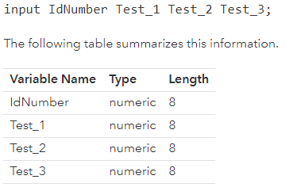

The values of numeric variables can contain only numbers. To store values that contain alphabetic or special characters, you must create a character variable. By following a variable name in an INPUT statement with a dollar sign ($), you create a character variable. The default length of a character variable is also eight bytes. The following statement creates a data set that contains one-character variable and four numeric variables, all with a default length of eight bytes.

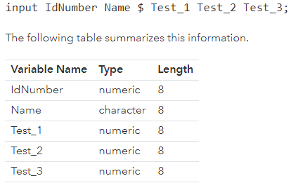

Note that the length of numeric variables is not affected by informats or column specifications in an INPUT statement.

## ATTRIB STATEMENT

Using the ATTRIB statement in the DATA step permanently associates attributes with variables by changing the descriptor information of the SAS data set that contains the variables.

You can use ATTRIB in a PROC step, but the rules are different. ATTRIB statement is sued to change the LENGTH, INFROMAT, FORMAT, LABEL & TRANSCODE for variables

Informats that are associated with variables that use the INFORMAT= option in the ATTRIB statement behave like informats that are used with modified list input.

Note: Modified list input uses format modifiers to help read in data. For example, use the: modifier with an informat to read character values that are longer than 8 bytes or vary in length. For numeric values, you can use the: modifier to read values that contain nonstandard values.

Here is how SAS treats variables in modified list input:

* Uses the value of w in an informat to specify the length of previously undefined character variables
* Does not use the value of w in an informat to specify input field widths or column positions in an external file
* Ignores the value of w in numeric informats
* Uses the value of d in an informat in the same way SAS usually does for numeric informats
* Treats blanks that are embedded as input data as delimiters unless you change their status with the DLM= or DLMSTR= option specification in an INFILE statement

If you have coded the INPUT statement to use another style of input, such as formatted input or column input, that style of input is not used when you use the INFORMAT= option in the ATTRIB statement.

Example of ATTRIB Statement:

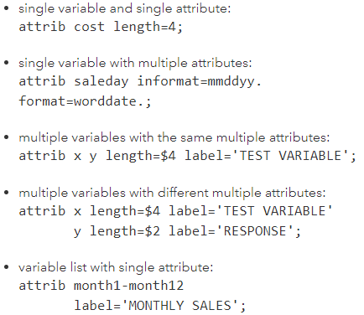

# DATA LOCATIONS

To create a SAS data set, you can read data from one of four locations:

* Raw data in the data stream (data available inside SAS code), that is, following a DATALINES or CARDS statement
* Raw data in a file that you specify with an INFILE statement
* Data from an existing SAS data set
* Data in a database management system (DBMS) file

## INSTREAM RAW DATA

You can place data directly in the job stream with the programming statements that make up the DATA step. The DATALINES statement tells SAS that raw data follows. The single semicolon that follows the last line of data marks the end of the data. The DATALINES statement and data lines must occur last in the DATA step statements:

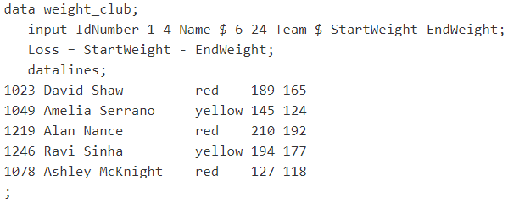

## DATA IN AN EXTERNAL FILE

If your raw data is already stored in a file, then you do not have to bring that file into the data stream. Use an INFILE statement to specify the file containing the raw data. For more information about the INFILE, FILE, and FILENAME statements, see Using External Files in Your SAS Job. The statements in the code that follows demonstrate the same example, this time showing that the raw data is stored in an external file:

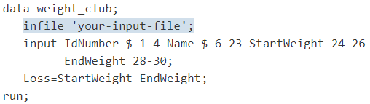

## DATA IN A SAS DATA SET

You can also use data that is already stored in a SAS data set as input to a new data set. To read data from an existing SAS data set, you must specify the existing data set's name in one of these statements:

* SET statement
* MERGE statement
* MODIFY statement
* UPDATE statement

For example, the statements that follow create a new SAS data set named RED that adds the variable LossPercent:

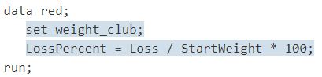

## DATA IN A DBMS FILE

If you have data that is stored in another vendor's database management system (DBMS) files, then you can use SAS/ACCESS software to bring this data into a SAS data set. SAS/ACCESS software enables you to assign a libref to a library containing the DBMS file. In this example, a libref is declared, and points to a library containing Oracle data. SAS reads data from an Oracle file into a SAS data set:

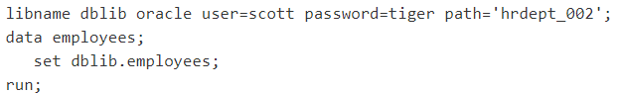

NOTE: See SAS/ACCESS for Relational Databases: Reference for more information about using SAS/ACCESS software to access DBMS files.

## EXTERNAL FILE WITH A FILEREF

An alternate method for referencing an external file is to use the FILENAME statement to set up a fileref for a file. The fileref functions as a shorthand way of referring to an external file. You then use the fileref in later SAS statements that reference the file, such as the FILE or INFILE statement. The advantage of this method is that if the program contains many references to the same external file and the external filename changes, then the program needs to be modified in only one place, rather than in every place where the file is referenced.

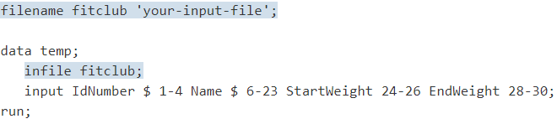

# READING RAW DATA

To create a SAS data set from raw data, you must examine the data records first to determine how the data values that you want to read are arranged. Then you can look at the styles of reading input that are available in the INPUT statement. SAS provides three basic input styles:

* List
* Column
* Formatted

You can use these styles individually, in combination with each other, or in conjunction with various line-hold specifiers, line-pointer controls, and column-pointer controls.8

Before you can select the appropriate style of input, examine the structure of the raw data that you want to read. Consider some of the following factors:

* How the data is arranged in the input records. For example, are data fields aligned in columns or unaligned? Are they separated by blanks or by other characters?
* Whether character values contain embedded blanks
* Whether numeric values contain nonnumeric characters such as commas
* Whether the data contains time or date values
* Whether each input record contains data for more than one observation
* Whether data for a single observation is spread over multiple input records

## LIST INPUT

The simplest form of the INPUT statement uses list input. List input is used to read data values that are separated by a delimiter character (by default, a blank space). With list input, SAS reads a data value until it encounters a blank space. SAS assumes that the value has ended and assigns the data to the appropriate variable in the program data vector. SAS continues to scan the record until it reaches a non-blank character again. SAS reads a data value until it encounters a blank space or the end of the input record.

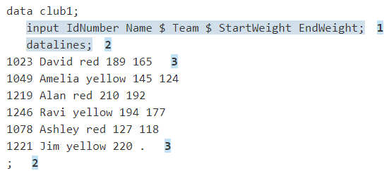

The following list corresponds to the numbered items in the preceding program:

* The variable names in the INPUT statement are specified in exactly the same order as the fields in the raw data records.
* The DATALINES statement marks the beginning of the data lines. The semicolon that follows the data lines marks the end of the data lines and the end of the DATA step.
* Each data value in the raw data record is separated from the next by at least one blank space. The last record contains a missing value, represented by a period, for the value of EndWeight.

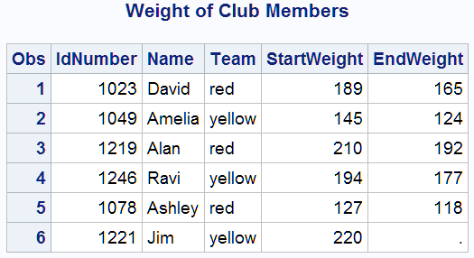

### DATA DELIMITED BY CHARACTERS NOT BLANK SPACE

This program also used above data set.

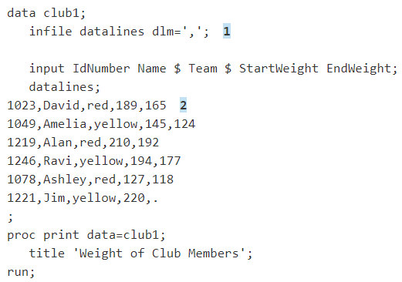

The following list corresponds to the numbered items in the preceding program:

* List input, by default, scans the input records, looking for blank spaces to delimit each data value. The DLM= option enables list input to recognize a character, here a comma, as the delimiter.
* These data values are separated by commas instead of blanks.

Note: This example requires the DLM= option, which is available only in the INFILE statement. Usually, this statement is used only when the input data resides in an external file. The DATALINES specification, however, enables you to take advantage of INFILE statement options, when you are reading data records from the job stream.

### WHEN CONSECUTIVE DELIMITERS INDICATE MISSING VALUES

This program also used above data set.

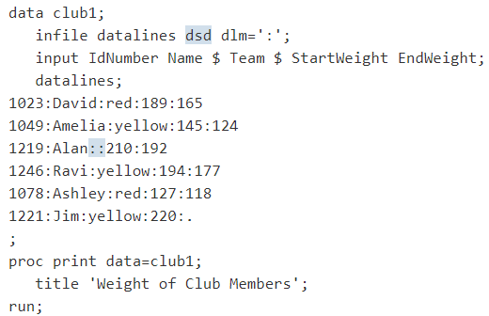

This example requires the DSD option, which is available only in the INFILE statement. Like the previous example, the DATALINES specification enables you to specify the INFILE statement with the DSD and DLM= options. The DSD option treats two consecutive delimiters as a missing value. (The DSD option also sets the default delimiter to a comma and ignores delimiters that occur within quoted strings.)

If you did not specify the DSD option in this example, then data values would become mismatched and the remaining data would not be read correctly. The following listing shows how the data would have been read if the DSD option were omitted. Notice that the values after Alan’s name are incorrect, and the observation for Ravi is omitted. Ravi’s IdNumber is read as Alan’s EndWeight value and the remainder of that record is ignored.

DSD Option omitted:

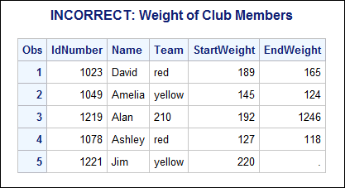

When you include the DSD option in the INFILE statement, the consecutive delimiters indicate a missing value, and the data is read correctly. The following listing shows the resulting data set. You can see that now the missing Team value for Alan appears as a blank value, and the remaining data set is now read as expected.

With DSD Option:

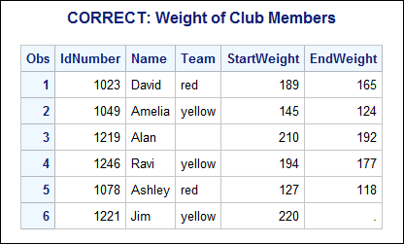

### POINTS TO REMEMBER

These are the points to remember when you use list input:

* Use list input when each field is separated by at least one blank space or delimiter. Use the DLM= option in an INFILE statement to indicate delimiters other than spaces. For list input, you must also specify DATALINES in the INFILE statement.
* Specify each field in the order in which they appear in the records of raw data.
* Use colon (:) to tell SAS to read data from datalines till a delimiter or new line character is encountered.
* Represent missing values by a placeholder such as a period.

Under the default behavior, a blank field causes the variable names and values to become mismatched. However, if you use the DSD option with comma delimiters, multiple commas indicate a missing value. To specify a delimiter other than a comma with the DSD option, use the DLM= option.

Note: Specify the DSD and DLM= options in an INFILE statement. For list input, you must also specify DATALINES in the INFILE statement.

* Character values cannot contain embedded blanks, unless you also specify the DSD and DLM= options in an INFILE statement.
* The default length of character variables is eight bytes. SAS truncates a longer value when it writes the value to the program data vector. (To read a character variable that contains more than eight characters with list input, use a LENGTH statement. See Defining Enough Storage Space for Variables.)
* Data must be in standard character or numeric format (that is, it can be read without an informat).

**Note:** List input requires the fewest specifications in the INPUT statement. However, the restrictions that are placed on the data might require that you learn to use other styles of input to read your data. For example, column input, which is discussed in the next section, is less restrictive. This section has introduced only simple list input. See Understanding How to Make List Input More Flexible to learn about modified list input.

## COLUMN INPUT

With column input, data values occupy the same fields within each data record. When you use column input in the INPUT statement, list the variable names and specify column positions that identify the location of the corresponding data fields. You can use column input when your raw data is in fixed columns and does not require the use of informats to be read.

The following program also uses the health and fitness club data, but now two more data values are missing. The data is aligned in columns and SAS reads the data with column input:

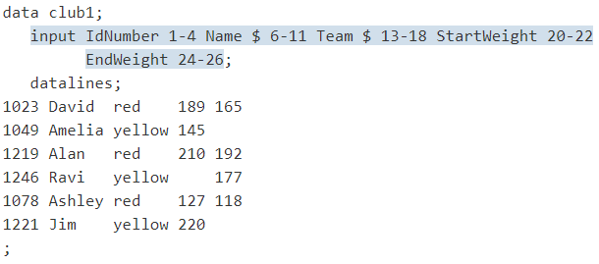

The specification that follows each variable name indicates the beginning and ending columns in which the variable value will be found. Note that with column input that you are not required to indicate missing values with a placeholder such as a period.

The following output displays the resulting data set. Missing numeric values occur three times in the data set, and are indicated by periods.

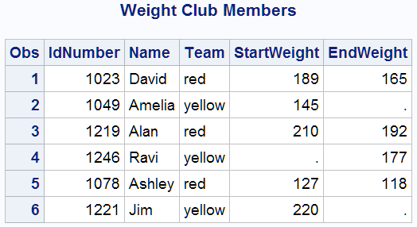

Advantages of Column Input over Simple List Input

Here are several advantages of using column input:

* With column input, character variables can contain embedded blanks.
* Column input also enables the creation of variables that are longer than eight bytes. In the preceding example, the variable Name in the data set CLUB1 contains only the members' first names. By using column input, you can read the first and last names as a single value. These differences between input styles are possible for two reasons:
  + Column input uses the columns that you specify to determine the length of character variables.
  + Column input, unlike list input, reads data until it reaches the last specified column, not until it reaches a blank space.
* Column input enables you to skip some data fields when reading records of raw data. It also enables you to read the data fields in any order and reread some fields or parts of fields.

### READING EMBEDDED BLANKS AND CREATING LONGER VARIABLES

This DATA step uses column input to create a new data set named CLUB2. The program still uses the health and fitness club weight data. However, the data has been modified to include members' first and last names. Now the second data field in each record or raw data contains an embedded blank and is 18 bytes long.

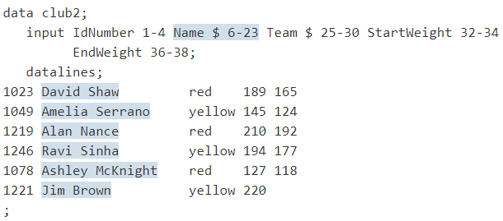

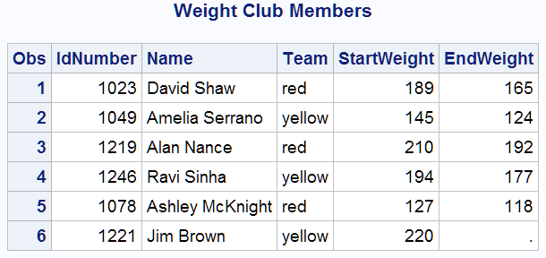

### SKIPPING FIELDS WHEN READING DATA RECORDS

Column input also enables you to skip over fields or to read the fields in any order. This example uses column input to read the same health and fitness club data, but it reads the value for the variable Team first and omits the variable IdNumber altogether.

You can read or reread part of a value when using column input. For example, because the team names begin with different letters, this program saves storage space by reading only the first character in the field that contains the team name. Note the INPUT statement: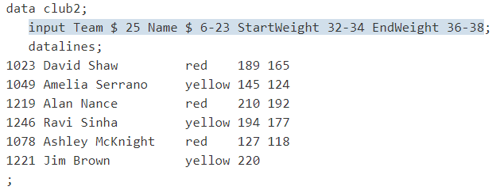

The following output displays the resulting data set. The variable that contains the identification number is no longer in the data set. Instead, Team is the first variable in the new data set, and it contains only one character to represent the team value.

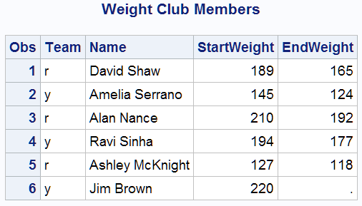

### POINTS TO REMEMBER

Remember the following rules when you use column input:

* Character variables can be up to 32,767 bytes (32KB) in length and are not limited to the default length of eight bytes.
* Character variables can contain embedded blanks.
* You can read fields in any order.
* A placeholder is not required to indicate a missing data value. A blank field is read as missing and does not cause other values to be read incorrectly.
* You can skip over part of the data in the data record.
* You can reread fields or parts of fields.
* You can read standard character and numeric data only. Informats are ignored.

## FORMATTED INPUT

Sometimes the INPUT statement requires special instructions to read the data correctly. For example, SAS can read numeric data that is in special formats such as binary, packed decimal, or date/time. SAS can also read numeric values that contain special characters such as commas and currency symbols. In these situations, use formatted input. Formatted input combines the features of column input with the ability to read nonstandard numeric or character values. The following data shows formatted input:

* 1,262
* $55.64
* 02JAN2013

The data in this program includes numeric values that contain a comma, which is an invalid character for a numeric variable:

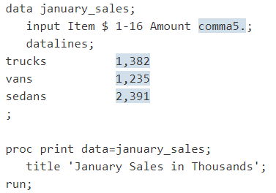

The INPUT statement cannot read the values for the variable Amount as valid numeric values without the additional instructions provided by an informat. The informat COMMA5. enables the INPUT statement to read and store this data as a valid numeric value.

The following figure shows that the informat COMMA5. instructs the program to read five characters of data (the comma counts as part of the length of the data), to remove the comma from the data, and to write the resulting numeric value to the program data vector. Note that the name of an informat always ends in a period (.).

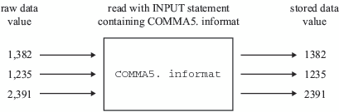

The following output displays the resulting data set. The values for Amount contain only numbers. Note that the commas are removed.

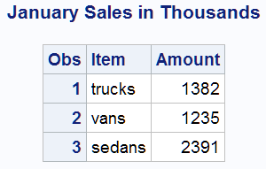

In a report, you might want to include the comma in numeric values to improve readability. Just as the informat gives instructions on how to read a value and to remove the comma, a format gives instructions to add characters to variable values in the output.

### UNDERSTANDING HOW TO CONTROL THE POSITION OF THE POINTER

As the INPUT statement reads data values, it uses an input pointer to keep track of the position of the data in the input buffer. Column-pointer controls provide additional control over pointer movement and are especially useful with formatted input. Column-pointer controls tell how far to advance the pointer before SAS reads the next value. In this example, SAS reads data lines with a combination of column and formatted input:

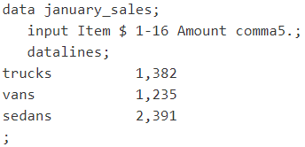

In the next example, SAS reads data lines by using formatted input with a column-pointer control:

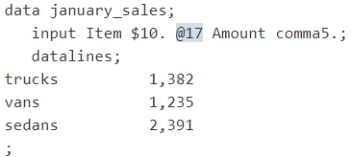

After SAS reads the first value for the variable Item, the pointer is left in the next position, column 11. Then the absolute column-pointer control, @17, directs the pointer to move to column 17 in the input buffer. Now, it is in the correct position to read a value for the variable Amount.

In the following program, the relative column-pointer control, +6, instructs the pointer to move six columns to the right before SAS reads the next data value.

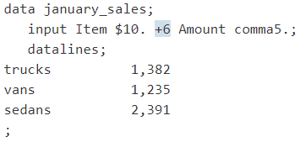

The data in these two programs is aligned in columns. As with column input, you instruct the pointer to move from field to field. You use column specifications with column input. However, with formatted input that you use the length that is specified in the informat together with pointer controls.

### POINTS TO REMEMBER

Remember the following rules when you use formatted input:

* SAS reads formatted input data until it has read the number of columns that the informat indicates. This method of reading the data is different from list input, which reads until a blank space (or other defined delimiter character) is reached.
* You can position the pointer to read the next value by using pointer controls.
* You can read data stored in nonstandard form such as packed decimal, or data that contains commas.
* You have the flexibility of using informats with all the features of column input, as described in Column Input: Points to Remember.

## MAKE LIST INPUT MORE FLEXIBLE

While list input is the simplest to code, remember that it places restrictions on your data. By using format modifiers, you can take advantage of the simplicity of list input without the inconvenience of the usual restrictions. For example, you can use modified list input to do the following:

* Create character variables that are longer than the default length of eight bytes.
* Read numeric data with special characters like commas, hyphens, and currency symbols.
* Read character data that contains embedded blanks.
* Read data values that can be stored as SAS date variables.

By simply modifying list input with the colon format modifier (:) you can read

* Character data that contains more than eight characters
* Numeric data that contains special characters

As in simple list input, at least one blank (or other defined delimiter character) must separate each value from the next, and character values cannot contain embedded blanks (or other defined delimiter characters). Consider this DATA step:

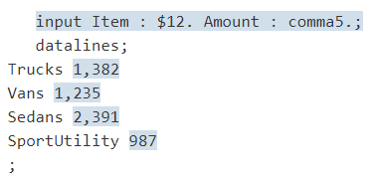

The variable Item has a length of 12, and the variable Amount requires an informat (in this case, COMMA5.) that removes commas from numbers so that they are read as valid numeric values. The data values are not aligned in columns as was required in the last example, which used formatted input to read the data.

The following output displays the resulting data set:

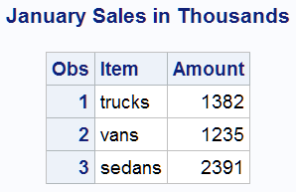

### READING CHARACTER DATA THAT CONTAINS EMBEDDED BLANKS

Because list input uses a blank space to determine where one value ends and the next one begins, values normally cannot contain blanks. However, with the ampersand format modifier (&) you can use list input to read data that contains single embedded blanks. The only restriction is that at least two blanks must divide each value from the next data value in the record.

To use the ampersand format modifier with list input, place the ampersand between the variable name and the informat. The following DATA step uses the ampersand format modifier with list input to create the data set CLUB2. Note that the data is not in fixed columns. Therefore, column input is not appropriate.

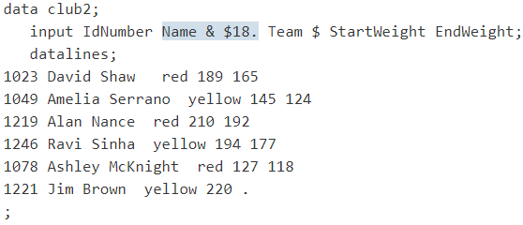

The character variable Name, with a length of 18, contains members' first and last names separated by one blank space. The data lines must have two blank spaces between the values for the variable Name and the variable Team for the INPUT statement to correctly read the data.

The following output displays the resulting data set:

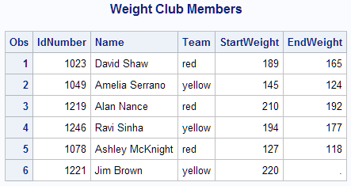

## MIXED INPUT

When you begin an INPUT statement in a particular style (list, column, or formatted), you are not restricted to using that style alone. You can mix input styles in a single INPUT statement as long as you mix them in a way that appropriately describes the raw data records. For example, this DATA step uses all three input styles:

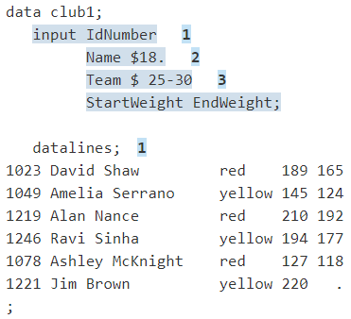

The following list corresponds to the numbered items in the preceding program:

* The variables IdNumber, StartWeight, and EndWeight are read with list input.
* The variable Name is read with formatted input.
* The variable Team is read with column input.

The following output demonstrates that the data is read correctly.

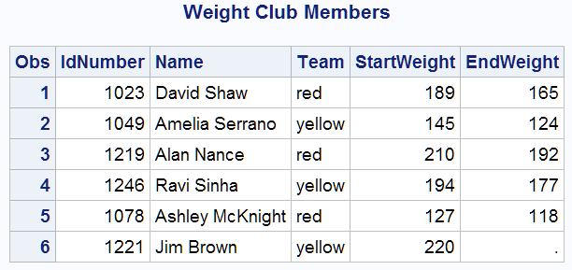

When you mix styles of input in a single INPUT statement, you can get unexpected results if you do not understand where the input pointer is positioned after SAS reads a value in the input buffer.

As the INPUT statement reads data values from the record in the input buffer, it uses a pointer to keep track of its position. Read the following sections so that you understand how the pointer movement differs between input styles before mixing multiple input styles in a single INPUT statement

### POINTER LOCATION WITH COLUMN AND FORMATTED INPUT

With column and formatted input, you supply the instructions that determine the exact pointer location. With column input, SAS reads the columns that you specify in the INPUT statement. With formatted input, SAS reads the exact length that you specify with the informat. In both cases, the pointer moves as far as you instruct it and stops. The pointer is left in the column that immediately follows the last column that is read.

Here are two examples of input followed by an explanation of the pointer location. The first DATA step shows column input:

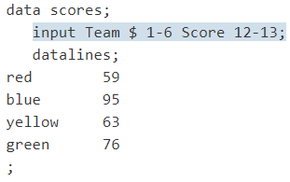

The second DATA step uses the same data to show formatted input:

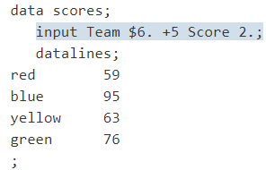

Unlike list input, column and formatted input rely totally on your instructions to move the pointer and read the value for the second variable, Score. Column input uses column specifications to move the pointer to each data field. Formatted input uses informats and pointer controls to control the position of the pointer.

This INPUT statement uses column input with the column specifications 12-13 to move the pointer to column 12 and read the value for the variable Score:



This INPUT statement uses formatted input with the +5 column-pointer control to move the pointer to column 12. Then the value for the variable Score is read with the 2. numeric informat.



Without the use of a pointer control, which moves the pointer to the column where the value begins, this INPUT statement would attempt to read the value for Score in columns 7 and 8, which are blank.

### POINTER LOCATION WITH LIST INPUT

List input, on the other hand, uses a scanning method to determine the pointer location. With list input, the pointer reads until a blank is reached and then stops in the next column. To read the next variable value, the pointer moves automatically to the first nonblank column, discarding any leading blanks that it encounters. Here is the same data that is read with list input:

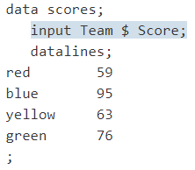

The following figure shows that the pointer is located in column 5 after the value red is read. Because Score, the next variable, is read with list input, the pointer scans for the next nonblank space before it begins to read a value for Score. Unlike column and formatted input, you do not have to explicitly move the pointer to the beginning of the next field in list input.

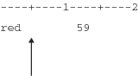

Following are various pointers available in SAS:

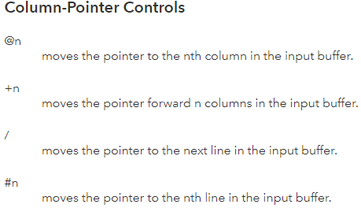

# INFILE STATEMENT

Because the INFILE statement identifies the file to read, it must execute before the INPUT statement that reads the input data records. You can use the INFILE statement in conditional processing, such as an IF-THEN statement, because it is executable. The INFILE statement enables you to control the source of the input data records.

Usually, you use an INFILE statement to read data from an external file. When data is read from the job stream, you must use a DATALINES statement. However, to take advantage of certain data-reading options that are available only in the INFILE statement, you can use an INFILE statement with the file-specification DATALINES and a DATALINES statement in the same DATA step.

When you use more than one INFILE statement for the same file specification and you use options in each INFILE statement, the effect is additive. To avoid confusion, use all the options in the first INFILE statement for a given external file.

## READING MULTIPLE INPUT FILES

You can read from multiple input files in a single iteration of the DATA step in one of two ways:

* To keep multiple files open and change which file is read, use multiple INFILE statements.
* To dynamically change the current input file within a single DATA step, use the FILEVAR= option in an INFILE statement. The FILEVAR= option enables you to read from one file, close it, and then open another.

## UPDATING EXTERNAL FILES IN PLACE

You can use the INFILE statement in combination with the FILE statement to update records in an external file:

* Specify the INFILE statement before the FILE statement.
* Specify the same fileref or physical filename in each statement.
* Use options that are common to both the INFILE and FILE statements in the INFILE statement instead of the FILE statement. (Any such options that are used in the FILE statement are ignored.)

To update individual fields within a record instead of the entire record, see the SHAREBUFFERS option.

## READING LONG INSTREAM DATA RECORDS

You can use the INFILE statement with the DATALINES file specification to process instream data. An INPUT statement reads the data records that follow the DATALINES statement. If you use the CARDIMAGE system option, or if this option is the default for your system, then SAS processes the data lines exactly like 80-byte punched card images that are padded with blanks. The default FLOWOVER option in the INFILE statement causes the INPUT statement to read the next record if it does not find values in the current record for all of the variables in the statement. To ensure that your data is processed correctly, use an external file for input when record lengths are greater than 80 bytes.

## READING PAST THE END OF A LINE

By default, if the INPUT statement tries to read past the end of the current input data record, then it moves the input pointer to column 1 of the next record to read the remaining values. This default behavior is specified by the FLOWOVER option. A message is written to the SAS log:

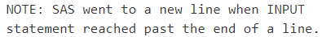

Several options are available to change the INPUT statement behavior when an end of line is reached. The STOPOVER option treats this condition as an error and stops building the data set. The MISSOVER and TRUNCOVER options do not allow the input pointer to go to the next record when the current INPUT statement is not satisfied. The SCANOVER option, used with @'character-string' scans the input record until it finds the specified character-string. The FLOWOVER option restores the default behavior.

The TRUNCOVER and MISSOVER options are similar. The MISSOVER option causes the INPUT statement to set a value to missing if the statement is unable to read an entire field because the value is shorter than the field length that is specified in the INPUT statement. The TRUNCOVER option writes whatever characters are read to the appropriate variable.

For example, an external file with variable-length records contains these records:

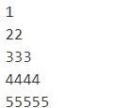

This DATA step reads this data to create a SAS data set. Only one of the input records is as long as the informatted length of the variable TESTNUM.

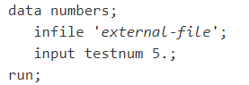

This DATA step creates the three observations from the five input records because by default the FLOWOVER option is used to read the input records.

If you use the MISSOVER option in the INFILE statement, then the DATA step creates five observations. All the values that were read from records that were too short are set to missing. Use the TRUNCOVER option in the INFILE statement if you prefer to see what values were present in records that were too short to satisfy the current INPUT statement.

The DATA step now reads the same input records and creates five observations. See this table to compare the SAS data sets.

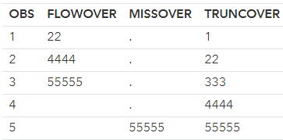

# RAW DATA: BEYOND BASICS

Following approaches shows how can we handle raw data in the input file or data stream if not available in standard format (all variables present in single line).

## TESTING A CONDITION BEFORE CREATING AN OBSERVATION

Sometimes you need to read a record, and hold that record in the input buffer while you test for a specified condition before a decision can be made about further processing. For example, the ability to hold a record so that you can read from it again, if necessary, is useful when you need to test for a condition before SAS creates an observation from a data record. To do this, you can use the trailing at-sign (@).

For example, to create a SAS data set that is a subset of a larger group of records, you might need to test for a condition to decide whether a particular record will be used to create an observation. The trailing at-sign placed before the semicolon at the end of an INPUT statement instructs SAS to hold the current data line in the input buffer. This makes the data line available for a subsequent INPUT statement. Otherwise, the next INPUT statement causes SAS to read a new record into the input buffer.

You can set up the process to read each record twice by following these steps:

* Use an INPUT statement to read a portion of the record.
* Use a trailing @ at the end of the INPUT statement to hold the record in the input buffer for the execution of the next INPUT statement.
* Use an IF statement on the portion that is read in to test for a condition.
* If the condition is met, use another INPUT statement to read the remainder of the record to create an observation.
* If the condition is not met, the record is released and control passes back to the top of the DATA step.

To read from a record twice, you must prevent SAS from automatically placing a new record into the input buffer when the next INPUT statement executes. Use of a trailing @ in the first INPUT statement serves this purpose. The trailing @ is one of two line-hold specifiers that enable you to hold a record in the input buffer for further processing.

For example, the health and fitness club data contains information about all members. This DATA step creates a SAS data set that contains only members of the red team:

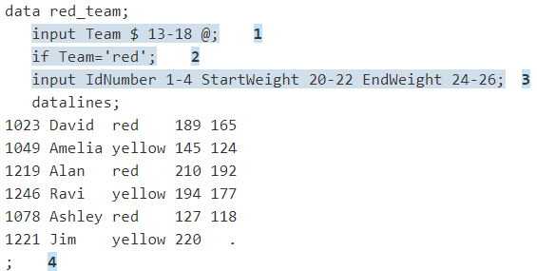

In this DATA step, these actions occur:

1. The INPUT statement reads a record into the input buffer, reads a data value from columns 13 through 18, and assigns that value to the variable Team in the program data vector. The single trailing @ holds the record in the input buffer.
2. The IF statement enables the current iteration of the DATA step to continue only when the value for Team is red. When the value is not red, the current iteration stops and SAS returns to the top of the DATA step, resets values in the program data vector to missing, and releases the held record from the input buffer.
3. The INPUT statement executes only when the value of Team is red. It reads the remaining data values from the record held in the input buffer and assigns values to the variables IdNumber, StartWeight, and EndWeight.
4. The record is released from the input buffer when the program returns to the top of the DATA step.

The following output displays the resulting data set:

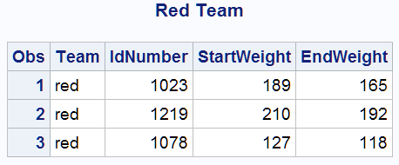

## USING THE DOUBLE TRAILING @ LINE-HOLD SPECIFIER

Sometimes you might need to create multiple observations from a single record of raw data. One way to tell SAS how to read such a record is to use the other line-hold specifier, the double trailing at-sign (@@ or “double trailing @”). The double trailing @ not only prevents SAS from reading a new record into the input buffer when a new INPUT statement is encountered. It also prevents the record from being released when the program returns to the top of the DATA step. (Remember that the trailing @ does not hold a record in the input buffer across iterations of the DATA step.)

For example, this DATA step uses the double trailing @ in the INPUT statement:

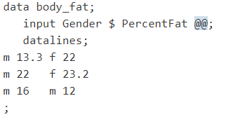

The following output displays the resulting data set:

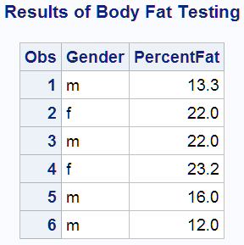

## USING MULTIPLE INPUT STATEMENTS

Multiple INPUT statements, one for each record, can read each record into a single observation, as in this example:

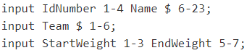

To understand how to use multiple INPUT statements, consider what happens as a DATA step executes. Remember that one record is read into the INPUT buffer automatically as each INPUT statement is encountered during each iteration. SAS reads the data values from the input buffer and writes them to the program data vector as variable values. At the end of the DATA step, all the variable values in the program data vector are written automatically as a single observation.

This example uses multiple INPUT statements in a DATA step to read only selected data fields and create a data set containing only the variables IdNumber, StartWeight, and EndWeight.

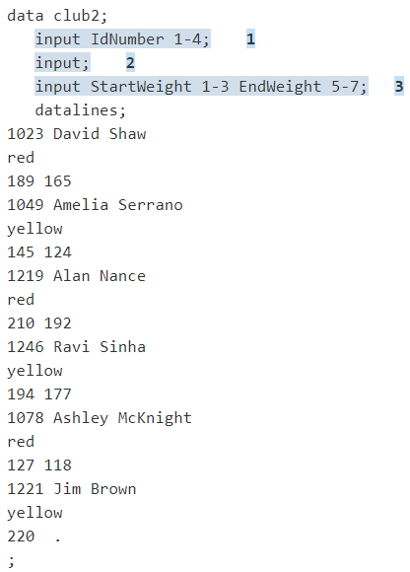

The following list corresponds to the numbered items in the preceding program:

1. The first INPUT statement reads only one data field in the first record and assigns a value to the variable IdNumber.
2. The second INPUT statement, without arguments, is a null INPUT statement that reads the second record into the input buffer. However, it does not assign a value to a variable.
3. The third INPUT statement reads the third record into the input buffer and assigns values to the variables StartWeight and EndWeight.

The following output displays the resulting data set:

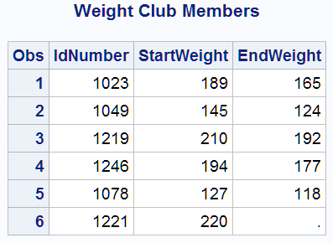

## USING THE / LINE-POINTER CONTROL

Writing a separate INPUT statement for each record is not the only way to create a single observation. You can write a single INPUT statement and use the slash (/) line-pointer control. The slash line-pointer control forces a new record into the input buffer and positions the pointer at the beginning of that record.

This example uses only one INPUT statement to read multiple records:

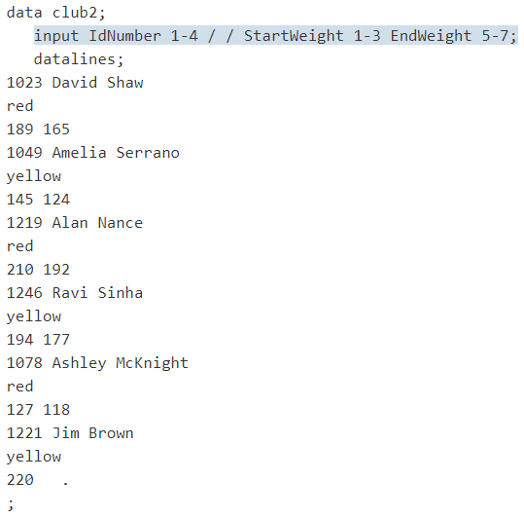

The / line-pointer control appears exactly where a new INPUT statement begins in the previous example. See Method 1: Using Multiple Input Statements. The sequence of events in the input buffer and the program data vector as this DATA step executes is identical to the previous example in method 1. The / is the signal to read a new record into the input buffer, which happens automatically when the DATA step encounters a new INPUT statement. The preceding example shows two slashes (/ /), indicating that SAS skips a record. SAS reads the first record, skips the second record, and reads the third record.

The following output displays the resulting data set:

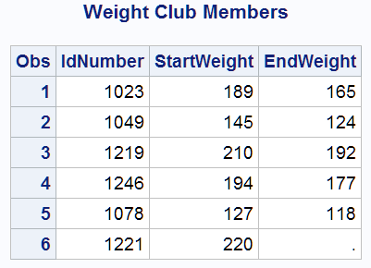

## READING VARIABLES FROM MULTIPLE RECORDS IN ANY ORDER

You can also read multiple records to create a single observation by pointing to a specific record in a set of input records with the #n line-pointer control. As you saw in the last section, the advantage of using the / line-pointer control over multiple INPUT statements is that it requires fewer statements. However, using the #n line-pointer control enables you to read the variables in any order, no matter which record contains the data values. It is also useful if you want to skip data lines.

This example uses one INPUT statement to read multiple data lines in a different order:

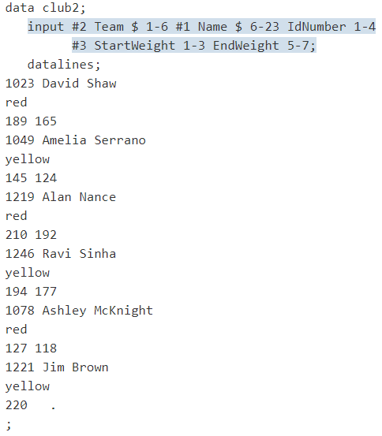

The following output displays the result:

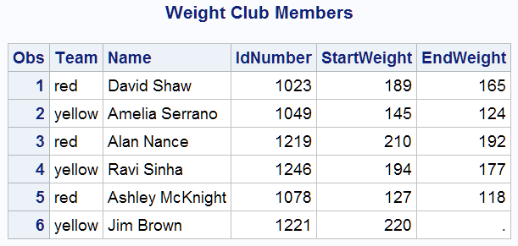

The order of the observations is the same as in the raw records (shown in the section Reading Variables from Multiple Records in Any Order). However, the order of the variables in the data set differs from the order of the variables in the raw input data records. This occurs because the order of the variables in the INPUT statements corresponds with their order in the resulting data sets.

## #N LINE-POINTER CONTROL

To understand the importance of the #n line-pointer control, remember the sequence of events in the DATA steps that demonstrate the / line-pointer control and multiple INPUT statements. Each record is read into the input buffer sequentially. The data is read, and then a / or a new INPUT statement causes the program to read the next record into the input buffer. It is impossible for the program to read a value from the first record after a value from the second record is read because the data in the first record is no longer available in the input buffer.

To solve this problem, use the #n line-pointer control. The #n line-pointer control signals the program to create a multiple-line input buffer so that all the data for a single observation is available while the observation is being built in the program data vector. The #n line-pointer control also identifies the record in which data for each variable appears. To use the #n line-pointer control, the raw data must have the same number of records for each observation; for example, it cannot have three records for one observation and two for the next.

When the program compiles and builds the input buffer, it looks at the INPUT statement and creates an input buffer with as many lines as are necessary to contain the number of records that it needs to read for a single observation. In this example, the highest number of records specified is three, so the input buffer is built to contain three records at one time. The following figures demonstrate the flow of the DATA step in this example.

The following figure shows that the values are set to missing in the program data vector and that the INPUT statement reads the first three records into the input buffer.

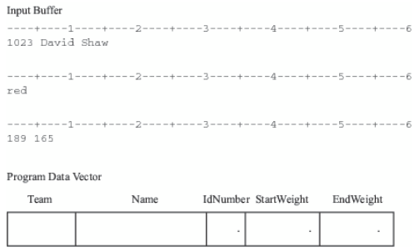

The INPUT statement for this example is as follows:

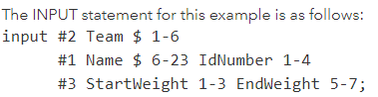

The first variable is preceded by #2 to indicate that the value in the second record is assigned to the variable Team.

The following figure shows that the pointer advances to the second line in the input buffer, reads the value, and writes it to the program data vector.

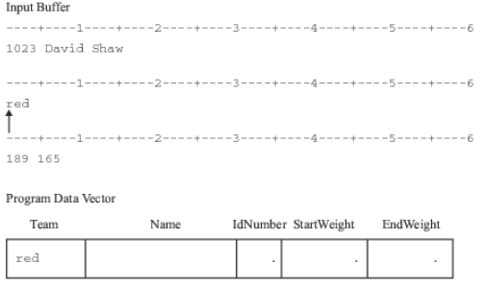

The following figure shows that the pointer then moves to the sixth column in the first record, reads a value, and assigns it to the variable Name in the program data vector. It then moves to the first column to read the ID number, and assigns it to the variable IdNumber

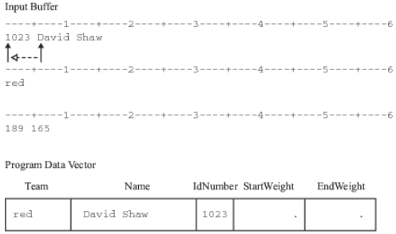

The following figure shows that the process continues with the pointer moving to the third record in the first observation. Values are read and assigned to StartWeight and EndWeight, the last variable that is listed.

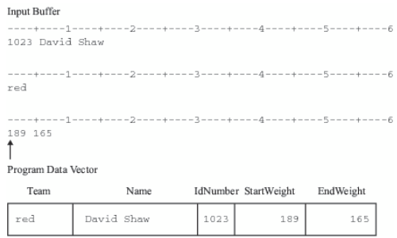

When the bottom of the DATA step is reached, variable values in the program data vector are written as an observation to the data set. The DATA step returns to the top, and values in the program data vector are set to missing. The INPUT statement executes again.

The final figure shows that the next three records are read into the input buffer, ready to create the second observation.

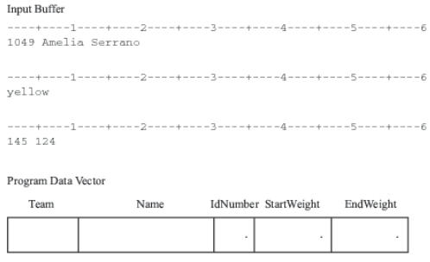

# INPUT RECORD UNEXPECTEDLY DOES NOT HAVE ENOUGH VALUES

When a DATA step reads raw data from an external file, problems can occur when SAS encounters the end of an input line before reading in data for all variables specified in the input statement. This problem can occur when reading variable-length records, records containing missing values, or both.

The following is an example of an external file that contains variable-length records:

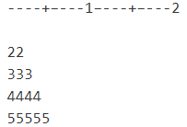

This DATA step uses the numeric informat 5. to read a single field in each record of raw data and to assign values to the variable TestNumber:

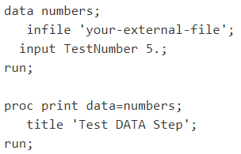

The DATA step reads the first value (22). Because the value is shorter than the 5 characters expected by the informat, the DATA step attempts to finish filling the value with the next record (333). This value is entered into the PDV and becomes the value of the TestNumber variable for the first observation. The DATA step then goes to the next record, but encounters the same problem because the value (4444) is shorter than the value that is expected by the informat. Again, the DATA step goes to the next record, reads the value (55555), and assigns that value to the TestNumber variable for the second observation.

The following output displays the results. After this program runs, the SAS log contains a note to indicate the places where SAS went to the next record to search for data values.

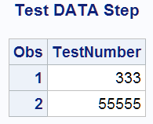

To control how SAS behaves after it attempts to read past the end of a data line, you can use the following options in the INFILE statement:

* FLOWOVER



* STOPOVER



* MISSOVER



* TRUNCOVER



You can also use these options even when your data lines are in the program itself, that is, when they follow the DATALINES statement. Simply use datalines instead of a reference to an external file to indicate that the data records are in the DATA step itself:

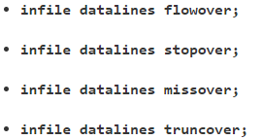

Note: The examples in this section show the use of the MISSOVER and TRUNCOVER options with formatted input. You can also use these options with list input and column input.

## MISSOVER OPTION

The MISSOVER option prevents the DATA step from going to the next line if it does not find values in the current record for all of the variables in the INPUT statement. Instead, the DATA step assigns a missing value for all variables that do not have complete values according to any specified informats. The input file contains the following raw data:

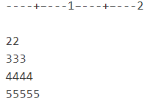

The following example uses the MISSOVER option:

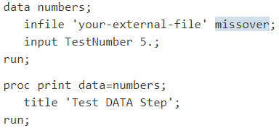

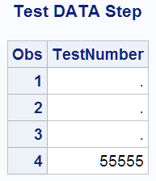

Because the fourth record is the only one whose value matches the informat, it is the only record whose value is assigned to the TestNumber variable. The other observations receive missing values.

## TRUNCOVER OPTION

The TRUNCOVER option causes the DATA step to assign the raw data value to the variable even if the value is shorter that the length that is expected by the INPUT statement. If, when the DATA step encounters the end of an input record, there are variables without values, the variables are assigned missing values for that observation. The following example demonstrated the use of the TRUNCOVER option:

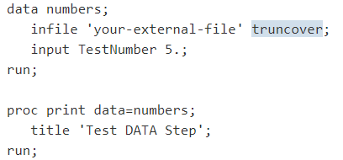

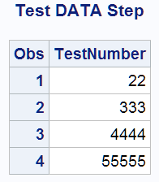

This result shows that all of the values were assigned to the TestNumber variable, despite the fact that three of them did not match the informat. For another example using the TRUNCOVER option.

## FLOWOVER

Is the default behavior. The DATA step simply reads the next record into the input buffer, attempting to find values to assign to the rest of the variable names in the INPUT statement.

## STOPOVER

Causes the DATA step to stop processing if an INPUT statement reaches the end of the current record without finding values for all variables in the statement. Use this option if you expect all of the data in the external file to conform to a given standard, and if you want the DATA step to stop when it encounters a data record that does not conform to the standard.

# READING SELECTED OBSERVATIONS

If you are interested in only part of a large data set, you can use data set options to create a subset of your data. Data set options specify which observations you want the new data set to include. In Creating Subsets of Observations, you learn how to use the subsetting IF statement to create a subset of a large SAS data set. In this section, you learn how to use the FIRSTOBS= and OBS= data set options to create subsets of a larger data set.

## FIRSTOBS

For example, you might not want to read the observations at the beginning of the data set. You can use the FIRSTOBS= data set option to define which observation should be the first one that is processed. For the data set CITY, this example creates a data set that excludes observations that contain data prior to 1991 by specifying FIRSTOBS=12. As a result, SAS does not read the first 11 observations, which contain data prior to 1991.

The following program creates the data set CITY2, which contains the same number of variables but fewer observations than CITY.

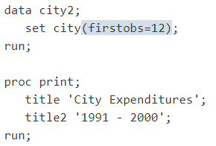

## OBS

We can also specify the last observation that you want to include in a new data set with the OBS= data set option. For example, the next program creates a SAS data set containing only the observations for 1989 (the 10th observation) through 1994 (the 15th observation).

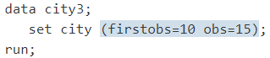

# READING SELECTED VARIABLES

You can create a subset of a larger data set not only by excluding observations but also by specifying which variables you want the new data set to contain. In a DATA step, you can use the SET statement and the KEEP= or DROP= data set options (or the DROP and KEEP statements) to create a subset from a larger data set by specifying which variables you want the new data set to include.

## KEEP

This example uses the KEEP= data set option in the SET statement to read only the variables that represent the services-related expenditures of the data set CITY.

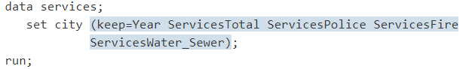

The following example uses the KEEP statement instead of the KEEP= data set option to read all of the variables from the CITY data set. The KEEP statement creates a new data set (SERVICES) that contains only the variables listed in the KEEP statement. The following program gives results that are identical to those in the previous example:

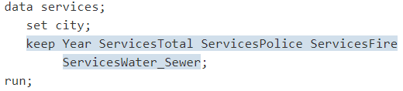

The following example has the same effect as using the KEEP= data set option in the DATA statement. All of the variables are read into the program data vector, but only the specified variables are written to the SERVICES data set:

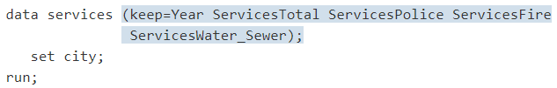

KEEP is not allowed in PROC statement instead we should use where statement.

## DROP

Use the DROP= option to create a subset of a larger data set when you want to specify which variables are being excluded rather than which ones are being included. The following DATA step reads all of the variables from the data set CITY except for those that are specified with the DROP= option. It then creates a data set named SERVICES2:

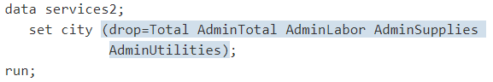

The following example uses the DROP statement instead of the DROP= data set option to read all of the variables from the CITY data set. It also excludes the variables that are listed in the DROP statement from being written to the new data set. The results are identical to those in the previous example:

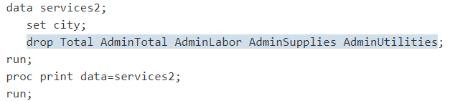

DROP is not allowed in PROC statement.

## CREATING MORE THAN ONE DATA SET IN A SINGLE DATA STEP

You can use a single DATA step to create more than one data set at a time. You can create data sets with different contents by using the KEEP= or DROP= data set options. For example, the following DATA step creates two SAS data sets: SERVICES contains variables that show services-related expenditures, and ADMIN contains variables that represent the administration-related expenditures. Use the KEEP= option after each data set name in the DATA statement to determine which variables are written to each SAS data set being created.

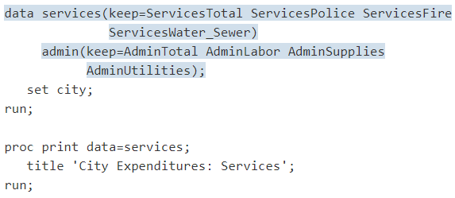

# ADDING INFORMATION TO DATASET

One of the most common reasons for using program statements in the DATA step is to produce new information from the original information or to change the information read by the INPUT or SET/MERGE/MODIFY/UPDATE statement.

The basic method of adding information to a SAS data set is to create a new variable in a DATA step with an assignment statement.

The variable receives the new information; the expression creates the new information. You specify the calculation necessary to produce the information and write the calculation as the expression. When the expression contains character data, you must enclose the data in quotation marks. SAS evaluates the expression and stores the new information in the variable that you name. It is important to remember that if you need to add the information to only one or two observations out of many, SAS creates that variable for all observations. The SAS data set that is being created must have information in every observation and every variable.

## CREATING A VARIABLE

Sometimes you want to make a particular change to every observation. For example, at Tradewinds Travel the airfare must be increased for every tour by $10 because of a new tax. One way to do this is to write an assignment statement that creates a new variable that calculates the new airfare:



This statement directs SAS to read the value of AirCost, add 10 to it, and assign the result to the new variable, NewAirCost.

When this assignment statement is included in a DATA step, the DATA step looks like this:

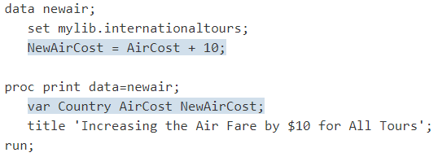

In this example, the VAR statement in the PROC PRINT step determines which variables are displayed in the output.

The following output shows the resulting SAS data set, NEWAIR:

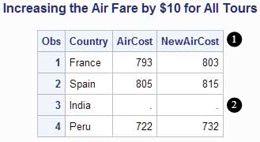

Notice the following in this data set:

* Because SAS carries out each statement in the DATA step for every observation, NewAirCost is calculated during each iteration of the DATA step.
* The observation for India contains a missing value for AirCost; SAS therefore assigns a missing value to NewAirCost for that observation.

The SAS data set has information in every observation and every variable.

## ADDING TO SELECTED OBSERVATIONS

Often you need to add information to some observations but not to others. For example, some tour operators award bonus points to travel agencies for scheduling particular tours. Two companies, Hispania and Mundial, are offering bonus points this year.

IF-THEN/ELSE statements can cause assignment statements to be carried out only when a condition is met. In the following DATA step, the IF statements check the value of the variable Vendor. If the value is either Hispania or Mundial, information about the bonus points is added to those observations.

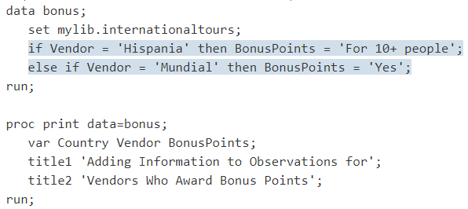

The following output displays the results:

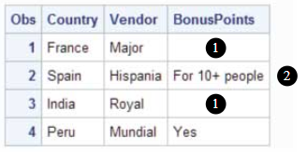

The new variable BonusPoints has the following information:

* In the two observations that are not assigned a value for BonusPoints, SAS assigns a missing value, represented by a blank in this case, to indicate the absence of a character value.
* The first value that SAS encounters for BonusPoints contains 14 characters; therefore, SAS sets aside 14 bytes of storage in each observation for BonusPoints, regardless of the length of the value for that observation.

Variables that contain information that applies to only one or two observations use more storage space than necessary. When possible, create fewer variables that apply to more observations in the data set, and allow the different values in different observations to supply the information.

For example, the Major company offers discounts, not bonus points, for groups of 30 or more people. An inefficient program would create separate variables for bonus points and discounts, as follows:

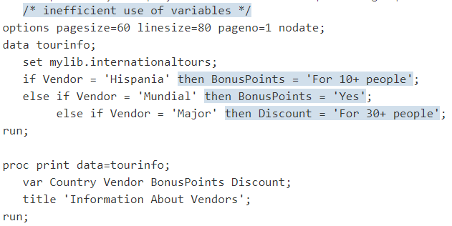

The following output displays the results:

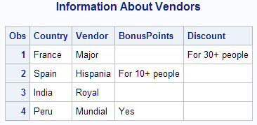

As you can see, storage space is used inefficiently. Both BonusPoints and Discount have a significant number of missing values.

With a little planning, you can make the SAS data set much more efficient. In the following DATA step, the variable Remarks contains information about bonus points, discounts, and any other special features of any tour.

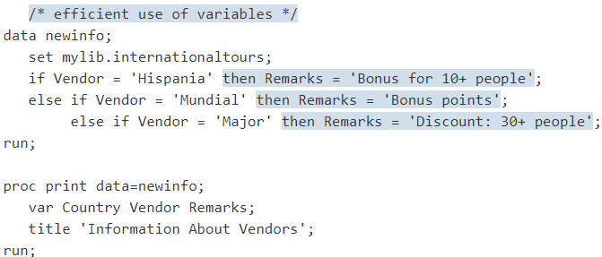

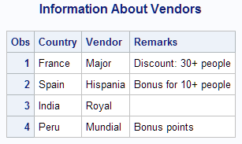

## MAKING CHANGES WITHOUT CREATING VARIABLES

Sometimes you want to change the value of existing variables without adding new variables. For example, in one DATA step a new variable, NewAirCost, was created to contain the value of the airfare plus the new $10 tax:

NewAirCost = AirCost + 10;

You can also decide to change the value of an existing variable rather than create a new variable. Following the example, AirCost is changed as follows:

AirCost = AirCost + 10;

SAS processes this statement just as it does other assignment statements. It evaluates the expression on the right side of the equal sign and assigns the result to the variable on the left side of the equal sign. The fact that the same variable appears on the right and left sides of the equal sign does not matter. SAS evaluates the expression on the right side of the equal sign before looking at the variable on the left side.

## DELETE

If you do not want the program data vector to write to a data set based on a condition, use the DELETE statement in the DATA step. For example, if the tour to Peru has been discontinued, it is no longer necessary to include the observation for Peru in the data set that is being created. The following example uses the DELETE statement to prevent SAS from writing that observation to the output data set:

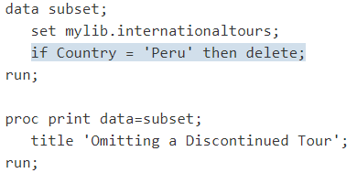

The following output displays the results:

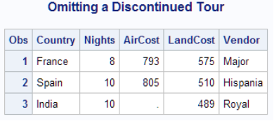

# NUMERIC VARIABLES IN SAS

A numeric variable is a variable whose values are numbers. SAS uses double-precision floating-point representation for calculations and, by default, for storing numeric variables in SAS data sets.

## ARITHMETIC OPERATORS

One way to perform calculations on numeric variables is to write an assignment statement using arithmetic operators. Arithmetic operators indicate addition, subtraction, multiplication, division, and exponentiation (raising to a power). For more information about arithmetic expressions, see the discussion in SAS Language Reference: Concepts.

The following table shows operators that you can use in arithmetic expressions.

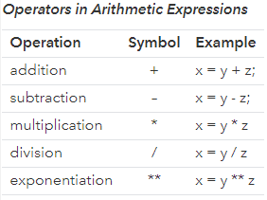

## COMPARING OPERATORS

Often in a program, you need to know whether variables are equal to each other, or whether they are greater than or less than each other. To compare two numeric variables, you can write an IF-THEN/ELSE statement using logical operators.

The following table lists some of the logical operators that you can use for variable comparisons.

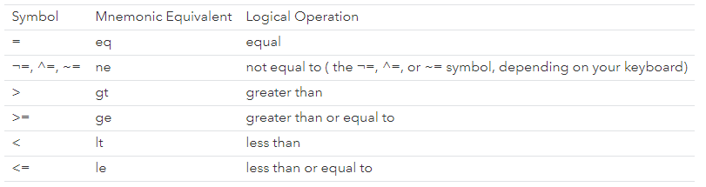

Example:

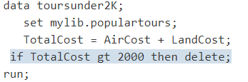

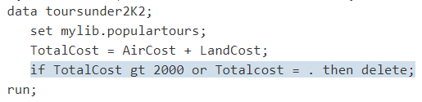

## MISSING NUMBERIC VALUES

A missing value indicates that no information is present for the variable in that observation. SAS uses a period (.) to show a missing value for a numeric variable.

RULES FOR MISSING VALUES

The following rules describe missing values in several situations:

* In data lines, a missing numeric value is represented by a period, for example,



By default, SAS interprets a single period in a numeric field as a missing value. If the INPUT statement reads the value from particular columns, as in column input, a field that contains only blanks also produces a missing value.

* In an expression, a missing numeric value is represented by a period, for example,



* In a comparison and in sorting, a missing numeric value is a lower value than any other numeric value.
* In procedure output, SAS by default represents a missing numeric value with a period.
* Some procedures eliminate missing values from their analyses; others do not. Documentation for individual procedures describes how each procedure handles missing values.

# CHARACTER VARIABLES

To store character values in a SAS data set, you need to create a character value. One way to create a character variable is to define it in an input statement. Simply place a dollar sign after the variable name in the INPUT statement, as shown in the DATA step that created AIR.DEPARTURES:



In character values, SAS distinguishes uppercase letters from lowercase letters. For example, in the data set AIR.DEPARTURES, the value of USGate in the observation for Australia is Honolulu. The following IF condition is true; therefore, SAS assigns to Airport the value HNL:



However, the following condition is false:



SAS does not select that observation because the characters in Honolulu and HONOLULU are not equivalent.

## MISSING CHARACTER VALUES

When you want to check for missing character values, compare the character variable to a blank enclosed in quotation marks:



The following DATA step includes this statement to check USGate for missing information. The results are recorded in GateInformation:

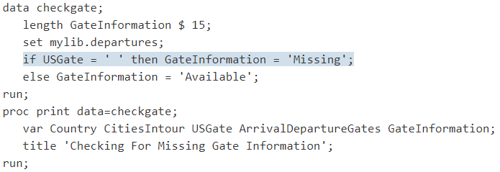

## SETTING A CHARACTER VARIABLE VALUE TO MISSING

You can assign missing character values in assignment statements by setting the character variable to a blank enclosed in quotation marks. For example, the following statement sets the day of departure based on the number of days in the tour. If the number of cities in the tour is a week or less, then the day of departure is a Sunday. Otherwise, the day of departure is not known and is set to a missing value.

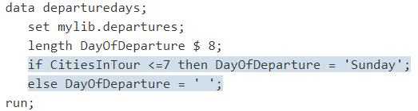

# SELECTING OBSERVATIONS

The most common way that SAS selects observations for action in a DATA step is through the IF-THEN statement:

IF condition THEN action;

The condition is one or more comparisons, for example:

* City = 'Rome'
* NumberOfEvents > Nights
* TourGuide = 'Lucas' and Nights > 7

When the condition is true, SAS takes the action in the THEN clause. The action must be expressed as a SAS statement that can be executed in an individual iteration of the DATA step. Such statements are called executable statements. The most common executable statements are assignment statements, as shown in the following examples:

* LandCost=LandCost + 30;
* Calendar='Check schedule';
* TourGuide='Torres';

Statements that provide information about a data set are not executable. Such statements are called declarative statements. For example, the LENGTH statement affects a variable as a whole, and not how the variable is treated in a particular observation. Therefore, you cannot use a LENGTH statement in a THEN clause.

When the condition is false, SAS ignores the THEN clause and proceeds to the next statement in the DATA step.

## SAMPLE DATA SET

Following data will be sued to explain the examples:

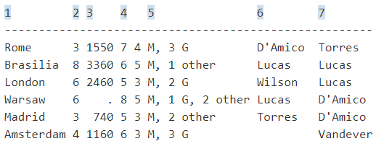

The following list explains the numbered items in the preceding file:

* Identifies the name of the destination city
* Specifies the number of nights in the city
* Specifies the cost of the land package in U.S. dollars
* Specifies the number of events the trip offers (such as visits to museums and galleries)
* Provides a brief description of events. M indicates a museum, G indicates a gallery, and Other indicates another type of event
* Provides the name of the tour guide
* Provides the name of the backup tour guide

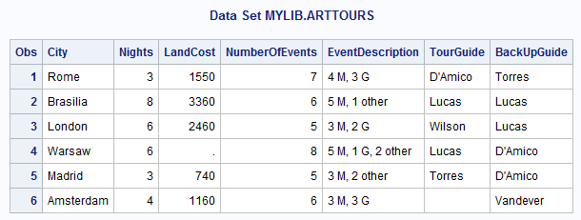

## BASED ON A SIMPLE CONDITION

The following DATA step uses the previous example conditions and actions in IF-THEN statements:

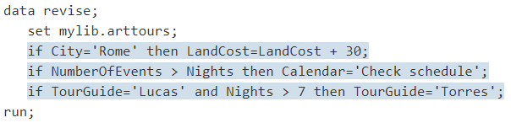

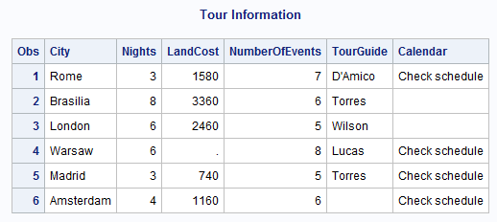

## ALTERNATIVE ACTIONS

Remember that SAS creates a variable in all observations, even if you do not assign the variable a value in all observations. In the previous output, the value of Calendar is blank in two observations. A second IF-THEN statement can assign a different value, as in these examples:



An ELSE statement names an alternative action to be taken when the IF condition is false. It must immediately follow the corresponding IF-THEN statement, as shown here:



The REVISE2 DATA step adds the preceding ELSE statement to the previous DATA step:

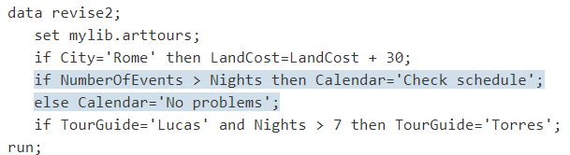

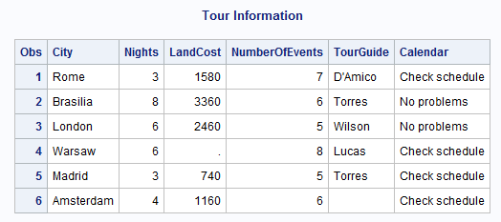

## MUTUALLY EXCLUSIVE CONDITIONS

Using an ELSE statement after an IF-THEN statement provides one alternative action when the IF condition is false. However, many cases involve a series of mutually exclusive conditions, each of which requires a separate action. In this example, tour prices can be classified as high, medium, or low. A series of IF-THEN and ELSE statements classifies the tour prices appropriately:

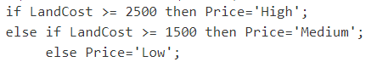

The following output displays the results.

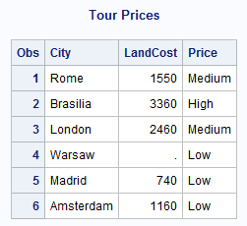

# CONSTRUCTING CONDITIONS

When you use an IF-THEN statement, you ask SAS to make a comparison. SAS must determine whether a value is equal to another value, greater than another value, and so on.

The following DATA step illustrates selecting observations based on simple conditions:

## SIMPLE CONDITION

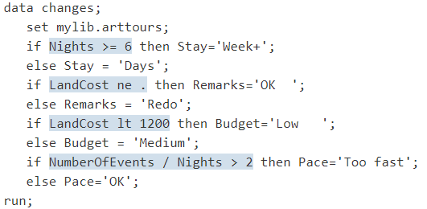

## MULTIPLE COMPARISONS

You can specify more than one comparison in a condition with these operators:

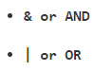

A condition can contain any number of AND operators, OR operators, or both.

### AND

When comparisons are connected by AND, all of the comparisons must be true for the condition to be true. Consider this example:



The comparison is true for observations in which the value of City is Brasilia and the value of TourGuide is Lucas.

The following DATA step includes these multiple comparison statements:

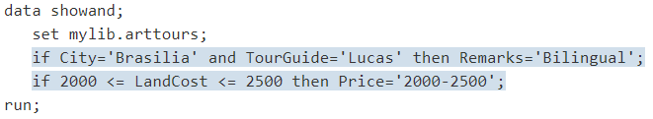

### OR

When comparisons are connected by OR, only one of the comparisons needs to be true for the condition to be true. Consider the following example:



Any observation in which the land cost is over $1500, the cost per night is over $200, or both, satisfies the condition. The following DATA step shows this condition:

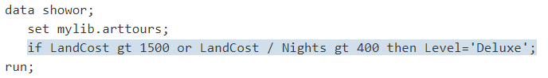

## NEGATIVE OPERATORS WITH AND & OR

Be careful when you combine negative operators with OR. Often, the operator that you really need is AND. For example, the variable TourGuide contains some problems with the data. In the observation for Brasilia, the tour guide and the backup tour guide are both Lucas. In the observation for Amsterdam, the name of the tour guide is missing. You want to label the observations that have no problems with TourGuide as OK. Should you write the IF condition with OR or with AND?

The following DATA step shows both conditions:

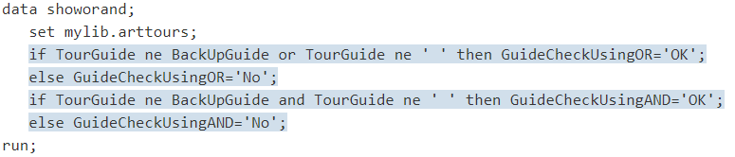

## COMPLEX COMPARISONS

A condition can contain both AND operators and OR operators. When it does, SAS evaluates the AND operators before the OR operators. The following example specifies a list of cities and a list of guides:

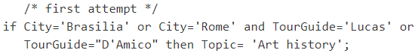

SAS first joins the items that are connected by AND:



Then SAS makes the following OR comparisons:

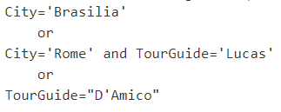

To group the City comparisons and the TourGuide comparisons, use parentheses:

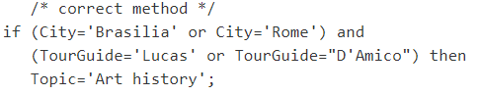

SAS evaluates the comparisons within parentheses first and uses the results as the terms of the larger comparison. You can use parentheses in any condition to control the grouping of comparisons or to make the condition easier to read.

## ABBREVIATING NUMERIC COMPARISONS

Two considerations about numeric comparisons are especially helpful to know:

* An abbreviated form of comparison is possible.
* Abbreviated comparisons with OR require you to use caution.

In computing terms, a value of TRUE is 1 and a value of FALSE is 0. In SAS, the following rules apply:

* Any numeric value other than 0 is true.
* A value of 0 or missing is false.

Therefore, a numeric variable or expression can stand alone in a condition. If its value is a number other than 0, then the condition is true. If its value is 0 or missing, then the condition is false.

The following example assigns a value to the variable Remarks only if the value of LandCost is present for a given observation:



This statement is equivalent to



Be careful when you abbreviate comparisons with OR. It is easy to produce unexpected results. For example, this IF-THEN statement selects tours that last six or eight nights:

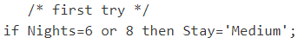

SAS treats the condition as the following comparisons:

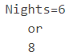

The second comparison does not use the values of Nights. The comparison uses the number 8 standing alone. Because the number 8 is neither 0 nor a missing value, it always has the value TRUE. Because only one comparison in a series of OR comparisons needs to be true to make the condition true, this condition is true for all observations.

The following comparisons correctly select observations that have six or eight nights:

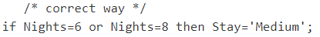

## COMPARING CHARACTERS

Some special situations occur when you make character comparisons. You might need to perform the following tasks:

* Compare uppercase and lowercase characters
* Select all values that begin with a particular group of characters
* Select all values that begin with a particular range of characters
* Find a particular value anywhere within another character value

### UPPERCASE & LOWECASE

SAS distinguishes between uppercase and lowercase letters in comparisons. For example, the values Madrid and MADRID are not equivalent. To compare values that might occur in different cases, use the UPCASE function to produce an uppercase value. Then make the comparison between two uppercase values, as shown here:

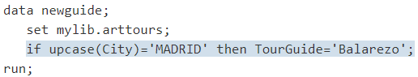

Within the comparison, SAS produces an uppercase version of the value of City and compares it to the uppercase constant MADRID. The value of City in the observation remains in its original case.

### BEGINNING CHARACTER

Sometimes you need to select a group of character values, such as all tour guides whose names begin with the letter D.

By default, SAS compares values of different lengths by adding blanks to the end of the shorter value and testing the result against the longer value. Here is an example:

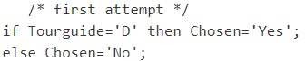

SAS interprets the comparison as



D is followed by seven blanks because TourGuide, a character variable created by column input, has a length of eight bytes. Because the value of TourGuide never consists of the single letter D, the comparison is never true.

To compare a long value to a shorter standard, put a colon (:) after the operator, as in this example:

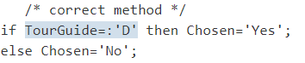

The colon causes SAS to compare the same number of characters in the shorter value and the longer value. In this case, the shorter string contains one character. Therefore, SAS tests only the first character from the longer value. All names that begin with a D make the comparison true. (If you are not sure that all the values of TourGuide begin with a capital letter, then use the UPCASE function.) The following DATA step selects names that begin with D:

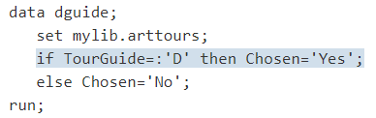

### RANGE OF CHARACTER VALUES

You might want to select values that begin with a range of characters, such as all names that begin with A through L or M through Z. To select a range of character values, you need to understand the following points:

* In computer processing, letters have magnitude. A is the smallest letter in the alphabet and Z is the largest. Therefore, the comparison A<B is true; so is the comparison D>C.
* A blank is smaller than any letter.

The following statements divide the names of the guides into two groups, A-L and M-Z, by combining the comparison operator with the colon:

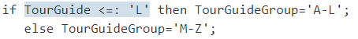

The following DATA step creates the groups:

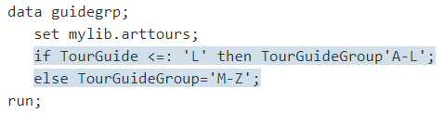

# SELECT STATEMENT

Below is the syntax of select statement:

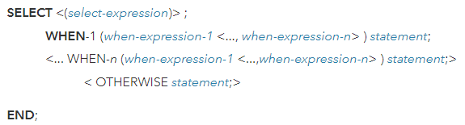

The SELECT statement begins a SELECT group. SELECT groups contain WHEN statements that identify SAS statements that are executed when a particular condition is true. Use at least one WHEN statement in a SELECT group. An optional OTHERWISE statement specifies a statement to be executed if no WHEN condition is met. An END statement ends a SELECT group.

Null statements that are used in WHEN statements cause SAS to recognize a condition as true without taking further action. Null statements that are used in OTHERWISE statements prevent SAS from issuing an error message when all WHEN conditions are false.

## WHEN A SELECT-EXPRESSION IS INCLUDED

If the select-expression is present, SAS evaluates the select-expression and when-expression. SAS compares the two for equality and returns a value of true or false. If the comparison is true, statement is executed. If the comparison is false, execution proceeds either to the next when-expression in the current WHEN statement, or to the next WHEN statement if no more expressions are present. If no WHEN statements remain, execution proceeds to the OTHERWISE statement, if one is present. If the result of all SELECT-WHEN comparisons is false and no OTHERWISE statement is present, SAS issues an error message and stops executing the DATA step.

## WHEN A SELECT-EXPRESSION IS NOT INCLUDED

If no select-expression is present, the when-expression is evaluated to produce a result of true or false. If the result is true, statement is executed. If the result is false, SAS proceeds to the next when-expression in the current WHEN statement, or to the next WHEN statement if no more expressions are present, or to the OTHERWISE statement if one is present. (That is, SAS performs the action that is indicated in the first true WHEN statement.) If the result of all when-expressions is false and no OTHERWISE statement is present, SAS issues an error message. If more than one WHEN statement has a true when-expression, only the first WHEN statement is used. Once a when-expression is true, no other when-expressions are evaluated.

The SELECT statement works much like the CASE statement in the SQL procedure.

Example 1: Using Statements

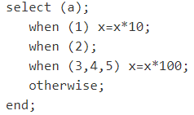

Example 2: Using DO Groups

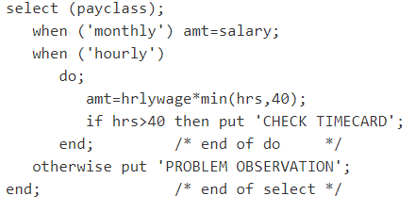

Example 3: Using a Compound Expression

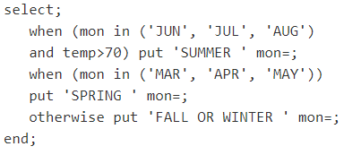

Example 4: Making Comparisons for Equality

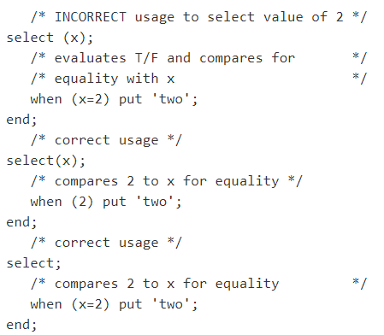

Example 5: Processing Large Amounts of Data

In this example, the %INCLUDE statements contain code that includes WHEN statements to process new and old items in the inventory. The main program shows the overall logic of the DATA step.

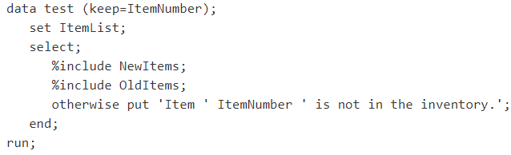

# CREATING SUBSETS OF OBSERVATIONS

There are two ways to select specific observations in a SAS data set when you create a new SAS data set:

* Delete the observations that do not meet a condition, keeping only the ones that you want.
* Accept only the observations that meet a condition.

Processing the DELETE statement for an observation causes SAS to return immediately to the beginning of the DATA step for a new observation without writing the current observation to the output DATA set. The DELETE statement does not include the observation in the output data set, but it does not delete the observation from the input data set. For example, the following statement deletes observations that contain a missing value for LandCost:

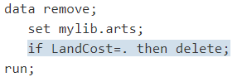

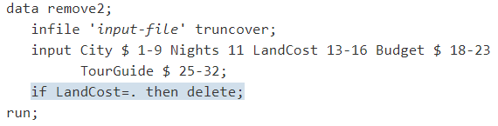

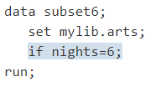

These are the main reasons to consider when choosing between a DELETE statement and a subsetting IF statement:

* It is usually easier to choose the statement that requires the fewest comparisons to identify the condition.
* It is usually easier to think in positive terms than negative ones (this favors the subsetting IF).

One additional situation favors the subsetting IF: it is the safer method to use if your data has missing or misspelled values. Consider the following situation.

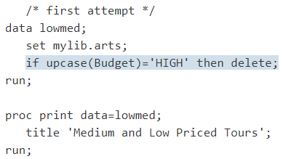

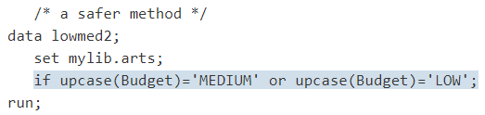

## WRITING OBSERVATIONS TO ONE OR MORE SAS DATA SETS

SAS enables you to create multiple SAS data sets in a single DATA step using an OUTPUT statement:

When you use an OUTPUT statement without specifying a data set name, SAS writes the current observation to all data sets that are named in the DATA statement. If you want to write observations to a selected data set, then you specify that data set name directly in the OUTPUT statement. Any data set name appearing in the OUTPUT statement must also appear in the DATA statement.

One of the SAS data sets contains tours that are guided by the tour guide Lucas and the other contains tours led by other guides. Writing to multiple data sets is accomplished by performing the following tasks:

* Naming both data sets in the DATA statement
* Selecting the observations using an IF condition
* Using an OUTPUT statement in the THEN and ELSE clauses to output the observations to the appropriate data sets

## OUTPUT STAEMENT

The following DATA step shows how to write to multiple data sets:

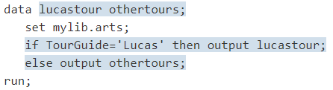

If you use an OUTPUT statement, then you suppress the automatic output of observations at the end of the DATA step. Therefore, if you plan to use any OUTPUT statements in a DATA step, then you must program all output for that step with OUTPUT statements. For example, in the previous DATA step you sent output to both LUCASTOUR and OTHERTOURS. For comparison, the following program shows what would happen if you omit the ELSE statement in the DATA step:

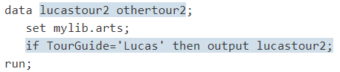

No observations are written to OTHERTOUR2 because output was not directed to it.

### PLACEMENT OF THE OUTPUT STATEMENT

By default, SAS writes an observation to the output data set at the end of each iteration. When you use an OUTPUT statement, you override the automatic output feature. Where you place the OUTPUT statement, therefore, is very important. For example, if a variable value is calculated after the OUTPUT statement executes, then that value is not available when the observation is written to the output data set.

For example, in the following DATA step, an assignment statement is placed after the IF-THEN/ELSE group:

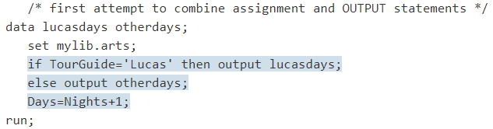

The following output displays the results.

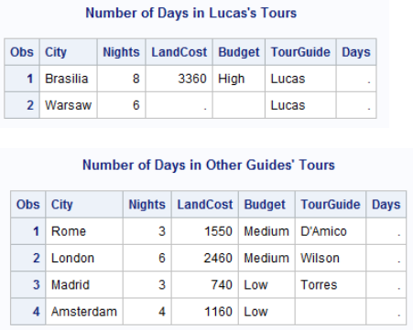

The value of Days is missing in all observations because the OUTPUT statement writes the observation to the SAS data sets before the assignment statement is processed. If you want the value of Day to appear in the data sets, then use the assignment statement before you use the OUTPUT statement. The following program shows the correct position:

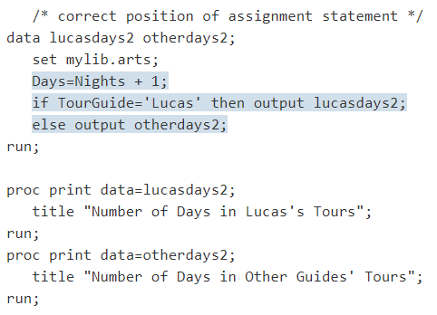

The following output displays the results.

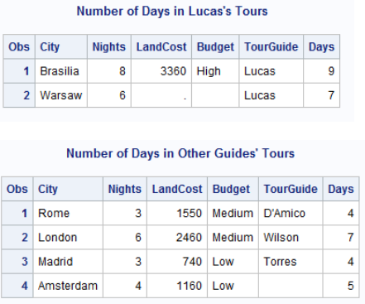

### WRITING MULTIPLE TIMES TO ONE OR MORE DATA SETS

After SAS processes an OUTPUT statement, the observation remains in the program data vector and you can continue programming with it. You can even write it again to the same SAS data set or to a different one. The following example creates two pairs of data sets, one pair based on the name of the tour guide and one pair based on the number of nights.

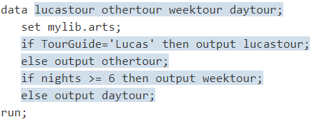

# GROUPED OR SORTED OBSERVATIONS

Sometimes you need to create reports where observations are grouped according to the values of a particular variable, or where observations are sorted alphabetically.

The basic method for grouping data is to use a BY statement:

The BY statement can be used in a DATA step with a SET, MERGE, MODIFY, or UPDATE statement, or it can be used in SAS procedures.

To work with grouped data using the SET, MERGE, MODIFY, or UPDATE statements, the data must meet these conditions:

* The observations must be in a SAS data set, not an external file.
* The variables that define the groups must appear in the BY statement.
* All observations in the input data set must be in ascending or descending numeric or character order, or grouped in some way, such as by calendar month or by a formatted value, according to the variables that are specified in the BY statement.

Note: If you use the MODIFY statement, the input data does not need to be in any order. However, ordering the data can improve performance.

If the third condition is not met, the data is stored in a SAS data set but is not arranged in the groups that you want. You can order the data using the SORT procedure (discussed in the next section).

After the SAS data set is arranged in some order, you can use the BY statement to group values of one or more common variables.

## GROUPING WITH SORT PROCEDURE

To see the sorted data set, add a PROC PRINT step to the program:

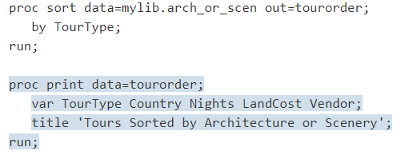

By default, SAS arranges groups in ascending order of the BY values, smallest to largest. Sorting a data set does not change the order of the variables within it. However, most examples in this section use a VAR statement in the PRINT procedure to display the BY variable in the first column. (The PRINT procedure and other procedures used in this documentation can also produce a separate report for each BY group.)

Arranging Groups in Descending Order:

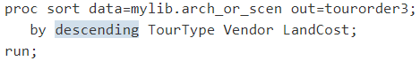

## FINDING THE FIRST OR LAST OBSERVATION IN A GROUP

If you do not want to display the entire data set, you can create a data set that contains only the least expensive tour that features architecture, and the least expensive tour that features scenery:

First, sort the data set by TourType and LandCost:

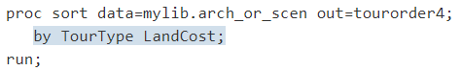

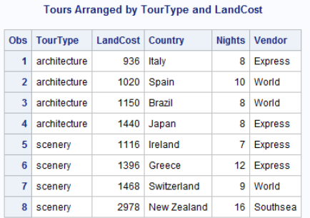

You sorted LandCost in ascending order, so the first observation in each value of TourType has the lowest value of LandCost. If you can locate the first observation in each BY group in a DATA step, you can use a subsetting IF statement to select that observation. SAS provides a way to locate the first observation with each value of TourType.

When you use a BY statement in a DATA step, SAS automatically creates two additional variables for each variable in the BY statement. One variable is named FIRST.variable, where variable is the name of the BY variable. The other variable is named LAST.variable. Their values are either 1 or 0. They exist in the program data vector and are available for DATA step programming, but SAS does not add them to the SAS data set that is being created. For example, the DATA step begins with these statements:

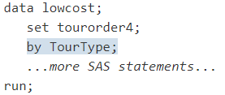

The BY statement causes SAS to create one variable called FIRST.TOURTYPE and another variable called LAST.TOURTYPE. When SAS processes the first observation with the value architecture, the value of FIRST.TOURTYPE is 1. In other observations with the value architecture, it is 0. Similarly, when SAS processes the last observation with the value architecture, the value of LAST.TOURTYPE is 1. In other observations with the value architecture, it is 0. The same result occurs in the scenery group with the observations.

SAS does not write FIRST. and LAST. variables to the output data set, so you cannot display their values with the PRINT procedure. Therefore, the simplest method of displaying the values of FIRST. and LAST. variables are to assign their values to other variables. This example assigns the value of FIRST.TOURTYPE to a variable named FirstTour and the value of LAST.TOURTYPE to a variable named LastTour:

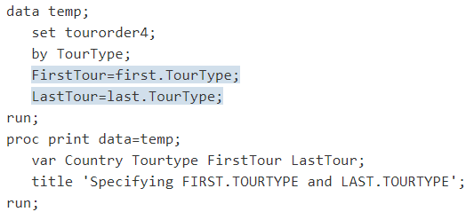

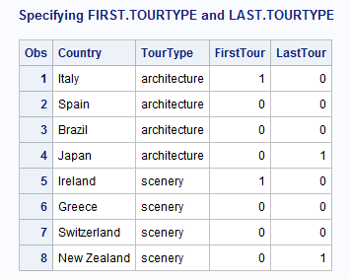

In this data set, Italy is the first observation with the value architecture. For that observation, the value of FIRST.TOURTYPE is 1. Italy is not the last observation with the value architecture, so the value of LAST.TOURTYPE is 0. The observations for Spain and Brazil are neither the first nor the last with the value architecture. Both FIRST.TOURTYPE and LAST.TOURTYPE are 0 for them. Japan is the last observation with the value architecture. The value of LAST.TOURTYPE is 1. The same rules apply to observations in the scenery group.

Now we can to use FIRST.TOURTYPE in a subsetting IF statement. When the data is sorted by TourType and LandCost, selecting the first observation in each type of tour gives you the lowest price of any tour in that category:

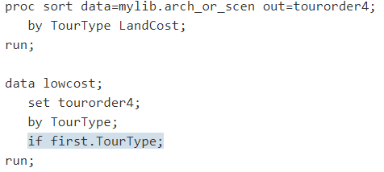

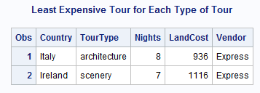

## WORKING WITH SORTED DATA

You can eliminate duplicate observations in a SAS data set by using the NODUPRECS option with the SORT procedure. The following programs show you how to create a SAS data set and then remove duplicate observations.

The external file shown below contains a duplicate observation for Switzerland:

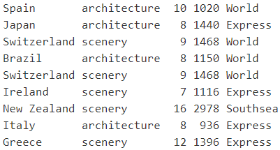

The following program uses the NODUPRECS option in the SORT procedure to delete duplicate observations. The program creates a new data set called FIXED:

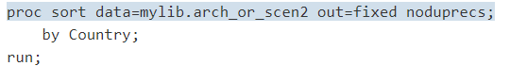

The following output shows the results of the NODUPRECS option:

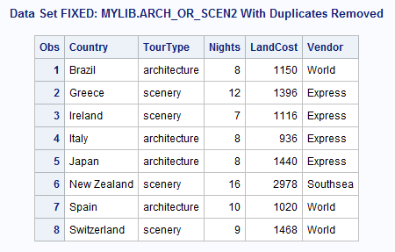

## NOTSORTED OPTION

The NOTSORTED option can be used in both DATA and PROC steps, except for the SORT procedure. The NOTSORTED option is useful when data is grouped according to the values of a variable, but the groups are not in ascending or descending order. Using the NOTSORTED option in the BY statement enables SAS to process them.

# CALCULATIONS

The following external file contains data about Tradewinds Travel tours:

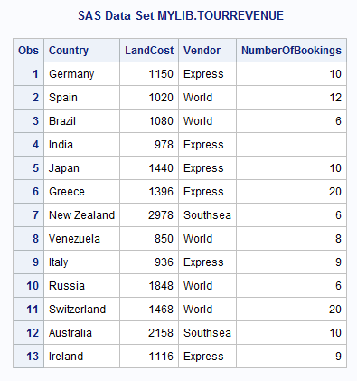

## RUNNING TOTAL

The first task in performing calculations on the data set MYLIB.TOURREVENUE is to find the total number of people who booked tours with Tradewinds Travel. Therefore, a variable is needed whose value starts at 0 and increases by the number of bookings in each observation. The Sum statement gives you that capability:

variable + expression

In a Sum statement, the value of variable on the left side of the plus sign is 0 before the statement is processed for the first time. Processing the statement adds the value of expression on the right side of the plus sign to the initial value. The Sum variable retains the new value until the next processing of the statement. The Sum statement ignores a missing value for the expression. The previous total remains unchanged.

The following statement creates the total number of bookings:



The following output displays the results:

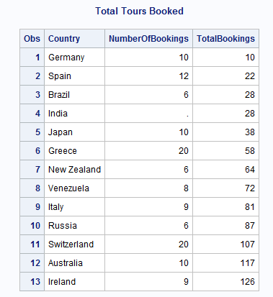

The TotalBookings variable in the last observation of the TOTAL data set contains the total number of bookings for the year.

## WRITING ONLY THE TOTAL

If the total is the only information that is needed from the data set, a data set that contains only one observation and one variable (the TotalBookings variable) can be created by writing a DATA step that performs all of the following functions:

* Specifies the END= option in the SET statement to determine whether the current observation is the last observation
* Uses a subsetting IF statement to write only the last observation to the SAS data set
* Specifies the KEEP= option in the DATA step to keep only the variable that totals the bookings

When the END= option in the SET statement is specified, the variable that is named in the END= option is set to 1 when the DATA step is processing the last observation. The variable that is named in the END= option is set to 0 for other observations:

SAS does not add the END= variable to the data set that is being created. By testing the value of the END= variable, you can determine which observation is the last observation.

The following program selects the last observation with a subsetting IF statement and uses a KEEP= data set option to keep only the variable TotalBookings in the data set:

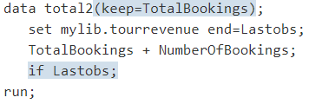

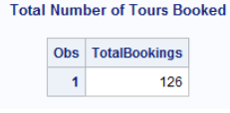

## OBTAINING A TOTAL FOR EACH BY GROUP

An additional requirement of Tradewinds Travel is to determine the number of tours that are booked with each vendor. In order to accomplish this task, a program must group the data by a variable. That is, the program must organize the data set into groups of observations, with one group for each vendor. In this case, the program must group the data by the Vendor variable. Each group is known generically as a BY- group. The variable that is used to determine the groupings is called a BY variable.

In order to group the data by the Vendor variable:

* Include a PROC SORT step to group the observations by the Vendor variable
* Use a BY statement in the DATA step
* Use a Sum statement to total the bookings
* Reset the Sum variable to 0 at the beginning of each group of observations

The following program sorts the data set by Vendor and sums the total bookings for each vendor.

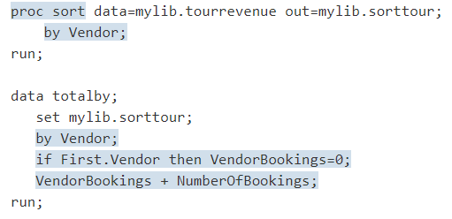

In the preceding program, the FIRST.Vendor variable is used in an IF-THEN statement to set the Sum variable (VendorBookings) to 0 in the first observation of each BY group.

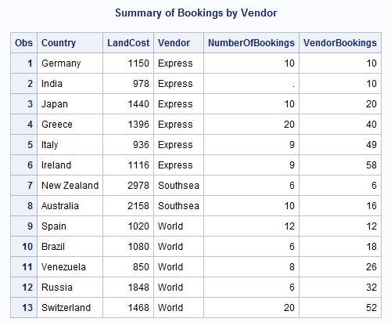

The following program creates data set TOTALBY:

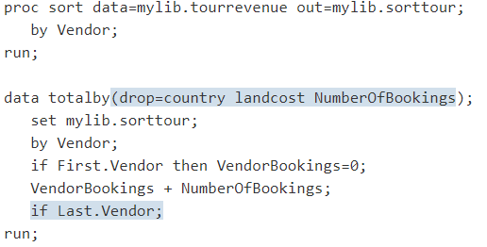

The following output displays the results:

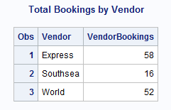

## WRITING OBSERVATIONS TO SEPARATE DATA SETS

If the data is not already grouped by Vendor, first use the SORT procedure. Add a BY statement to the DATA step for use with VENDORDETAILS.

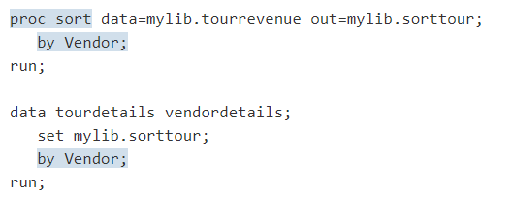

## USING A VALUE IN A LATER OBSERVATION

The RETAIN statement causes a variable that is created in the DATA step to retain its value from the current observation into the next observation. The variable is not set to missing at the beginning of each iteration of the DATA step. RETAIN is a declarative statement, not an executable statement. This statement has the following form:

To compare the Revenue value in one observation to the Revenue value in the next observation, create a retained variable named HoldRevenue and assign the value of the current Revenue variable to it. In the next observation, the HoldRevenue variable contains the Revenue value from the previous observation, and its value can be compared to that of Revenue in the current observation.

To see how the RETAIN statement works, look at the next example. The following DATA step writes observations to data set TEMP before SAS assigns the current revenue to HoldRevenue:

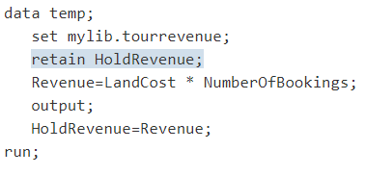

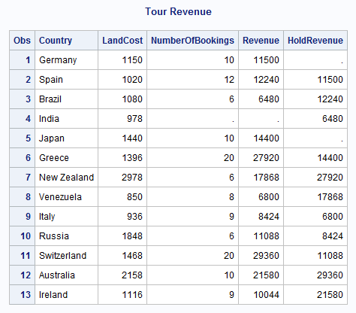

The value of HoldRevenue is missing at the beginning of the first observation. It is still missing when the OUTPUT statement writes the first observation to TEMP. After the OUTPUT statement, an assignment statement assigns the value of Revenue to HoldRevenue. Because HoldRevenue is retained, that value is present at the beginning of the next iteration of the DATA step. When the OUTPUT statement executes again, the value of HoldRevenue still contains that value.

To find the largest value of Revenue, assign the value of Revenue to HoldRevenue only when Revenue is larger than HoldRevenue, as shown in the following program:

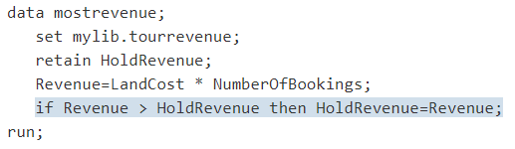

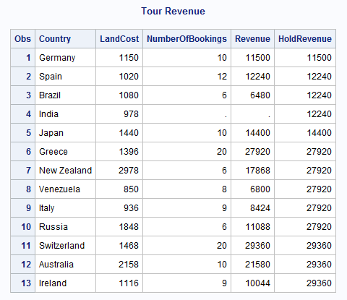

The value of HoldRevenue in the last observation represents the largest revenue that is generated by any tour. To determine which observation the value came from, create a variable named HoldCountry to hold the name of the country from the observation with the largest revenue. Include HoldCountry in the RETAIN statement to retain its value until explicitly changed. Then use the END= data set option to select the last observation, and use the KEEP= data set option to keep only HoldRevenue and HoldCountry in MOSTREVENUE:

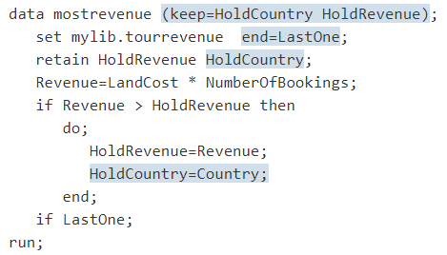

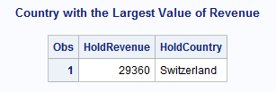

# WORKING WITH DATES

SAS stores dates as single, unique numbers so that they can be used in programs like any other numeric variable.

In SAS, every date is a unique number on a number line. Dates before January 1, 1960, are negative numbers; those after January 1, 1960, are positive. Because SAS date values are numeric variables, you can sort them easily, determine time intervals, and use dates as constants, as arguments in SAS functions, or in calculations.

## INFORMATS FOR DATE VALUES

In order for SAS to read a value as a SAS date value, you must give it a set of directions called an informat. By default, SAS reads numeric variables with a standard numeric informat that does not include letters or special characters. When a field that contains data does not match the standard patterns, you specify the appropriate informat in the INPUT statement.

SAS provides many informats. Four informats that are commonly used to read date values are:

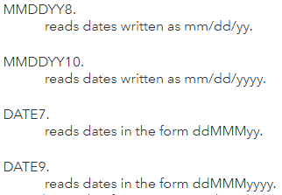

Note that each informat name ends with a period and contains a width specification that tells SAS how many columns to read.

Example:

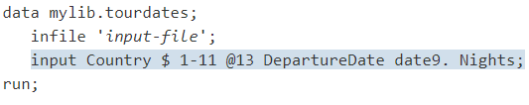

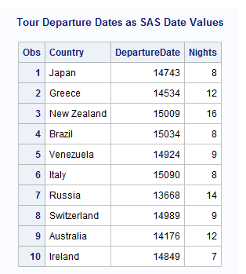

## GOOD PROGRAMMING PRACTICES TO READ DATES

When reading dates, it is good programming practice to always use the DATE9. or MMDDYY10. informats to make sure that the data is read correctly. If you use the DATE7. or MMDDYY8. informat, then SAS reads only the first two digits of the year. If the data contains four-digit years, then SAS reads the century and not the year.

In the example, the PRINT procedure uses the FORMAT option to format the dates.

Consider the Tradewinds Travel external file with both two-digit years and four-digit years:

The following DATA step creates a SAS data set MYLIB.TOURDATES7 by using the DATE7. informat:

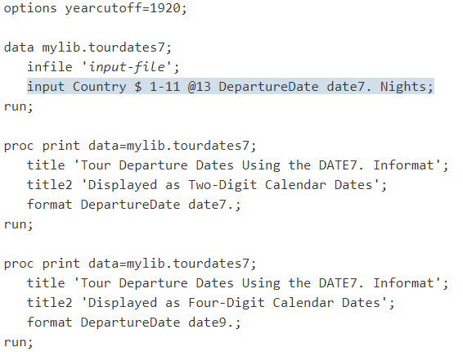

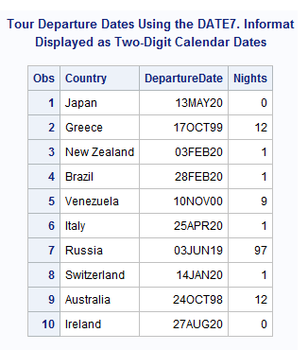

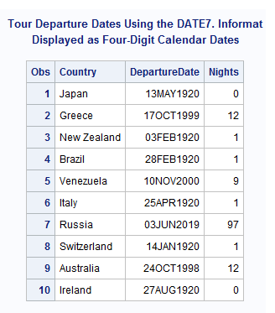

Notice that the four-digit years in the input file do not match the years in MYLIB.TOURDATES7 for observations 1, 3, 4, 6, 7, 8, and 10:

* SAS stopped reading the date after seven characters. It read the first two digits, the century, and not the complete four-digit year.
* To read the data for the next variable, SAS moved the pointer one column and read the next two numeric characters (the years 00, 01, and 97) as the value for the variable Nights. The data for Nights in the input file was ignored.
* When the dates were formatted for four-digit calendar dates, SAS used the YEARCUTOFF= 1920 system option to determine the century for the two-digit year. What was originally 1997 in observation 7 became 2019, and what was originally 2000 and 2001 in observations 1, 3, 4, 6, 8, and 10 became 1920.

## USING DATES AS CONSTANTS

If the tour of Switzerland leaves on January 21, 2001 instead of January 14, then you can use the following assignment statement to make the update:



The value '21jan2001'D is a SAS date constant. To write a SAS date constant, enclose a date in quotation marks in the standard SAS form ddMMMyyyy and immediately follow the final quotation mark with the letter D. The D suffix tells SAS to convert the calendar date to a SAS date value.

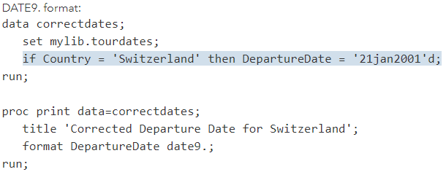

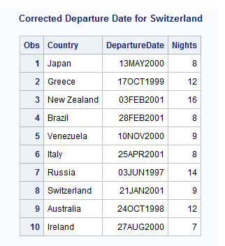

## DISPLAYING DATES

SAS date formats are available for the most common ways of writing calendar dates. The DATE9. format represents dates in the form ddMMMyyyy. If you want the month, day, and year to be spelled out, then use the WORDDATE18. format. The WEEKDATE29. format includes the day of the week. There are also formats available for number representations such as the format MMDDYY8., which displays the calendar date in the form mm/dd/yy, or the format MMDDYY10., which displays the calendar date in the form mm/dd/yyyy. Like informat names, each format name ends with a period and contains a width specification that tells SAS how many columns to use when displaying the date value.

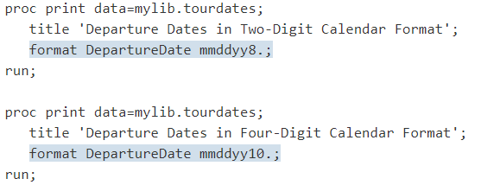

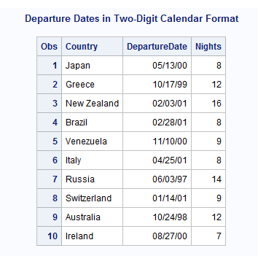

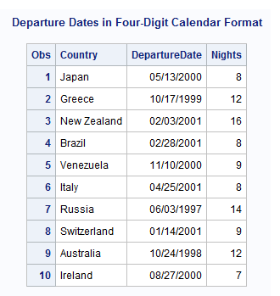

Placing a FORMAT statement in a PROC step associates the format with the variable only for that step. To associate a format with a variable permanently, use the FORMAT statement in a DATA step.

## ASSIGNING PERMANENT DATE FORMATS TO VARIABLES

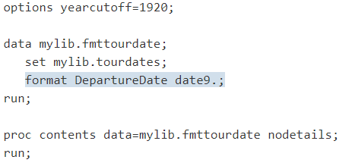

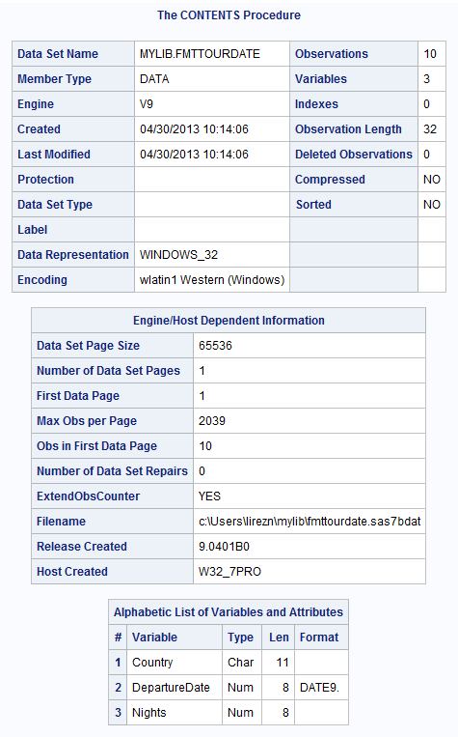

## CHANGING FORMATS TEMPORARILY

If you are preparing a report that requires the date in a different format, then you can override the permanent format by using a FORMAT statement in a PROC step.

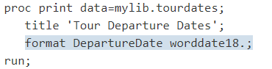

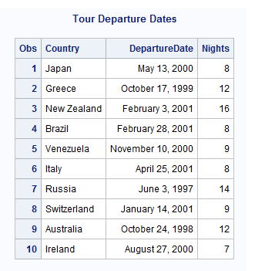

The format DATE9. is still permanently assigned to DepartureDate. Calendar dates in the remaining examples are in the form ddMMMyyyy unless a FORMAT statement is included in the PROC PRINT step.

## SORTING DATES

Because SAS date values are numeric variables, you can sort them and use them in calculations. The following example uses the data set MYLIB.TOURDATES to extract other information about the Tradewinds Travel data.

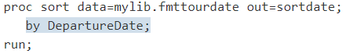

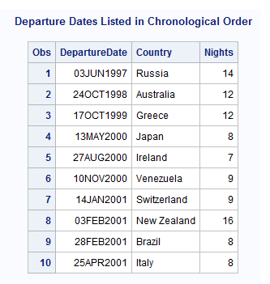

## CREATING NEW DATE VARIABLES

Because you know the departure date and the number of nights spent on each tour, you can calculate the return date for each tour. To start, create a new variable by adding the number of nights to the departure date, as follows:

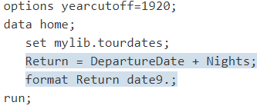

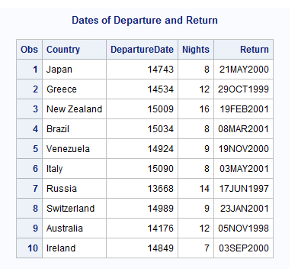

## FORMATS AND INFORMATS FOR DATES

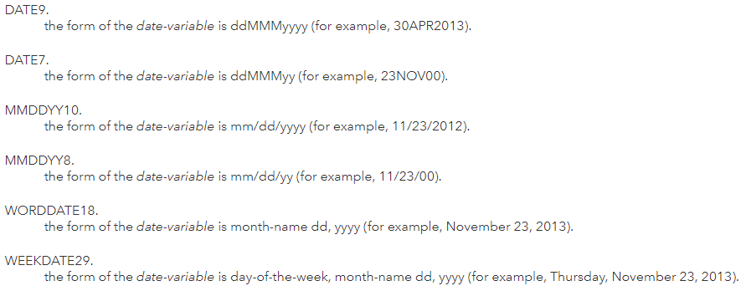

## SYSTEM OPTIONS

YEARCUTOFF: specifies the first year of a 100-year span that is used by informats and functions to read two-digit years, and used by formats to display two-digit years. The value that is specified in YEARCUTOFF= can result in a range of years that span two centuries. If YEARCUTOFF=1950, then any two-digit value between 50 and 99 inclusive refers to the first half of the 100-year span, which is in the 1900s. Any two-digit value between 00 and 49 inclusive refers to the second half of the 100-year span, which is in the 2000s. YEARCUTOFF= has no effect on existing SAS dates or dates that are read from input data that include a four-digit year.

## DATES WITH TWO-DIGIT AND FOUR-DIGIT YEAR VALUES

SAS is also capable of reading two-digit year values (for example, 09/05/99). In this example, use the MMDDYY8. informat for the variable Date.

How does SAS know to which century a two-digit year belongs? SAS uses the value of the YEARCUTOFF= SAS system option. In Version 7 and later of SAS, the default value of the YEARCUTOFF= option is 1926. This means that two-digit years from 00 to 19 are assumed to be in the twenty-first century, that is, 2000 to 2019. Two-digit years from 20 to 99 are assumed to be in the twentieth century, that is, 1920 to 1999.

Note: The YEARCUTOFF= option and the default setting might be different at your site.

To avoid confusion, you should use four-digit year values in your raw data wherever possible. For more information, see the Dates, Times, and Intervals section of SAS Language Reference: Concepts.

# COMBINING SAS DATA SETS

SAS provides several methods for combining SAS data sets.

* Concatenating
* Interleaving
* Merging
* Updating
* Modifying

## CONCATENATING

Concatenating combines two or more SAS data sets, one after the other, into a single SAS data set. You concatenate data sets by using either the

* SET statement in a DATA step or
* The APPEND procedure.

The following figure shows the results of concatenating two SAS data sets, and the DATA step that produces the results:

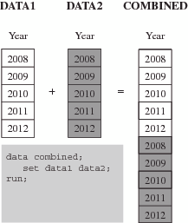

## INTERLEAVING

Interleaving combines individual, sorted SAS data sets into one sorted SAS data set. For each observation, the following figure shows the value of the variable by which the data sets are sorted. You interleave data sets using a SET statement along with a BY statement.

In the following example, the data sets are sorted by the variable Year.

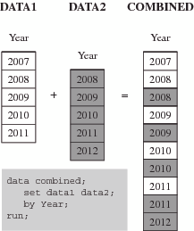

## MERGING

Merging combines observations from two or more SAS data sets into a single observation in a new data set.

A one-to-one merge, shown in the following figure, combines observations based on their position in the data sets. You use the MERGE statement for one-to-one merging.

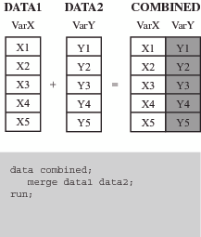

A match-merge, shown in the following figure, combines observations based on the values of one or more common variables. If you are performing a match-merge, use the MERGE statement along with a BY statement.

In the following example, two data sets are match-merged by the value of the variable Year.

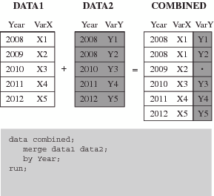

Notice that there is a missing value for the variable VarY in the COMBINED data set. The value is missing because the DATA2 data set has no observations for the year 2009.

## UPDATING

Updating a SAS data set replaces the values of variables in one data set (the master data set) with values from another data set (the transaction data set). If the UPDATEMODE= option in the UPDATE statement is set to MISSINGCHECK, then missing values in a transaction data set do not replace existing values in a master data set. If the UPDATEMODE= option is set to NOMISSINGCHECK, then missing values in a transaction data set replace existing values in a master data set. The default setting is MISSINGCHECK.

You update a data set by using the UPDATE statement along with a BY statement. Both of the input data sets must be sorted by the variable that you use in the BY statement.

The following figure shows the results of updating a SAS data set.

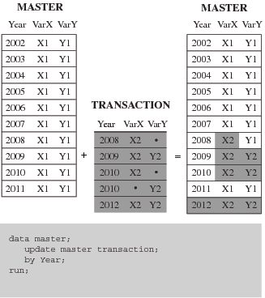

## MODIFYING

Modifying a SAS data set replaces, deletes, or appends observations in an existing data set. Modifying a SAS data set is similar to updating a SAS data set, but the following differences exist:

* Modifying cannot create a new data set, but updating can.
* Unlike updating, modifying does not require that the master data set or the transaction data set be sorted.

You use a MODIFY statement along with a BY statement to change an existing data set.

In the following example, the MASTER data set is updated by YEAR.

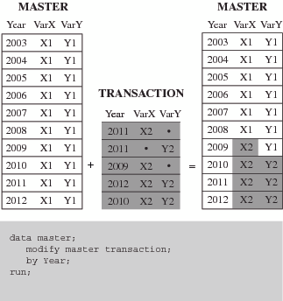

Notice that the TRANSACTION data set contains missing values. When the MASTER data set is modified, the new MASTER data set retains the values from the original MASTER data set, and no missing values appear.

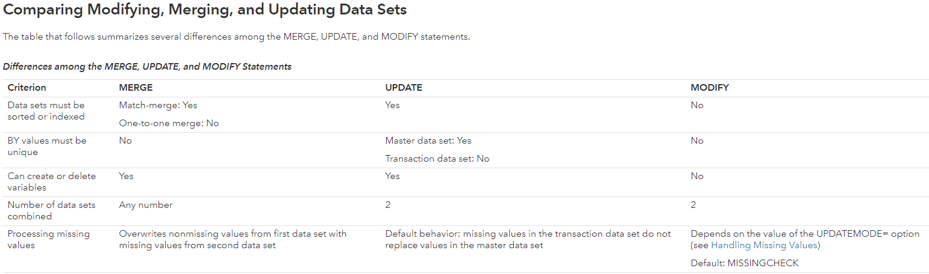

# CONCATENATING SAS DATA SETS

Concatenating combines two or more SAS data sets, one after the other, into a single data set. The number of observations in the new data set is the sum of the number of observations in the original data sets.

You can concatenate SAS data sets by using one of the following methods:

* The SET statement in a DATA step
* The APPEND procedure

If the data sets that you concatenate contain the same variables, and each variable has the same attributes in all data sets, then the results of the SET statement and PROC APPEND are the same. In other cases, the results differ.

If data sets used for concatenating are having some common variables and some different variables then when using PROC APPEND only the variables available in base data set will be appended.

## USING SET

In the simplest situation, the data sets that you concatenate contain the same variables (variables with the same name). In addition, the type, length, informat, format, and label of each variable match across all data sets. In this case, SAS copies all observations from the first data set into the new data set. It then copies all observations from the second data set into the new data set, and so on. Each observation is an exact copy of the original.

Example:

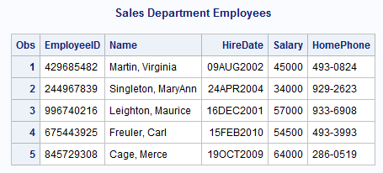

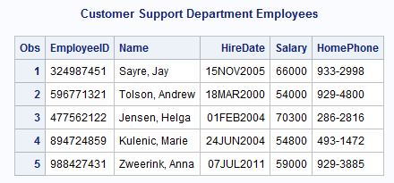

To concatenate the two data sets, list them in the SET statement. Use the PRINT procedure to display the resulting DEPT1_2 data set.

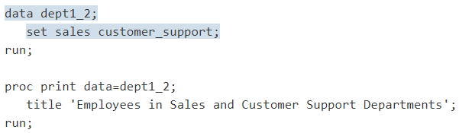

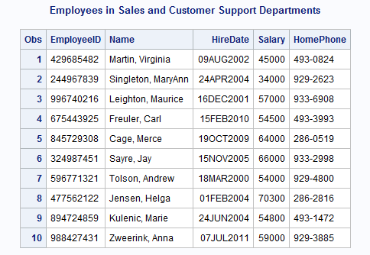

### DATA SETS CONTAIN DIFFERENT VARIABLES

The two data sets in the previous example contain the same variables, and each variable is defined the same way in both data sets. However, you might want to concatenate data sets when not all variables are common to the data sets that are named in the SET statement. In this case, each observation in the new data set includes all variables from the SAS data sets that are named in the SET statement.

The examples in this section show the SECURITY data set, and the concatenation of this data set to the SALES and the CUSTOMER_SUPPORT data sets. Not all variables are common to the three data sets. The personnel records for the Security department do not include the variable HomePhone. The variable Gender does not appear in the SALES or the CUSTOMER_SUPPORT data sets.

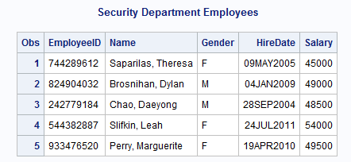

The following program concatenates the SALES, CUSTOMER_SUPPORT, and SECURITY data sets, and creates the new data set, DEPT1_3:

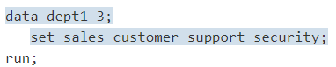

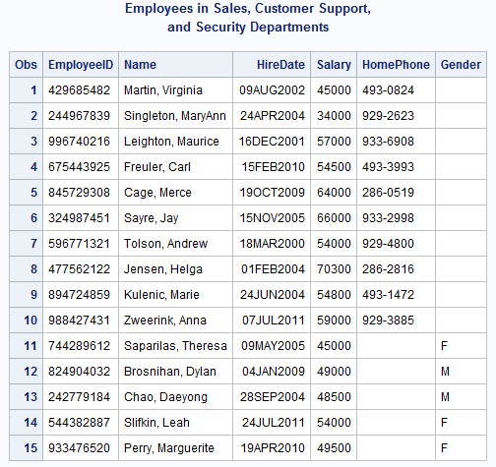

All observations in the data set DEPT1_3 have values for both the variable Gender and the variable HomePhone. Observations from data sets SALES and CUSTOMER_SUPPORT, the data sets that do not contain the variable Gender, have missing values for Gender (indicated by blanks under the variable name). Observations from SECURITY, the data set that does not contain the variable HomePhone, have missing values for HomePhone (indicated by blanks under the variable name).

### VARIABLES HAVE DIFFERENT ATTRIBUTES

Each variable in a SAS data set can have as many as six attributes that are associated with it. The following is a list of the attributes:

* Name
* Type
* Length
* Informat
* Format
* Label

### VARIABLES HAVE DIFFERENT TYPES

If a variable is defined as a character variable in one data set that is named in the SET statement, and as a numeric variable in another, SAS issues an error message and does not concatenate the data sets.

In below data set EmployeeID has been defined as Numeric where as in other data sets it has been defined as Character value.

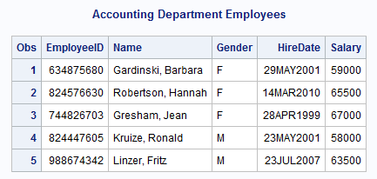

he following program attempts to concatenate the data sets for all four departments:

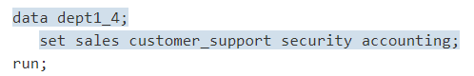

The program fails because of the difference in variable type among the four departments. SAS writes the following error message to the log:



One way to correct the error in the previous example is to change the type of the variable EmployeeID in ACCOUNTING from numeric to character.

You can change the type of the variable EmployeeID in the following ways:

* Re-create the data set, changing the INPUT statement so that it identifies EmployeeID as a character variable
* Use the PUT function to create a new variable, and data set options to rename and drop variables

The following program uses the PUT function and data set options to change the variable type of EmployeeID from numeric to character.

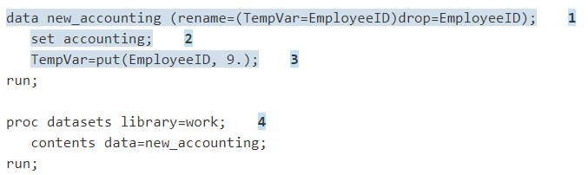

### VARIABLES HAVE DIFFERENT FORMATS, INFORMATS, OR LABELS

When you concatenate data sets with the SET statement, the following rules determine which formats, informats, and labels are associated with variables in the new data set.

* An explicitly defined format, informat, or label overrides a default, regardless of the position of the data sets in the SET statement.
* If two or more data sets explicitly define different formats, informats, or labels for the same variable, then the variable in the new data set assumes the attribute from the first data set in the SET statement that explicitly defines that attribute.

### WHEN VARIABLES HAVE DIFFERENT LENGTHS

If you use the SET statement to concatenate data sets in which the same variable has different lengths, the outcome of the concatenation depends on whether the variable is character or numeric. The SET statement determines the length of variables as follows:

* For a character or numeric variable, an explicitly defined length overrides a default, regardless of the position of the data sets in the SET statement.
* If two or more data sets explicitly define different lengths for the same numeric variable, the variable in the new data set has the same length as the variable in the data set that appears first in the SET statement.
* If the length of a character variable differs among data sets, whether the differences are explicit, the variable in the new data set has the same length as the variable in the data set that appears first in the SET statement.

## APPEND

The APPEND procedure adds the observations from one SAS data set to the end of another SAS data set. PROC APPEND does not process the observations in the first data set. It adds the observations in the second data set directly to the end of the original data set.

The APPEND procedure has the following form:



* base-SAS-data-set: names the SAS data set to which you want to append the observations. If this data set does not exist, then SAS creates it. At the completion of PROC APPEND, the value of base-SAS-data-set becomes the current (most recently created) SAS data set.
* SAS-data-set-to-append: names the SAS data set that contains the observations to add to the end of the base data set. If you omit this option, then PROC APPEND adds the observations in the most recently created SAS data set to the end of the base data set.
* FORCE: forces PROC APPEND to concatenate the files in some situations in which the procedure would normally fail.

### SIMPLEST CASE

The following program appends the data set CUSTOMER_SUPPORT to the data set SALES. Both data sets contain the same variables and each variable has the same attributes in both data sets.

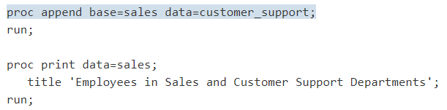

The following output shows the results:

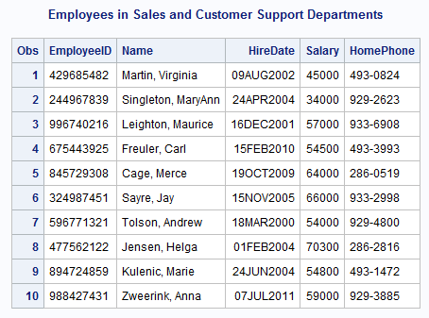

PROC APPEND permanently alters the SALES data set, which is the data set for the BASE= option. SALES now contains observations from both the Sales and the Customer Support departments.

### DATA SETS CONTAIN DIFFERENT VARIABLES

Recall that the SECURITY data set contains the variable Gender, which is not in the SALES data set, and lacks the variable HomePhone, which is present in the SALES data set. What happens if you try to use PROC APPEND to concatenate data sets that contain different variables?

If you try to append SECURITY to SALES using the following program, then the concatenation fails:

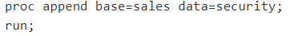

SAS writes the following messages to the log:

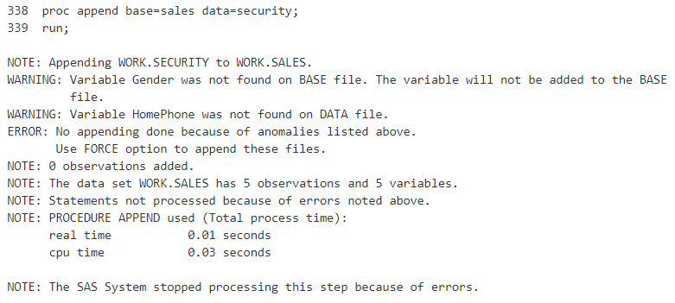

You must use the FORCE option with PROC APPEND when the DATA= data set contains a variable that is not in the BASE= data set. If you modify the program to include the FORCE option, then it successfully concatenates the files.

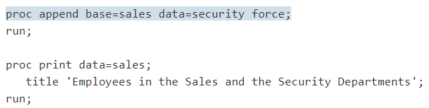

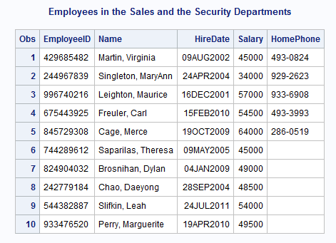

This output illustrates two important points about using PROC APPEND to concatenate data sets with different variables:

* If the BASE= data set contains a variable that is not in the DATA= data set (for example, HomePhone), then PROC APPEND concatenates the data sets and assigns a missing value to that variable in the observations that are taken from the DATA= data set.
* If the DATA= data set contains a variable that is not in the BASE= data set (for example, Gender), then the FORCE option in PROC APPEND forces the procedure to concatenate the two data sets. But because that variable is not in the descriptor portion of the BASE= data set, the procedure cannot include it in the concatenated data set.

### VARIABLES HAVE DIFFERENT ATTRIBUTES

When you use PROC APPEND with variables that have different attributes, the following rules apply:

* If a variable has different attributes in the BASE= data set than it does in the DATA= data set, then the attributes in the BASE= data set prevail. In the cases of different formats, informats, and labels, the concatenation succeeds.
* If the length of a variable is longer in the BASE= data set than in the DATA= data set, then the concatenation succeeds.
* If the length of a variable is longer in the DATA= data set than in the BASE= data set, or if the same variable is a character variable in one data set and a numeric variable in the other, then PROC APPEND fails to concatenate the files unless you specify the FORCE option.

Using the FORCE option has these consequences:

* The length that is specified in the BASE= data set prevails. Therefore, SAS truncates values from the DATA= data set to fit them into the length that is specified in the BASE= data set.
* The type that is specified in the BASE= data set prevails. The procedure replaces values of the wrong type (all values for the variable in the DATA= data set) with missing values.

## SET vs APPEND

The following table summarizes the major differences between using the SET statement and using the APPEND procedure to concatenate files.

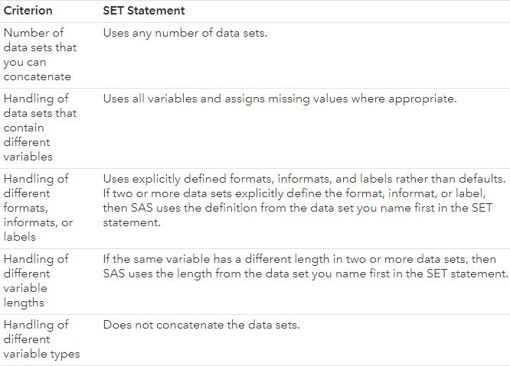

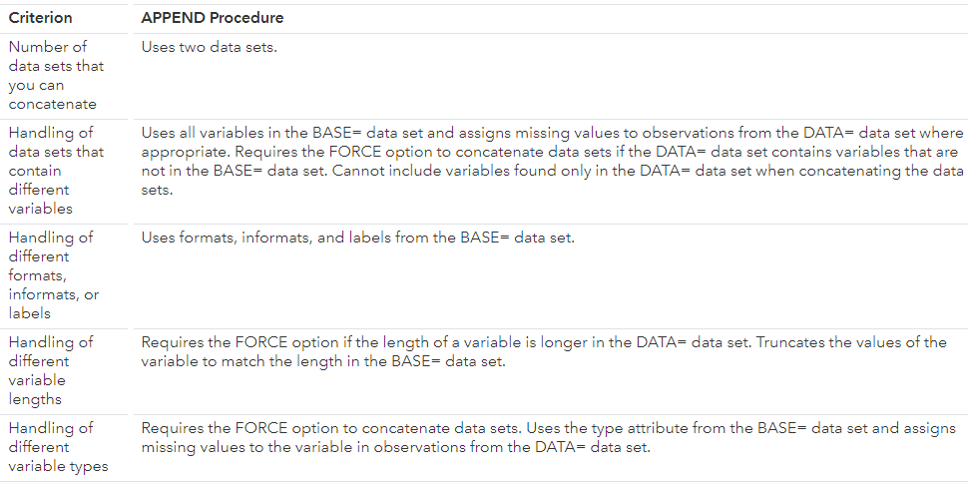

# PROC PRINT

Reports that you create with the PRINT procedure contain one row for every observation that is selected for inclusion in the report. A report provides information about every record that is processed.

Below is the syntax for PROC Print:

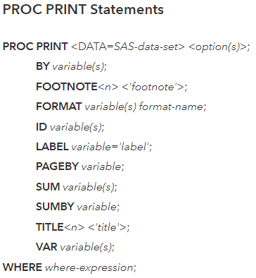

Below data set will be used as example:

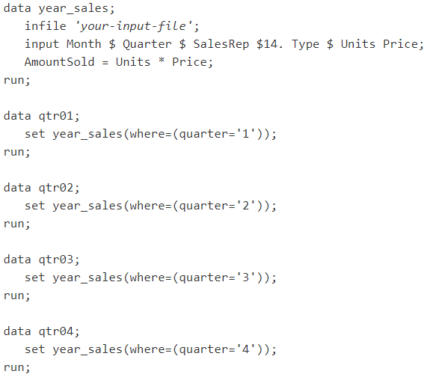

## SHOWING ALL THE VARIABLES

By default, the PRINT procedure generates a simple report that shows the values of all the variables and the observations in the data set. For example, the following PROC PRINT step creates a report for the first sales quarter:

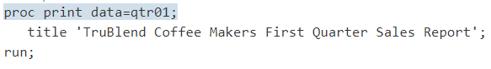

The following output shows the values of all the variables for all the observations in QTR01:

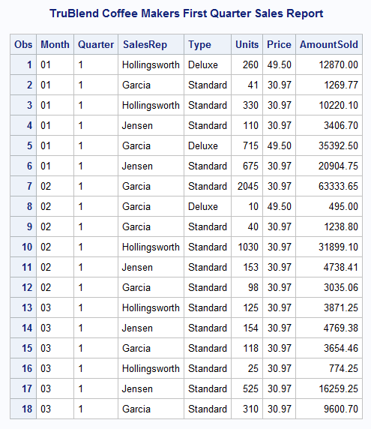

The Obs column identifies each observation by number. By default, SAS displays the observation number at the beginning of each row.

The top of the report has a title. The TITLE statement in the PROC PRINT step produces the title. For more information about the TITLE statement, see Creating Customized Reports. For now, remember that all the examples include at least one TITLE statement that produces a descriptive title similar to the one in this example.

The content of the report is very similar to the contents of the original data set QTR01. However, the report is easy to produce and to enhance.

## OBS

A quick way to modify the report is to label the observation number (Obs column). The following SAS program includes the OBS= option in the PROC PRINT statement to change the column label for the Obs column:

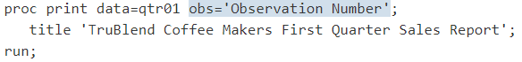

The following output shows the report:

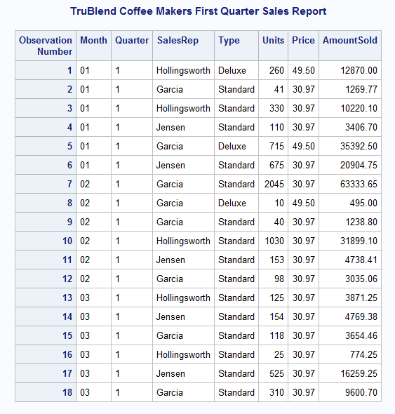

## NOOBS

A quick way to simplify the report is to suppress the observation number (Obs column). Usually, it is unnecessary to identify each observation by number. (In some cases, you might want to show the observation numbers.) The following SAS program includes the NOOBS option in the PROC PRINT statement to suppress the Obs column:

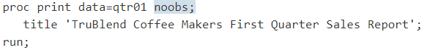

The following output shows the report:

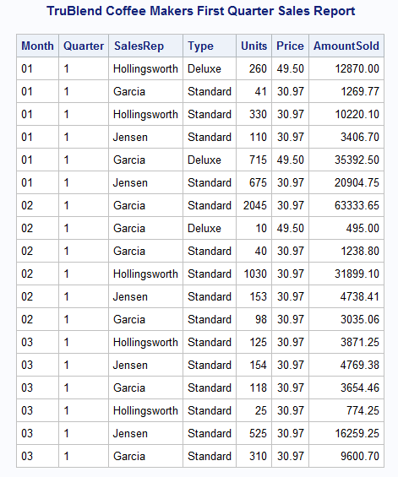

## ID

To emphasize a key variable in a data set, you can use the ID statement in the PROC PRINT step. When you identify a variable in the ID statement, PROC PRINT displays the values of this variable in the first column of each row of the report. Highlighting a key variable in this way can help answer questions about your data

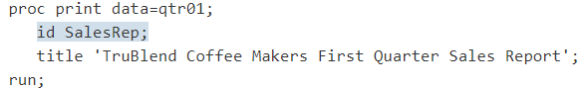

Because the ID statement automatically suppresses the observation numbers, the NOOBS option is not needed in the PROC PRINT statement.

The following output shows the report:

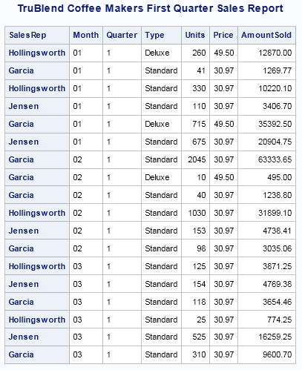

Notice that the names of the sales representatives are not in any particular order. The report will be easier to read when the observations are grouped together in alphabetical order by sales representative.

## ID (SORTED)

If your data is not already ordered by the key variable, then use PROC SORT to sort the observations by this variable. If you do not specify an output data set, then PROC SORT permanently changes the order of the observations in the input data set.

The following program shows how to alphabetically order the observations by sales representative:

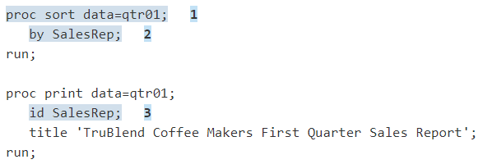

The following output shows the report:

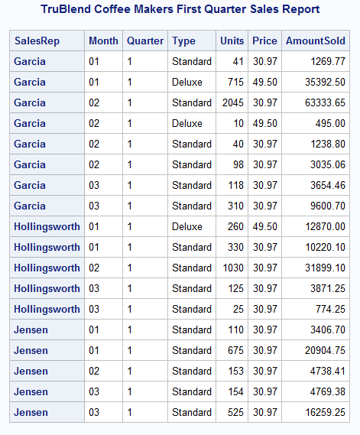

Now, the report clearly shows what each sales representative sold during the first three months of the year.

## VAR

By default, the PRINT procedure reports the values of all the variables in the data set. However, to control which variables are shown and in what order, add a VAR statement to the PROC PRINT step.

The following program adds the VAR statement to create a report that lists the values of the four variables in a specific order:

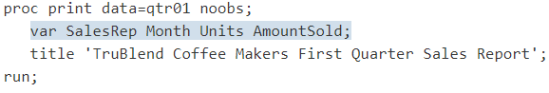

This program does not include the ID statement. It is unnecessary to identify the observations because the variable SalesRep is the first variable that is specified in the VAR statement. The NOOBS option in the PROC PRINT statement suppresses the observation numbers so that the sales representative appears in the first column of the report.

Note: If the ID statement is used and it names one of the variables in the VAR statement, the information is duplicated and two columns for the same variable appear in the report.

The following output shows the report:

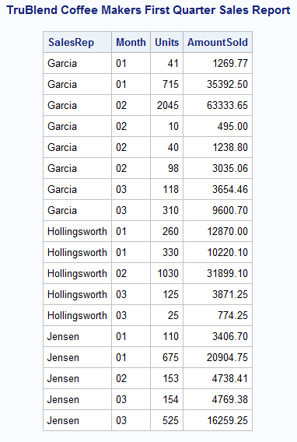

The report is concise because it contains only those variables that are specified in the VAR statement.

## WHERE

To select observations that meet a particular condition from a data set, use a WHERE statement. The WHERE statement subsets the input data by specifying certain conditions that each observation must meet before it is available for processing.

Using the WHERE statement might improve the efficiency of your SAS programs because SAS is not required to read all the observations in the input data set.

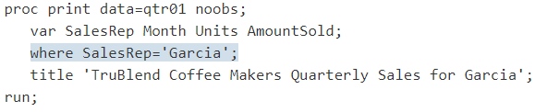

In the WHERE statement, the value Garcia is enclosed in quotation marks because SalesRep is a character variable. In addition, the letter G in the value Garcia is uppercase so that it matches exactly the value in the data set QTR01.

The following output shows the report:

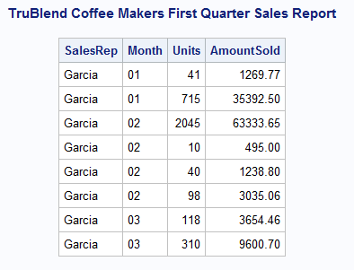

You can also select observations based on two or more comparisons by using the WHERE statement. However, when you use multiple WHERE statements in a PROC step, then only the last statement is used.

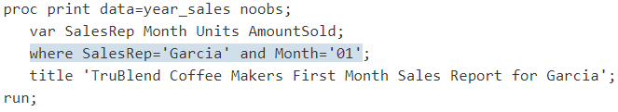

The WHERE statement uses the logical AND operator. Therefore, both comparisons must be true for PROC PRINT to include an observation in the report.

The following output shows the report:

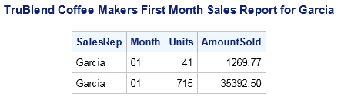

# CREATING ENHANCED REPORTS

With just a few PROC PRINT statements and options, you can produce a variety of detail reports. By using additional statements and options that enhance the reports, you can do the following using PROC PRINT:

* Format the columns
* Sum the numeric variables
* Group the observations based on variable values
* Sum the groups of variable values
* Group the observations in separate sections

## FORMAT

Specifying the formats of variables is a simple yet effective way to enhance the readability of your reports. By adding the FORMAT statement to your program, you can specify formats for variables. The format of a variable is a pattern that SAS uses to write the values of the variables. For example, SAS contains formats that add commas to numeric values, that add dollar signs to figures, or that report values as Roman numerals.

The following program illustrates how to apply these formats using a FORMAT statement:

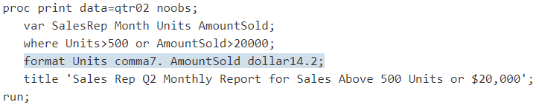

PROC PRINT applies the COMMA7. format to the values of the variable Units and the DOLLAR14.2 format to the values of the variable AmountSold.

The following output shows the report:

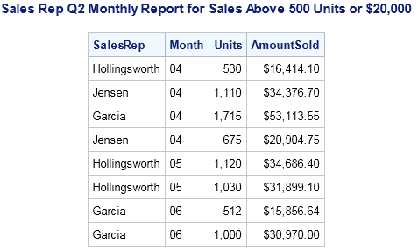

Be sure to specify enough columns in the format to contain the largest value. If the format that you specify is not wide enough to contain the largest value, including special characters such as commas and dollar signs, then SAS applies the most appropriate format.

## SUM

In addition to reporting the values in a data set, you can add the SUM statement to compute subtotals and totals for the numeric variables. The SUM statement enables you to request totals for one or more variables.

The following program produces a report that shows totals for the two numeric variables Units and AmountSold:

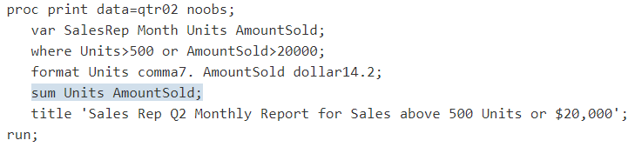

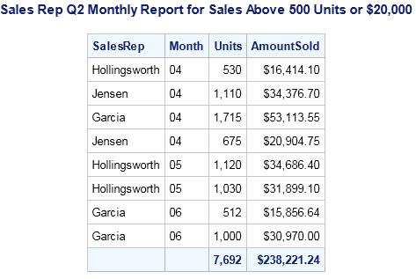

The totals for Units and AmountSold are computed by summing the values for each sale made by all the sales representatives. As the next example shows, the PRINT procedure can also separately compute subtotals for each sales representative.

## BY

The BY statement enables you to obtain separate analyses on groups of observations.

The previous example used the SUM statement to compute totals for the variables Units and AmountSold. However, the totals were for all three sales representatives as one group. The following examples show how to use the BY, ID, and SUMBY statements as a part of the PROC PRINT step to separate the sales representatives into three groups with three separate subtotals and one grand total.

The following program uses the BY statement in the PROC PRINT step to obtain separate subtotals of the variables Units and AmountSold for each sales representative:

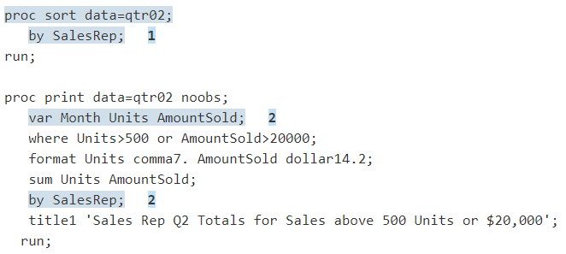

The following output shows the report:

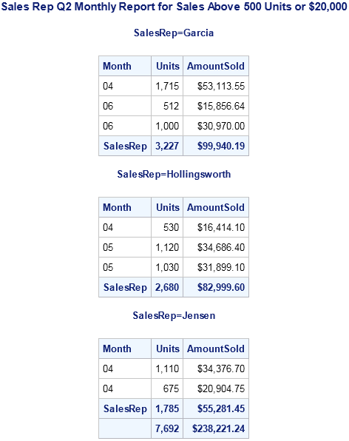

## SUMLABEL & GRANDTOTAL_LABEL

The following example adds the SUMLABEL= option and the GRANDTOTAL_LABEL= option to the PROC PRINT statement. This program assumes that QTR02 data has been previously sorted by the variables SalesRep.

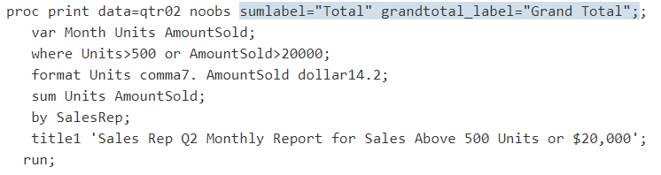

The following output shows the report:

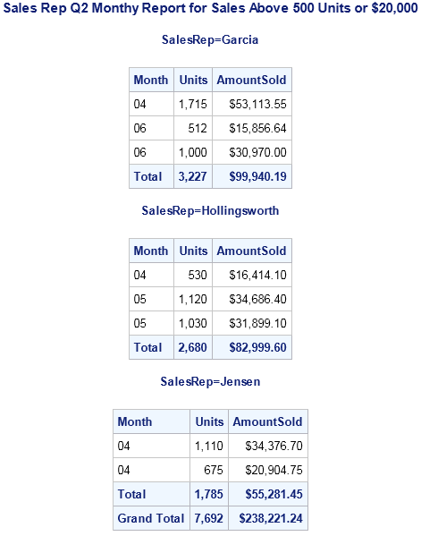

## IDENTIFYING GROUP SUBTOTALS

You can use both the BY and ID statements in the PROC PRINT step to modify the appearance of your report. When you specify the same variables in both the BY and ID statements, the PRINT procedure uses the ID variable to identify the start of the BY group.

The following example uses the data set that was sorted in the last example and adds the ID statement to the PROC PRINT step:

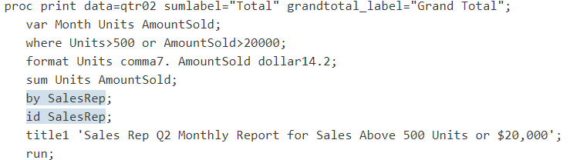

The following output shows the report:

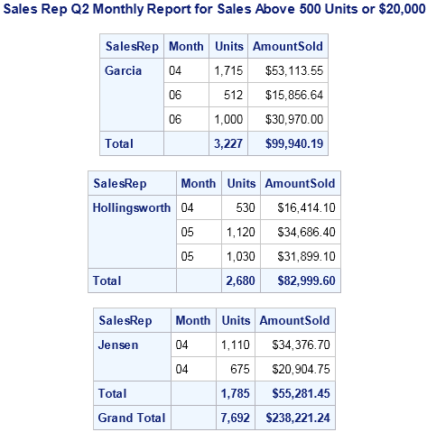

Remember these general rules about the SUM, BY, and ID statements:

* You can specify a variable in the SUM statement while omitting it in the VAR statement. PROC PRINT simply adds the variable to the list of variables in the VAR statement.
* You do not specify variables in the SUM statement that you used in the ID or BY statement.
* When you use a BY statement and you specify only one BY variable, PROC PRINT subtotals the SUM variable for each BY group that contains more than one observation.
* When you use a BY statement and you specify multiple BY variables, PROC PRINT shows a subtotal for a BY variable only when the value changes and when there are multiple observations with that value.

## MULTIPLE GROUP SUBTOTALS

You can also use two or more variables in a BY statement to define groups and subgroups. The following program produces a report that groups observations first by sales representative and then by month:

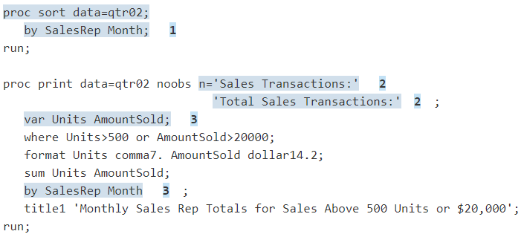

The following output shows the report:

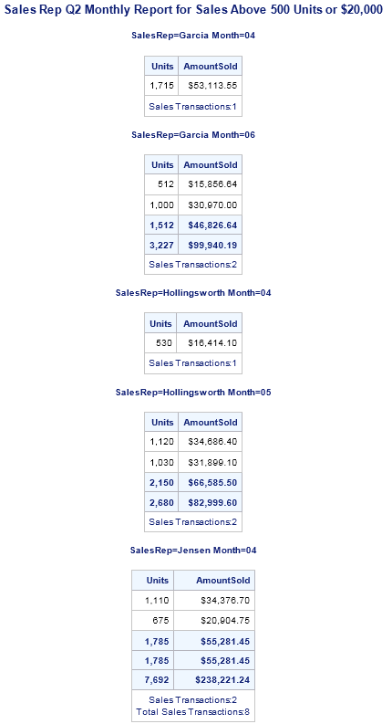

## SUMBY

When you use multiple BY variables as in the previous example, you can suppress the subtotals every time a change occurs for the value of the BY variables. Use the SUMBY statement to control which BY variable causes subtotals to appear.

You can specify only one SUMBY variable, and this variable must also be specified in the BY statement. PROC PRINT computes sums when a change occurs to the following values:

* The value of the SUMBY variable
* The value of any variable in the BY statement that is specified before the SUMBY variable

For example, consider the following statements:

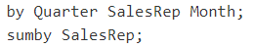

SalesRep is the SUMBY variable. In the BY statement, Quarter comes before SalesRep while Month comes after SalesRep. Therefore, these statements cause PROC PRINT to compute totals when either Quarter or SalesRep changes value, but not when Month changes value.

The following program omits the monthly subtotals for each sales representative by designating SalesRep as the variable to sum by:

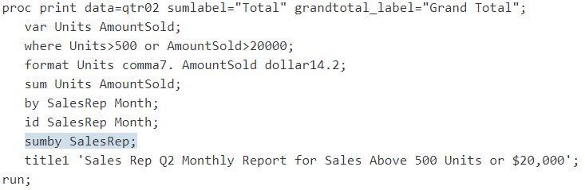

The following output shows the report:

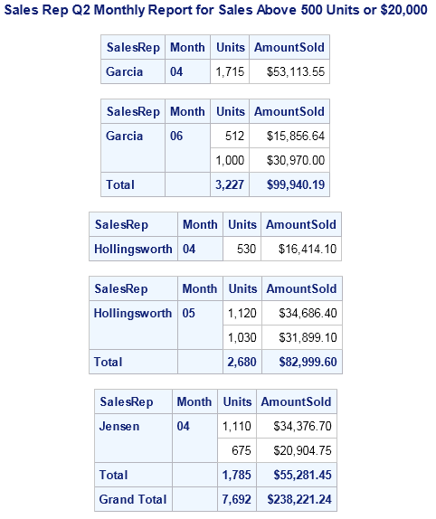

## PAGEBY

You can also create a report with multiple sections by using the PAGEBY statement with the BY statement. The PAGEBY statement identifies a variable in the BY statement that causes the PRINT procedure to begin the report in a new section when a change occurs to the following values:

the value of the BY variable

the value of any BY variable that precedes it in the BY statement

The following program uses a PAGEBY statement with the BY statement to create a report with multiple sections. This program assumes that QTR02 data has been previously sorted by the variables SalesRep and Month.

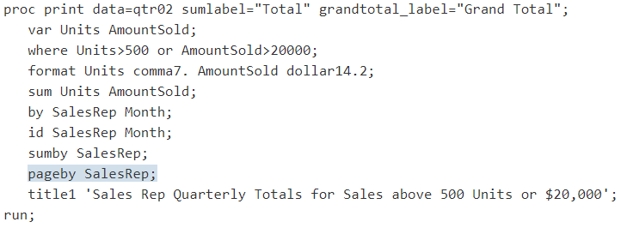

The following output shows the report:

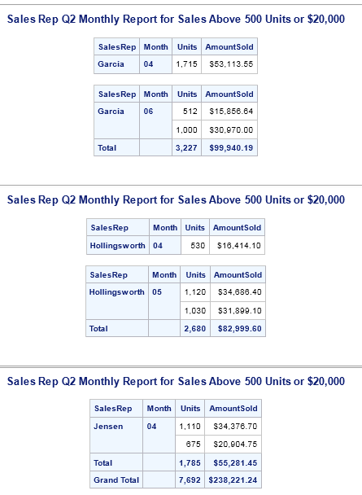

# CUSTOMIZE A REPORT

As you have seen from the previous examples, the PRINT procedure produces simple reports quickly and easily. With additional statements and options, you can enhance the readability of your reports. For example, you can do the following:

* Add descriptive titles and footnotes.
* Define and split labels across multiple lines.
* Add double spacing.
* Ensure that the column widths are uniform across the pages of the report.
* Change the style of the output.

## ADDING TITLES AND FOOTNOTES

The following program includes titles and footnotes in a report of second quarter sales during the month of April:

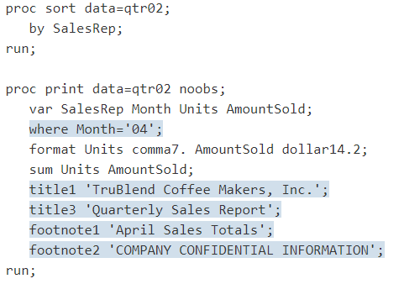

The following output shows the report:

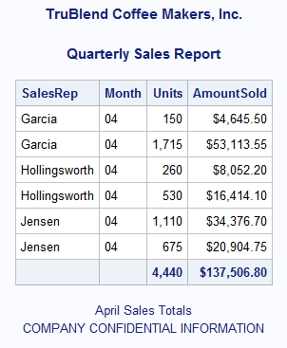

## DEFINING LABELS

By default, SAS uses variable names for column headings. However, to improve the appearance of a report, you can specify your own column headings.

To override the default headings, you need to do the following:

* Add the LABEL option to the PROC PRINT statement.
* Define the labels in the LABEL statement.

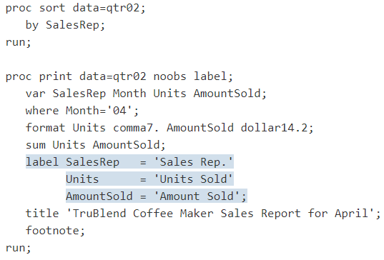

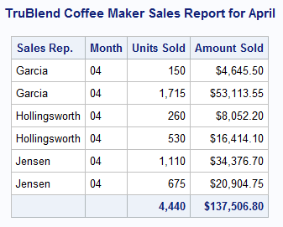

## SPLIT

Sometimes labels are too long to fit on one line, or you might want to split a label across two or more lines. You can use the SPLIT= option to control where the labels are separated into multiple lines.

The SPLIT= option replaces the LABEL option in the PROC PRINT statement. (You do not need to use both SPLIT= and LABEL because SPLIT= implies that PROC PRINT use labels.) In the SPLIT= option, you specify an alphanumeric character that indicates where to split labels. To use the SPLIT= option, you need to do the following:

* Define the split character as a part of the PROC PRINT statement.
* Define the labels with a split character in the LABEL statement.

The following PROC PRINT step defines the slash (/) as the split character and includes slashes in the LABEL statements to split the labels Sales Representative, Units Sold, and Amount Sold into two lines each:

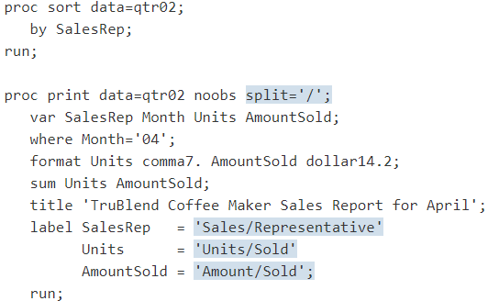

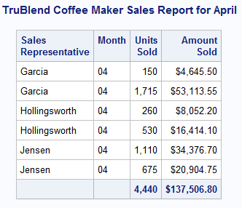

## ADDING BLANKS LINES

You might want to improve the appearance of a report by adding one or more blank lines between the rows of the report. The following program uses the BLANKLINE option in the PROC PRINT statement to add lines between the observations for sales representatives in the report:

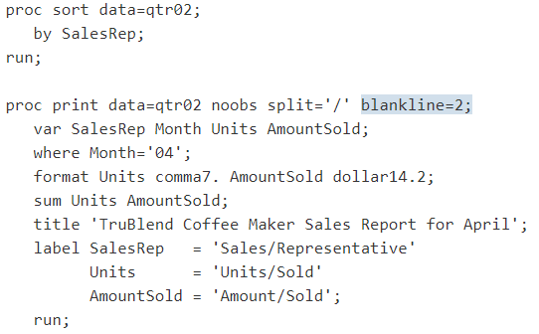

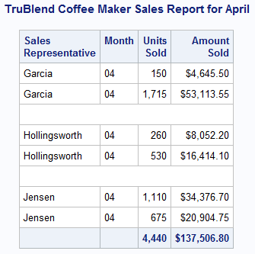

# PROC FREQ

The FREQ procedure produces one-way to n-way frequency (crosstabulation) tables. For two-way tables, PROC FREQ computes tests and measures of association. For n-way tables, PROC FREQ provides stratified analysis by computing statistics within strata and across strata.

Syntax:

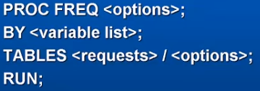

If data set is not mentioned then the PROC FREQ will use the last data set worked on by SAS.

The variables for which we want the frequencies to be calculated are mentioned in the TABLES request.

The following DATA step statements create the SAS data set SummerSchool:

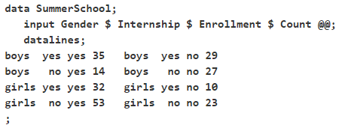

The variable Gender takes the values ‘boys’ or ‘girls,’ the variable Internship takes the values ‘yes’ and ‘no,’ and the variable Enrollment takes the values ‘yes’ and ‘no.’ The variable Count contains the number of students that correspond to each combination of data values. The double at sign (@@) indicates that more than one observation is included on a single data line. In this DATA step, two observations are included on each line.

Researchers are interested in whether there is an association between internship status and summer program enrollment. The Pearson chi-square statistic is an appropriate statistic to assess the association in the corresponding 2x2 table. The following PROC FREQ statements specify this analysis.

You specify the table for which you want to compute statistics with the TABLES statement. You specify the statistics you want to compute with options after a slash (/) in the TABLES statement.

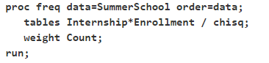

The ORDER= option controls the order in which variable values are displayed in the rows and columns of the table. By default, the values are arranged according to the alphanumeric order of their unformatted values. If you specify ORDER=DATA, the data are displayed in the same order as they occur in the input data set. Here, because ‘yes’ appears before ‘no’ in the data, ‘yes’ appears first in any table. Other options for controlling order include ORDER=FORMATTED, which orders according to the formatted values, and ORDER=FREQ, which orders by descending frequency count.

* In the TABLES statement, Internship*Enrollment specifies a table where the rows are internship status and the columns are program enrollment.
* The CHISQ option requests chi-square statistics for assessing association between these two variables.
* Because the input data are in cell count form, the WEIGHT statement is required. The WEIGHT statement names the variable Count, which provides the frequency of each combination of data values.

Below figure shows the crosstabulation of Internship and Enrollment:

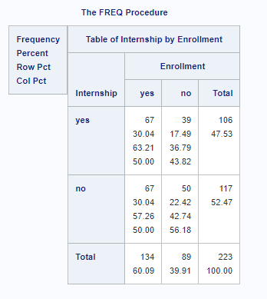

## BY STATEMENT

You can specify a BY statement with PROC FREQ to obtain separate analyses of observations in groups that are defined by the BY variables. When a BY statement appears, the procedure expects the input data set to be sorted in order of the BY variables. If you specify more than one BY statement, only the last one specified is used.

If your input data set is not sorted in ascending order, use one of the following alternatives:

* Sort the data by using the SORT procedure with a similar BY statement.
* Specify the NOTSORTED or DESCENDING option in the BY statement for the FREQ procedure. The NOTSORTED option does not mean that the data are unsorted but rather that the data are arranged in groups (according to values of the BY variables) and that these groups are not necessarily in alphabetical or increasing numeric order.
* Create an index on the BY variables by using the DATASETS procedure (in Base SAS software).

## TABLES STATEMENT

The TABLES statement requests one-way to n-way frequency and crosstabulation tables and statistics for those tables.

If you omit the TABLES statement, PROC FREQ generates one-way frequency tables for all data set variables that are not listed in the other statements.

## WEIGHT STATEMENT

The WEIGHT statement names a numeric variable that provides a weight for each observation in the input data set. The WEIGHT statement is most commonly used to input cell count data.

## FREQUENCY TABLE

For continuous variables, descriptive statistics like mean and standard deviation can be used to summarize the data. But for categorical variables, these measures are not appropriate. What descriptive statistics exist for categorical variables?

Categorical variables can be summarized using a frequency table, which shows the number and percentage of cases observed for each category of a variable.

PROC FREQ is used to create frequency tables that summarize individual categorical variables.

The FREQ procedure prints all values of a given categorical variable in the Output window, along with the number and percentage of times each value appears. The FREQ procedure can work with both string (character) or numeric categorical variables.

The basic syntax of the FREQ procedure is:

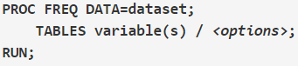

In the first line of the SAS code above, PROC FREQ tells SAS to execute the FREQ procedure on the dataset given in the DATA= argument.

On the next line, the TABLES statement is where you put the names of the variables you want to produce a frequency table for. You can list as many variables as you want, with each variable separated by a space. If the TABLES statement is not included, then SAS will generate a table for every variable in the dataset.

While too numerous to list in full, there are many data analysis and display control options available with the TABLES statement. These options are listed after a forward slash (/) following the variable name(s). Some of these options include:

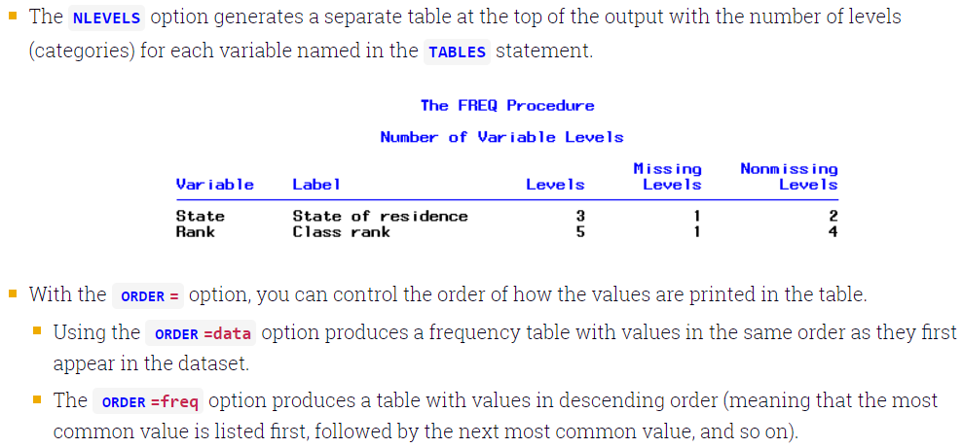

Sometimes, your dataset may contain a “count” variable. In this case, the WEIGHT statement specifies which variable acts as the frequency variable. This statement would be given after the TABLES statement.

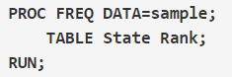

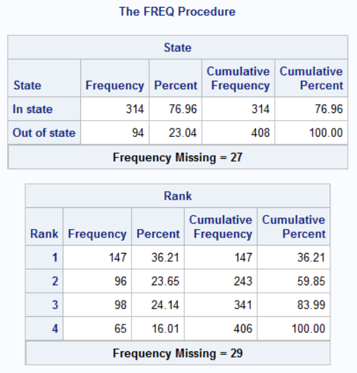

A basic frequency table created with PROC FREQ will have the following properties:

* It will include the frequency, percentage, cumulative frequency, and cumulative percent for each category.
* If there are cases with missing values for the variable, the number of missing values are given below the table.
* For string variables, the categories will be ordered alphabetically. For numeric variables, the categories will be ordered from smallest to largest indicator.

## DESCENDING ORDER AND MISSING VALUES

In the previous example, the number of missing values for each variable was printed outside their respective frequency table. Additionally, values were sorted alphabetically, which can make it difficult to locate the most "popular" category.

The ORDER=freq option in the first line of the syntax tells SAS to order the values in the table in descending order. The MISSING option appearing after the slash (/) in the TABLE statement tells SAS to include the missing values as a row in the table.

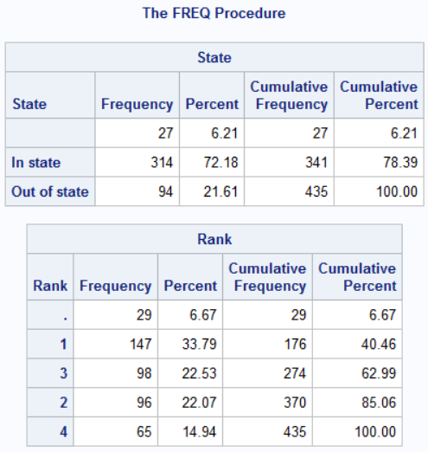

Notice that the information for missing values prints first, even though they are not the most frequent responses in this example. This is because the MISSING option ignores any ordering rules: the row of missing values will always print first, regardless of whether or not you specify an ORDER option. For the string variable State, missing values are indicated as blanks, which is why there appears to be no category label for the first row of that frequency table.

## USEFUL OPTIONS

We can use below option with table statement:

### ORDER

ORDER= Freq - sorts by descending frequency count (default is the unformatted value).

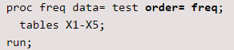

### LIST

prints two-way to n-way tables in a list format rather than as cross tabulation tables.

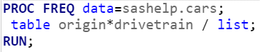

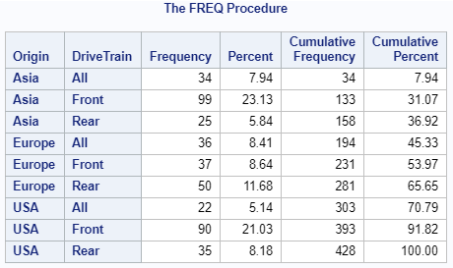

### CROSSLIST

prints two-way to n-way tables in a list format rather than as cross tabulation tables.

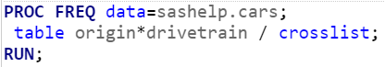

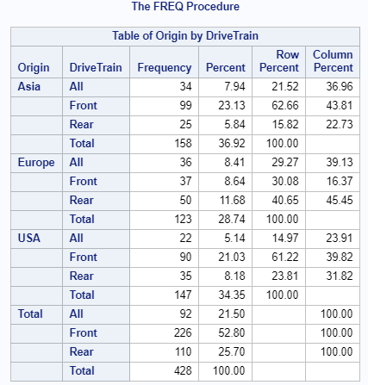

### OUT

If we want to save the frequency output in a data set then we can use the output statement.

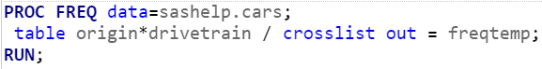

By default, only Count and Percent column are included u=in the data set.

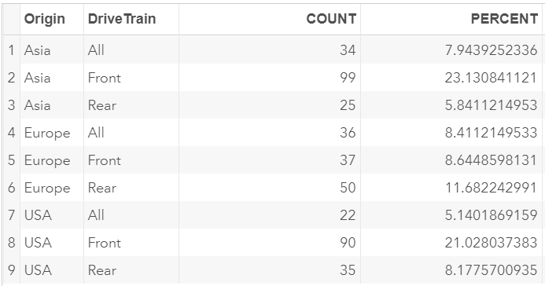

### SUPPRESSING DEFAULT STATS

Nocol - suppresses printing of column percentages of a crosstab.

Norow - suppresses printing of row percentages of a crosstab.

Nopercent - suppresses printing of cell percentages of a crosstab.

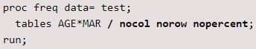

### MISSPRINT

Missprint - prints missing value frequencies for two-way to n-way tables but does not consider them while doing that calculations.

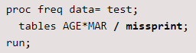

### MISSING

Missing - interprets missing values as nonmissing and includes them in % and statistics calculations.

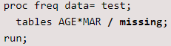

### CHISQ

Chisq - performs several chi-square tests.

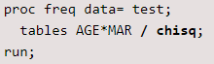

### NLEVELS

Nlevels option will give the count of distinct value for variable

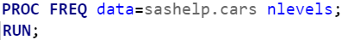

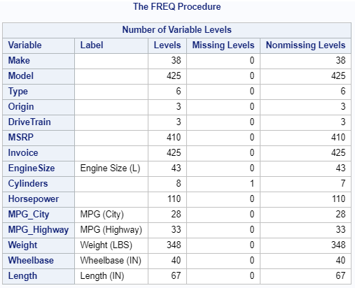

# PROC MEANS

PROC MEANS is one of the most common SAS procedure used for analyzing data. It is mainly used to calculate descriptive statistics such as mean, median, count, sum etc. It can also be used to calculate several other metrics such as percentiles, quartiles, standard deviation, variance and sample t-test.

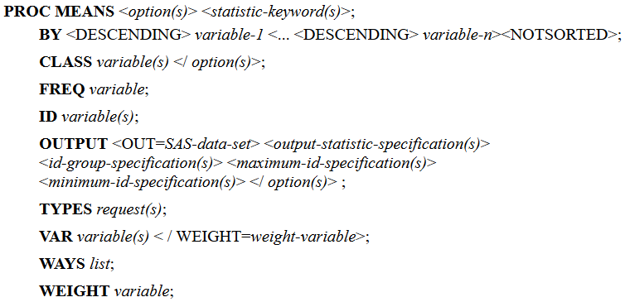

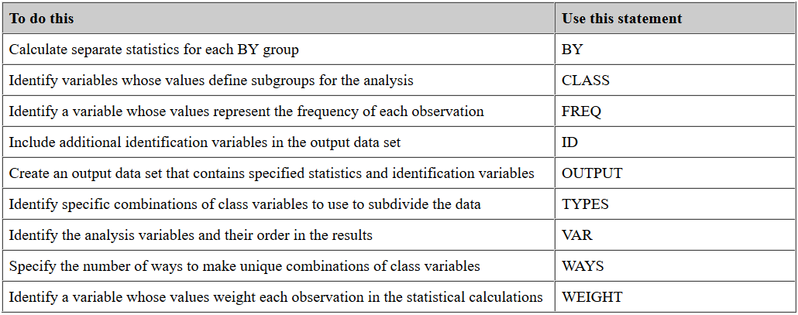

Uses of PROC MEANS

* Analyze numeric or continuous variables
* Analyze numeric variables by group(s)
* Identifies outlier or extreme values
* Hypothesis Testing with Sample T-test

In the DATA= option, you need to specify the dataset you want to use. If no data set is mentioned then the last data set used will be taken by SAS.

In the VAR= option, you need to refer the numeric variables you want to analyze. You cannot refer character variables in the VAR statement.

If we don’t specify the variables in PROC MEANS then it will calculate the stats for all numeric variables. Only numeric variables should be mentioned, if we specify character variable then SAS will produce an error message.

The most frequent statistical options used in PROC MEANS are listed below against their description.

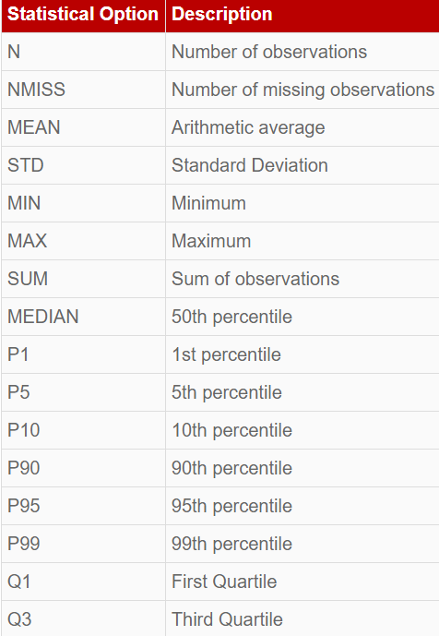

Other statistical options:

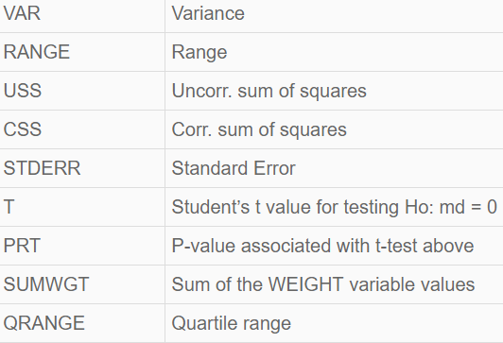

## VAR

Identifies the analysis variables and their order in the output.

In the DATA= option, you need to specify the dataset you want to use. In the VAR= option, you need to refer the numeric variables you want to analyze. You cannot refer character variables in the VAR statement.

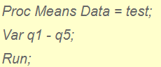

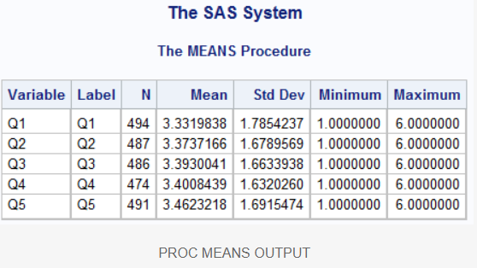

By default, PROC MEANS generates N, Mean, Standard Deviation, Minimum and Maximum statistics.

## CLASS

Specifies the variables whose values define the subgroup combinations for the analysis. Suppose you want to group or classify the analysis by Age. You can use the CLASS statement to accomplish this task. It is equivalent to GROUP BY in SQL.

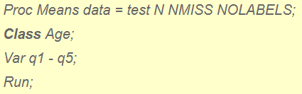

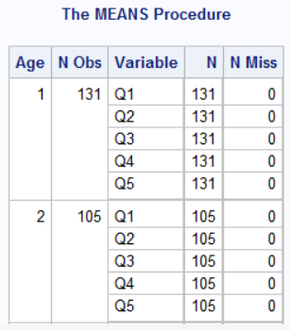

You can use NONOBS option to delete N Obs column from the Proc Means table.

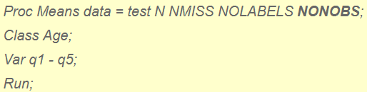

## BY

Produces separate statistics for each BY group. Suppose you want to analyze variables Q1 - Q5 by variable AGE and want the output of each levels of AGE in separate tables. You can use BY statement to accomplish this task. See the example below-

Make sure you sort the data before using BY statement.

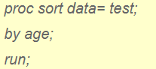

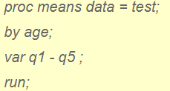

## OUTPUT

The output data set can contain these variables:

* The variables specified in the BY statement.
* The variables specified in the ID statement.
* The variables specified in the CLASS statement.
* The variable _TYPE_ that contains information about the class variables. By default, _TYPE_ is a numeric variable. If you specify CHARTYPE in the PROC statement, _TYPE_ is a character variable. When you use more than 32 class variables, _TYPE_ is automatically a character variable.
* The variable _FREQ_ that contains the number of observations that a given output level represents.
* The variables requested in the OUTPUT statement that contain the output statistics and extreme values.
* The variable _STAT_ that contains the names of the default statistics if you omit statistic keywords.
* The variable _LEVEL_ if you specify the LEVEL option.
* The variable _WAY_ if you specify the WAYS option.

The value of _TYPE_ indicates which combination of the class variables PROC MEANS uses to compute the statistics. The character value of _TYPE_ is a series of zeros and ones, where each value of one indicates an active class variable in the type.

Usually, the output data set contains one observation per level per type. However, if you omit statistical keywords in the OUTPUT statement, the output data set contains five observations per level (six if you specify a WEIGHT variable). Therefore, the total number of observations in the output data set is equal to the sum of the levels for all the types you request multiplied by 1, 5, or 6, whichever is applicable.

If you omit the CLASS statement (_TYPE_ = 0), there is always exactly one level of output per BY-group. If you use a CLASS statement, then the number of levels for each type you request has an upper bound equal to the number of observations in the input data set. By default, PROC MEANS generates all possible types. In this case the total number of levels for each BY-group has an upper bound equal to

## NWAYS

Limit the output statistics to the observations with the highest _TYPE_ value.

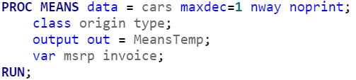

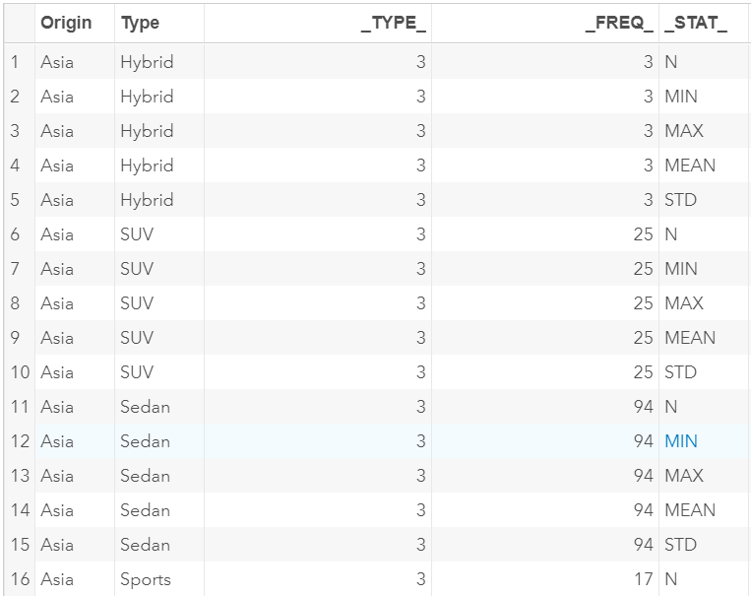

## MAXDEC

Specify the number of decimal places for the statistics in the output.



## NONOBS

N Obs Column is generated when CLASS is specified in the PROC MEAN. Suppress reporting the total number of observations for each unique combination of the class variables

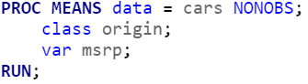

## NOPRINT

Suppress all displayed output. Usually used when the result is stored in data set using OUTPUT option.



## ORDER

Order the values of the class variables according to the specified order.

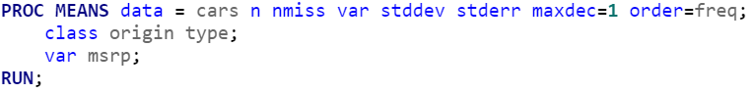

## DESCENDTYPES

Order the output data set by descending _TYPE_ value. Descending has no effect if you specify NWAY.

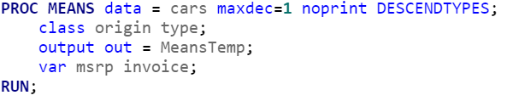

With CLASS statement it gives output for _Type_ 1,2 and 3 and with BY statement it gives output for 0.

## DIFFERENCE BETWEEN CLASS AND BY STATEMENT

The CLASS statement returns analysis for a grouping (classification) variable in a single table whereas BY statement returns the analysis for a grouping variable in separate tables.

Another difference is CLASS statement does not require the classification variable to be pre-sorted whereas BY statement demands sorting.

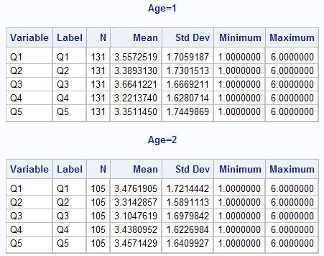

## FORMAT IN PROC MEANS

First, you need to create a user defined format.

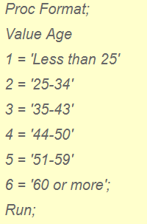

Add FORMAT statement to use user defined format in PROC MEANS.

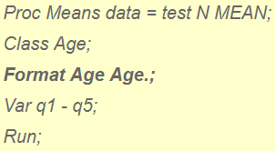

By default SAS searches for the custom format in WORK library, if it is not found then it is not applied. If the custom format is stored in permanent library then we will have to use

## LIMIT DESCRIPTIVE STATISTICS

Suppose you want to see only two statistics - number of non-missing values and number of missing values.

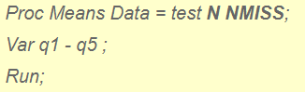

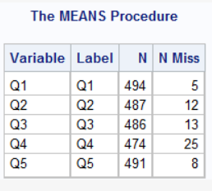

## CHANGE SORTING ORDER

The DESCENDING option to the right of the slash in the first CLASS statement instructs PROC MEANS to analyze the data in DESCENDING order of the values of Age.

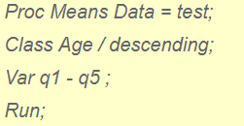

Instead of displaying the results in “sort order” of the values of the Classification Variable (s) you specified in the CLASS Statement, order the results by frequency order using the ORDER=FREQ option in the CLASS Statement.

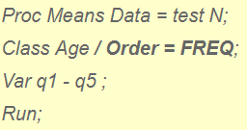

You can order the results by user defined format of a variable specified in the CLASS statement using the ORDER=FORMATTED option in the CLASS Statement.

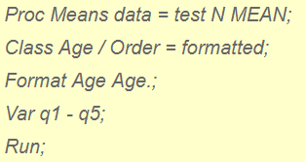

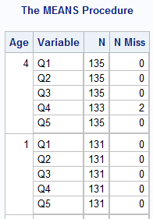

Note: If you specify CLASS statement without VAR statement, it classifies the analysis by all numeric variables in your data set.

## MISSING VALUES

PROC MEANS excludes missing values for the analysis variables before calculating statistics. Each analysis variable is treated individually; a missing value for an observation in one variable does not affect the calculations for other variables. The statements handle missing values as follows:

* If a class variable has a missing value for an observation, PROC MEANS excludes that observation from the analysis unless you use the MISSING option in the PROC statement or the CLASS statement.
* If a BY or an ID variable value is missing, PROC MEANS treats it like any other BY or ID variable value. The missing values form a separate BY group.
* If a FREQ variable value is missing or nonpositive, PROC MEANS excludes the observation from the analysis.
* If a WEIGHT variable value is missing, PROC MEANS excludes the observation from the analysis.

PROC MEANS tabulates the number of the missing values. Before the number of missing values are tabulated, PROC MEANS excludes observations with frequencies that are nonpositive when you use the FREQ statement and observations with weights that are missing or nonpositive (when you use the EXCLNPWGT option) when you use the WEIGHT statement. To report this information in the procedure output use the NMISS statistical keyword in the PROC statement.

# PROC FORMAT

PROC FORMAT is a procedure that creates a mapping of data values into data labels. The user defined FORMAT mapping is independent of a SAS DATASET and variables and must be explicitly assigned in a subsequent DATASTEP and/or PROC.

Below is the syntax for PROC FORMAT:

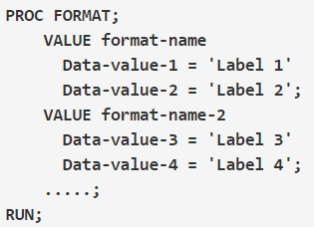

Rules for defining FORMAT NAME:

* For character values, first character must be a dollar sign ($), and a letter or underscore as the second character. For numeric values, name must have a letter or underscore as the first character
* Name cannot end with a number
* Cannot be the name of an existing SAS format
* Should not end with a period in the VALUE statement

Special keywords used to define the ranges are:

1. Ranges can be multiple values separated by commas.

* ‘A’, ’B’, ’C’
* 22, 44, 67

1. Ranges can include or exclude the bounding values, depending on the use of various keywords like:

* 24 – 45: It includes values from 24 to 45 including 24 and 45.
* 24 < – 45: It includes values between 24 to 45 including 45 and excluding 24.
* 24 – < 45: It includes values between 24 to 45 including 24 and excluding 45.
* 24 < – < 45: It includes values between 24 to 45 excluding 24 and 45.

1. LOW refers to least available number, HIGH refers to the highest available number and OTHER includes all numbers not specified. Others also include missing values if it is not specified.

PROC Format returns the original value if we have not included all data values while defining the format.

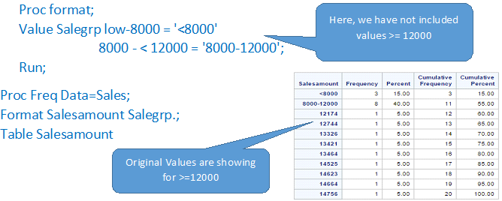

We can create multiple formats in a single PROC FORMAT statement, by specifying multiple values under PROC Format

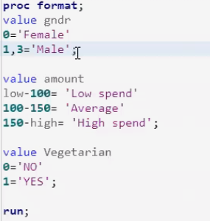

When we mention FORMAT statement anywhere in the DATA STEP then the format will be permanently stored in the dataset hence we don’t have to mention it in print statements.

## LABELS FOR EACH DATA VALUE

The most common way of labeling data is to simply assign each unique code its own label. Here, the format LIKERT7 assigns distinct labels to the values 1, 2, 3, 4, 5, 6, 7.

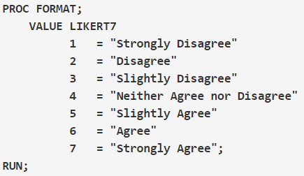

## LABELS THAT APPLY TO MORE THAN ONE DATA VALUE

We may want to use the same value for more than one numeric code. We can do this by listing all of the values (separated by commas) to assign a given label. Format LIKERT7_A assigns the label "Disagree" to values 1, 2, 3; and assigns the label "Agree" to values 5, 6, 7.

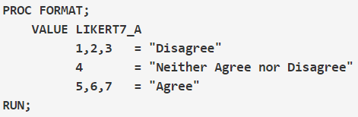

## LABEL TO A RANGE OF DATA VALUES

If a numeric variable represents ordinal codes (or has some discernible order), you can assign the same label to multiple codes in a range. Format LIKERT7_B assigns the label "Disagree" to values 1 through 3, and assigns the label "Agree" to values 5 through 7.

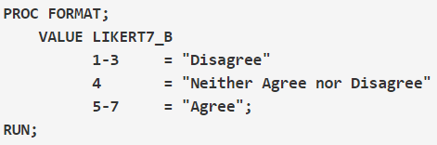

You can also use the keywords LOW and HIGH when assigning labels to a variable with continuous values. Here, format INCOME:

* Applies the label "Low" to all data values less than 20,000;
* Applies the value "Middle" to all data values greater than or equal to 20,00 and less than 60,000;
* And applies the value "High" to all data values greater than or equal to 60,000.

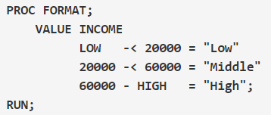

## OTHER

We can use OTHER keyword to apply formats to all other values than desired values:

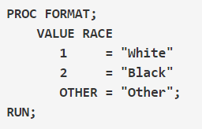

## SAVING USER FORMAT

All SAS formats are stored in a catalog (collection of formats). When we create a Format, it gets stored in the catalog. If we don’t specify the catalog, then SAS stores formats in the WORK library in a catalog called FORMATS. Like other datasets of WORK library, they also get deleted at the end of the session.

Now to save User defined formats, we need to specify where to store the catalog and what to call it. This can be achieved by storing formats in a library other than WORK.

* First of all, we have to define a library:



* Use library option in PROC format and provide a library name with the format file name. The file name must be a valid SAS dataset name.

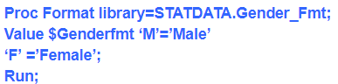

Above program has created a file called Gender_Fmt.sas7bcat in your directory location.

Now, whenever we want to use stored format, we have to tell SAS to look for formats in that catalog file. This is done with the fmtsearch option. So before using it, we need to write a statement.

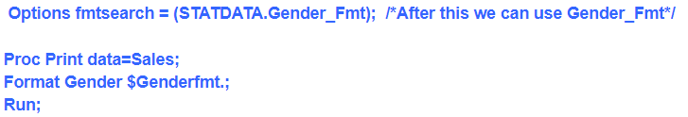

## FMTSEARCH

Now, whenever we want to use stored format, we have to tell SAS to look for formats in that catalog file. This is done with the fmtsearch option. So before using it, we need to write a statement.

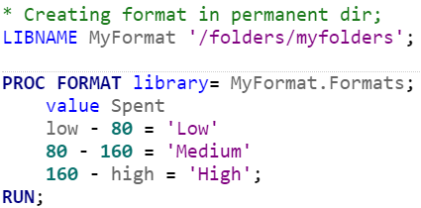

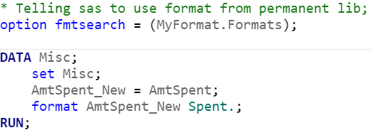

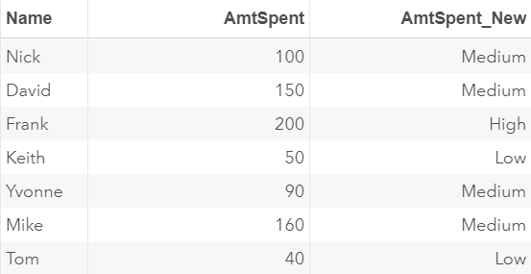

If same format name is available in WORK DIR as well as in permanent dir then the format in WORK dir will be applied.

## FMTLIB

To see all the formats created in a library we can use FMTLIB statement. It will list all the formats available in that particular library. One library can have only 1 format file (sas7bcat file). All the formats created are stored in that particular file.

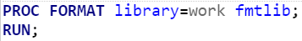

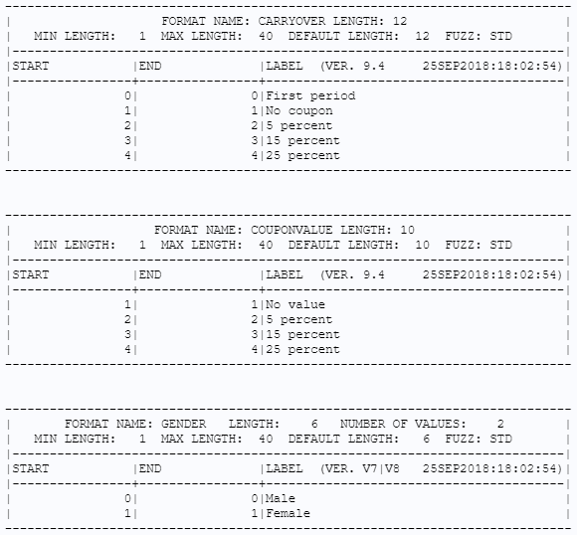

# DO LOOP

There are four forms of the DO statement:

* The DO statement designates a group of statements that are to be executed as a unit, usually as a part of IF-THEN/ELSE statements.
* The iterative DO statement executes a group of statements repetitively based on the value of an index variable. If you specify an UNTIL clause or a WHILE clause, then the execution of the statements is also based on the condition that you specify in the clause.
* The DO UNTIL statement executes a group of statements repetitively until the condition that you specify is true. The condition is checked after each iteration of the loop.
* The DO WHILE statement executes a group of statements repetitively as long as the condition that you specify remains true. The condition is checked before each iteration of the loop.

## DO

The DO statement designates a group of statements that are to be executed as a unit.

DO statement is often used within IF-THEN/ELSE statements to designate a group of statements to be executed if the IF condition is true. For example, in the following code, the statements between DO and END are performed only when YEARS is greater than 5.

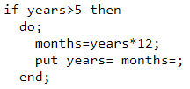

## ITERATIVE DO LOOPS

The iterative DO loop executes the statements between DO and END repetitively based on the value of an index variable.

The basic iterative DO statement in SAS has the syntax DO value = start TO stop. An END statement marks the end of the loop, as shown in the following example:

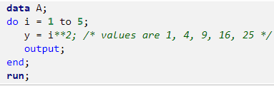

By default, each iteration of a DO statement increments the value of the counter by 1, but you can use the BY option to increment the counter by other amounts, including non-integer amounts.

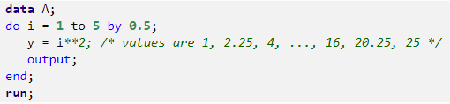

We can also iterate "backwards" by using a negative value for the BY option: do i =5 to 1 by -0.5.

## DO WHILE

You can use the DO statement with a WHILE clause to iterate while a condition is true. The condition is checked before each iteration, which implies that you should intialize the stopping condition prior to the loop. The following statements extend the DATA step example and iterate as long as the value of y is less than 20. When i=4, the WHILE condition is not satisfied, so the loop iterates again.

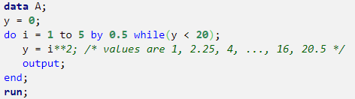

DO WHILE loop is also known as Entry Control Loop the WHILE expression is evaluated before the statements in the DO loop have executed. Hence if condition is false at the very 1st execution then no observation will be displayed.

## DO UNTIL

You can use the iterative DO statement with an UNTIL clause to iterate until a condition becomes true. The UNTIL condition is evaluated at the end of the loop, so you do not have to initialize the condition prior to the loop.

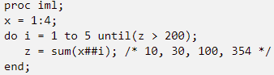

DO UNTIL loop is also known as Exit Control Loop coz the UNTIL expression is evaluated after the statements in the DO loop have executed. Hence if condition is false at very 1st execution then the 1st observation will be displayed in the output.

## CONTROLLING DO LOOPS

You can use the CONTINUE and LEAVE statements to control the flow of execution through DO loops.

### CONTINUE

The CONTINUE statement stops the processing of the current DO loop iteration and resumes with the next iteration of the loop. For example, the following code reads each row in the DEPT table, and if the status is not PT, it displays a frame that enables the user to update the full-time employee's salary.

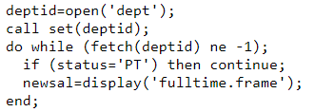

### LEAVE

The LEAVE statement stops processing the current DO loop and resumes with the next statement after the DO loop. With the LEAVE statement, you have the option of specifying a label for the DO statement.

If you have nested DO loops and you want to skip out of more than one loop, you can specify the label of the loop that you want to leave. For example, the following LEAVE statement causes execution to skip to the last PUT statement:

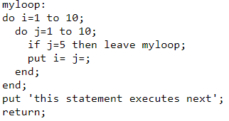

# BY STATEMENT

BY Statement is used to group data in SAS based on the variables mentioned in the BY statement. The 'BY' statement instructs SAS to apply the SAS procedure for each subset of data as defined by the different values of the variable specified in the BY statement, and this works in the majority of SAS procedures.

Sorting is necessary when using a BY statement in a procedure. If the data set is not sorted an error message will appear in the Log File.

The most common use of BY-group processing in the DATA step is to combine two or more SAS data sets using a BY statement with a SET, MERGE, MODIFY, or UPDATE statement.

When processing these statements, SAS reads one observation at a time into the program data vector. With BY-group processing, SAS selects the observations from the data sets according to the values of the BY variable or variables. After processing all the observations from one BY group, SAS expects the next observation to be from the next BY group.

SAS identifies the beginning and end of a BY group by creating two temporary variables for each BY variable:

* FIRST.variable
* LAST.variable

The value of these variables is either 0 or 1. SAS sets the value of FIRST.variable to 1 when it reads the first observation in a BY group, and sets the value of LAST.variable to 1 when it reads the last observation in a BY group. These temporary variables are available for DATA step programming but are not added to the output data set.

The following DATA step defines a variable named Count and initializes Count=0 at the beginning of each BY group. For every observation in the BY group, the Count variable is incremented by 1. When the last record in each BY group is read, that record is written to the Count data set.

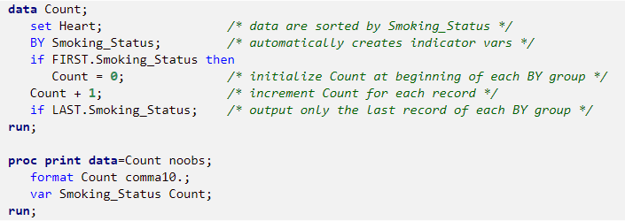

# PROC REPORT

PROC REPORT combines proc freq, proc means, proc print, proc sort, proc tabulate and can-do things for which normally proc template is used.

## BYPAGENO

BYPAGENO=number

If a BY statement is present, specifies the page number at the start of each BY group.

## COLWIDTH

COLWIDTH=column-width

Specifies the default number of characters for columns containing computed variables or numeric data set variables.